Network pharmacology of AYUSH recommended immune-boosting medicinal plants against COVID-19
Yadu Nandan Dey, School of Pharmaceutical Technology, Adamas University, Kolkata-700126, West Bengal, India
Pukar Khanal, KLE College of Pharmacy, Belagavi-590010, Karnataka, India
Taaza Duyu, KLE College of Pharmacy, Belagavi-590010, Karnataka, India
BM Patil, KLE College of Pharmacy, Belagavi-590010, Karnataka, India
Ismail Pasha, Orotta College of Medicine and Health Sciences, Asmara University, Asmara, Eritrea
Manish Wanjari, Regional Ayurveda Research Institute for Drug Development, Gwalior-474009, Madhya Pradesh, India
Shailendra S. Gurav, Goa College of Pharmacy, Panjim-403001, Goa, India

Abstract
The Ministry of AYUSH recommended the use of a decoction of the mixture of Ocimum tenuiflorum, Cinnamomum verum, Piper nigrum, Zingiber officinale, and Vitis vinifera as a preventive measure to boost immunity and to inhibit the severity of infection caused by a novel coronavirus (COVID-19). The present study aimed to identify the probable modulated pathways by the combined action of AYUSH recommended herbal tea and golden milk formulation as an immune booster against COVID-19. Reported phytoconstituents of all the medicinal plants were retrieved from the ChEBI database, and their targets were predicted using DIGEP-Pred. STRING database and Cytoscape were used to predict the protein-protein interaction and construct the network respectively. Likewise, MolSoft and admetSAR2.0 were used to predict the druglikeness score and ADMET profile of phytoconstituents. The study identified the modulation of HIF-1, p53, PI3K-Akt, MAPK, cAMP, Ras, Wnt, NF-kappa B, IL-17, TNF, and cGMP-PKG signaling pathways to boost the immune system. Further, multiple pathways were also identified which are involved in the regulation of pathogenesis of the multiple infections and non-infectious diseases due to the lower immune system. Results indicated that the recommended herbal formulation not only modulated the pathways related to boost immunity but also modulated the multiple pathways that are contributing to the progression of multiple disease pathogenesis which would add the beneficial effect in the special subjects like patients from hypertension and diabetes. The study provides the scientific documentation of the role of the Ayurvedic formulation to combat COVID-19.

Image
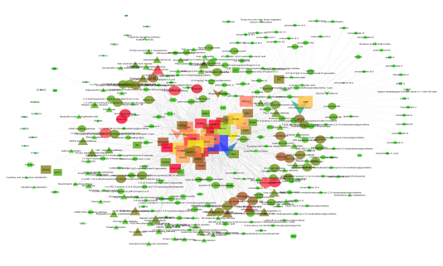
Figure 1. Interaction of bioactives from an herbal tea with their proteins and regulated pathway
Recent Publications (minimum 5)
- Ministry of AYUSH. Ayurveda’s immunity boosting measures for self care during COVID 19 crisis. 2020. Available at: https://www.ayush.gov.in/docs/123.pdf. Accessed on: 12 April 2020
- Mason RJ (2020). Pathogenesis of COVID-19 from a cell biology perspective. Eur Respir J55:2000607.
- Kaushik S, Jangra G, Kundu V, Yadav JP, Kaushik S (2020). Anti-viral activity of Zingiber officinale (Ginger) ingredients against the Chikungunya virus. Virus Disease. 5:1-7.
- Soares-Silva M, Diniz FF, Gomes GN, Bahia D (2016). The Mitogen-Activated Protein Kinase (MAPK) Pathway: Role in Immune Evasion by Trypanosomatids. Front Microbiol. 7:183.
- Johnson DS, Chen YH (2012). Ras family of small GTPases in immunity and inflammation. Curr Opin Pharmacol. 12(4):458–463.

Biography
Dr. Yadu Nandan Dey is working as an Assistant Professor in the School of Pharmaceutical Technology, Adamas University, Kolkata, West Bengal, India. He completed his B. Pharm. and M. Pharm. from West Bengal University of Technology. He worked as a Senior Research Fellow at CCRAS-RARIDD, Gwalior where he completed his Ph.D. studies. He has acquired more than 10 years of research experience and 1 year teaching experience. He was awarded with ICMR Centenary Post Doctoral Fellowship in 2017 and carried out his Post Doctoral research work at ICMR-National Institute of Traditional Medicine, Belagavi. He was also awarded with “Young Scientist” Award by Madhya Pradesh Council of Science and Technology, Bhopal in 2016. He has undergone various training programs and workshops in reputed organizations and presented more than 15 research papers in various national and international conferences. He contributed in 3 book chapters and has 35 research papers in various national and international journals which got more than 600 citations. He is also member of the Editorial Board and reviewer of various reputed journals. His area of research is safety and efficacy of herbal drugs in various animal models of inflammatory and metabolic diseases.
Email: yadunandan132@gmail.com

Notes/Comments
Presenting Author: Dr. Yadu Nandan Dey
Category: Young Scientist Award

