High antioxidant and high fiber cashew based functional drink improves lipid profiles, atherogenic index and cerebral ischemia in obese rats
Pratthana Srichomphu, M.Sc., ICAM R&D Center, KKU, Khon Kaen,Thailand
Jintanaporn Wattanathorn, Ph.D, ICAM R&D Center, KKU, Khon Kaen,Thailand
Wipawee Thukham-mee, Ph.D, ICAM R&D Center, KKU, Khon Kaen,Thailand

Abstract
Statement of the Problem: Although the cerebral ischemia in obesity is increasing its importance due to the increasing prevalence, the therapeutic efficacy is limited. Based on the antioxidant and neuroprotective effect of cashew extract and antidyslipidemia effect of dietary fiber, the beneficial effect of high antioxidant high fiber of cashew based functional drink was focused. Therefore, the purpose of this study is to determine the effect of this functional drink on lipid profiles, atherogenic index and cerebral ischemia in obese rats. Methodology & Theoretical Orientation: Male Wistar rats weighing 200-250 g were induced obesity by high fat diet (HFD) for 12 weeks and were orally given the high antioxidant high fiber of cashew based functional drink at doses of 1, 10 and 100 mg/kg BW for 14 days. Then, the determination of triglyceride, cholesterol, LDL, HDL and atherogenic index together with spatial memory were performed. At the end of experiment, They were induced cerebral ischemia and were also determined ischemic brain volume, oxidative stress status. Findings: All doses of the functional drink decreased total cholesterol, triglyceride but increased HDL Only the high dose of functional drink decreased LDL in obese rats. In addition, the improved brain infarcted volume, memory and atherogenic index were also observed in obese rats which received all doses of the functional drink used in this study. Moreover, the improved oxidative stress markers were observed in all treatment groups. Conclusion & Significance: These data suggest that given the high antioxidant high fiber of cashew based functional drink is the potential supplement for decreasing risk of cerebral ischemia in obesity. The possible underlying mechanism may occur partly via the improved serum lipid profiles and brain oxidative stress status. However further studies are still essential prior to the clinical trial study.

Key words; cerebral ischemia, obesity, cashew, dietary fiber
Acknowledgement: This study was supported by Thailand Research Fund and Integrative Complementary Alternative Medicine Research and Development Center, Khon Kaen University, Khon Kaen, Thailand

Image
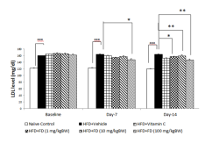
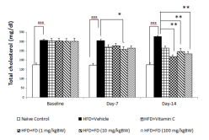
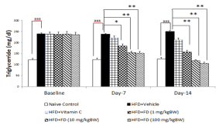

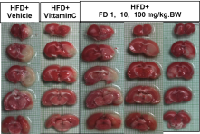
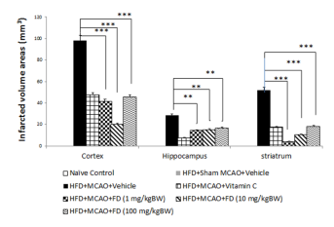
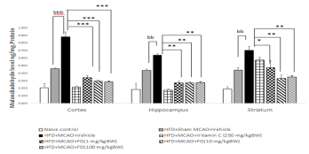
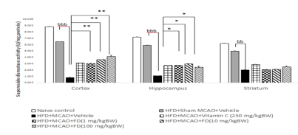
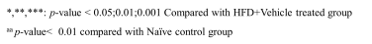
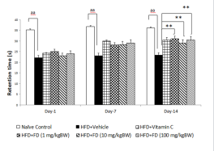
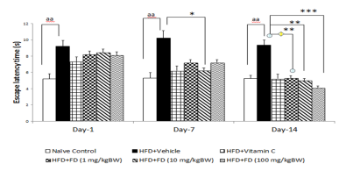
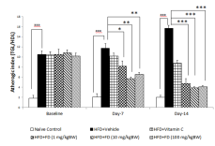
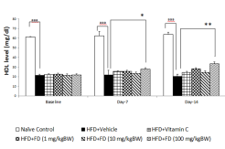
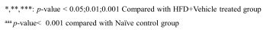

Figure 1 Effect of the high antioxidant high fiber of cashew based functional drink on lipid profile and atheroginic index
Figure 2 Effect of the high antioxidant high fiber of cashew based functional drink on spatial memory in Morris water maze test.
Figure 3 Effect of the high antioxidant high fiber of cashew based functional drink on brain infarcted volume.

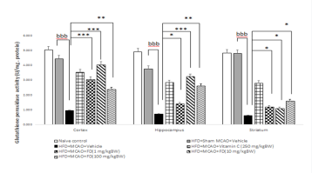
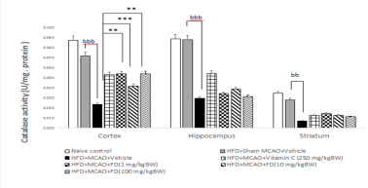


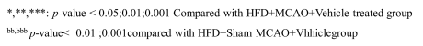

Figure 4 Effect of the high antioxidant high fiber of cashew based functional drink on oxidative stress status.

Biography
Pratthana Srichomphu is Ph.D student in neuroscience program of Integrative Complementary Alternative Medicine Research and Development Center, Khon Kaen University, Khon Kaen, Thailand. She received her M.Sc. from Faculty of Medicine, Khon Kaen University. Her research focuses on obesity and cerebral ischemia in animal models. She has experience in research of the functional food and herbal health product. The researchers are performed including in vitro and preclinical study. She has petty patent concerning functional food.
Email:Baifern_rabbitpink@hotmail.com

