ICAM611, a polyphenol-rich supplement, attenuates brain damage and dysfunction induced by cerebral ischemia in animal model of metabolic syndrome.
Warin Ohn-on, B.Sc, ICAM R&D Center, KKU, Khon Kaen,Thailand
Jintanaporn Wattanathorn, Ph.D, ICAM R&D Center, KKU, Khon Kaen,Thailand
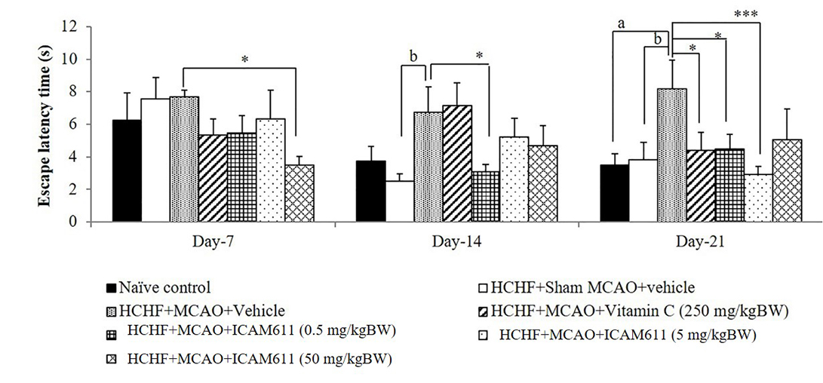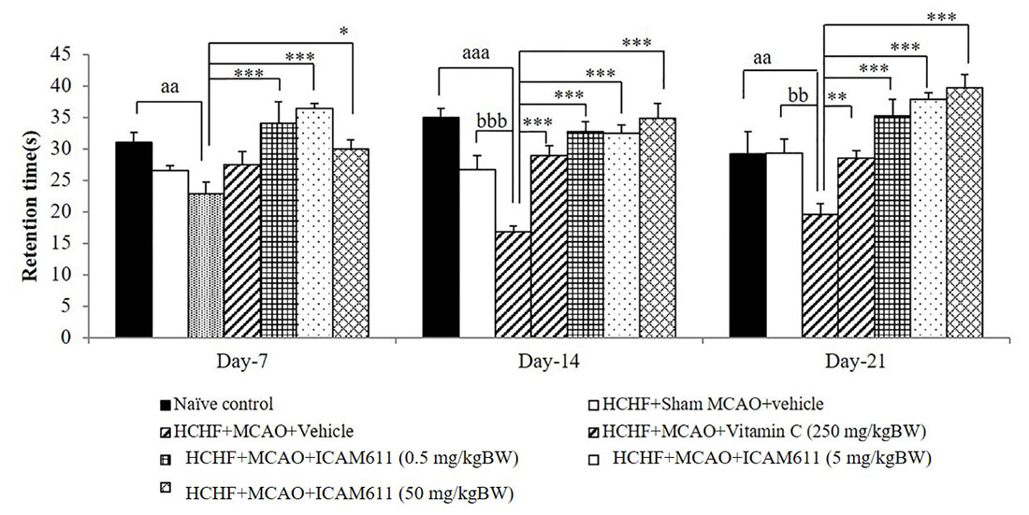Wipawee Thukham-mee, Ph.D, ICAM R&D Center, KKU, Khon Kaen,Thailand

Abstract
Statement of the Problem: Currently, the therapeutic intervention against cerebral ischemia associated with metabolic syndrome (MetS) is required. Based on the crucial roles of oxidative stress and inflammation on the pathophysiology of cerebral ischemia in MetS, the beneficial effect of the supplement possessing antioxidant and anti-inflammatory activities on aforementioned condition has been considered. Therefore, the purpose of this study is to investigate the effect of ICAM611, a polyphenol rich supplement on brain damage and dysfunction induced by cerebral ischemia in animal model of MetS. Methodology & Theoretical Orientation: Male Wistar rats weighing 200-250 g were induced metabolic syndrome by high carbohydrate high fat (HCHF) diet for 16 weeks. The rats which showed MetS characteristic were induced ischemic-reperfusion injury for 90 minutes and were orally given ICAM611, the supplement containing the combined extract of Oryza sativa (purple color) and Anethum graveolens at doses of 0.5, 5 and 50 mg/kg BW once daily for 14 days. The animals were determined spatial memory and neurological score every 7 days. At the end of experiment, they were also determined ischemic brain volume, oxidative stress status, neuron density. Findings: All doses of ICAM611significantly improve memory impairment, brain infarcted volume and edema. The improved oxidative stress status and neuron density in prefrontal cortex and hippocampus were also observed. Conclusion & Significance: The current results suggested the potential neuroprotective effect against cerebral ischemia in metabolic syndrome condition. The possible underlying mechanism occurs partly via the improved oxidative stress. However further investigations are required before moving forwards to clinical trial study.
Key words: cerebral ischemia, metabolic syndrome, Oryza sativa, Anethum graveolens
Acknowledgement: This study was supported by Integrative Complementary Alternative Medicine Research and Thailand.

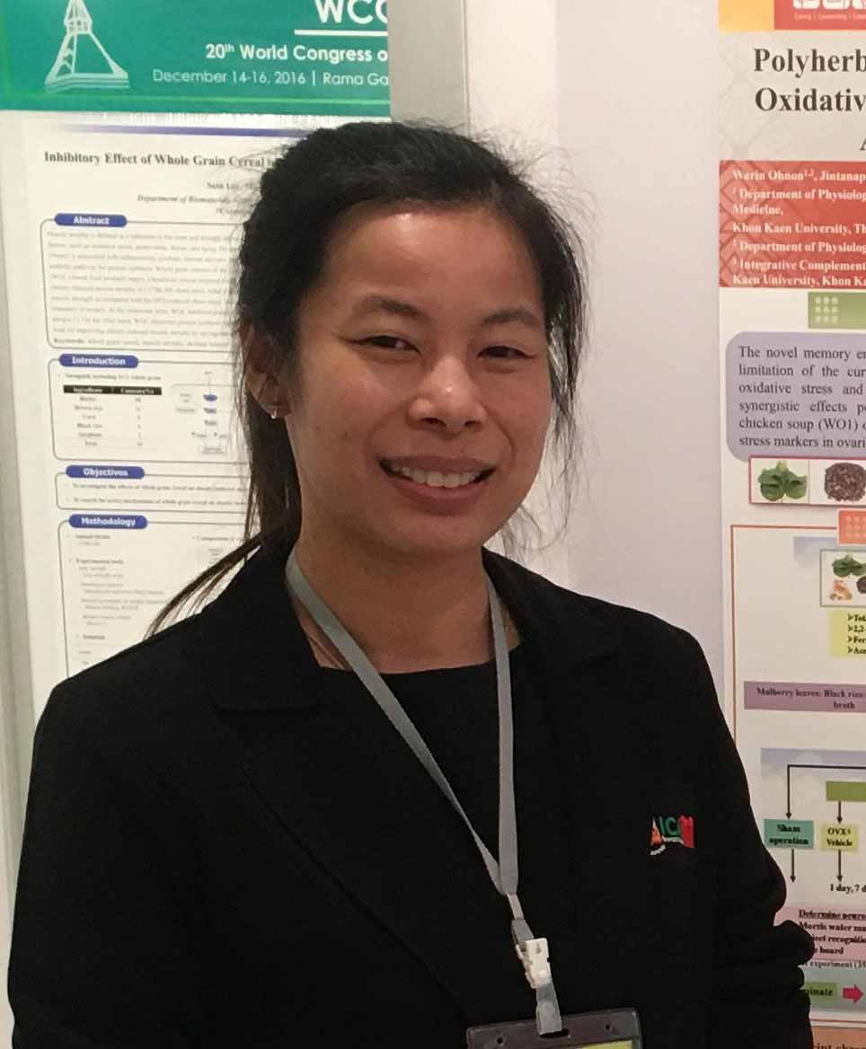
Biography
Email: warin_onohn@hotmail.com

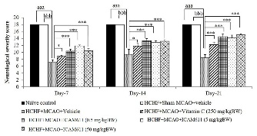
Figure 1 Effect of “ICAM611”, a polyphenol-rich supplement, on spatial memory in Morris water maze test.
Figure 2 Effect of “ICAM611”, a polyphenol-rich supplement, on neurological score.
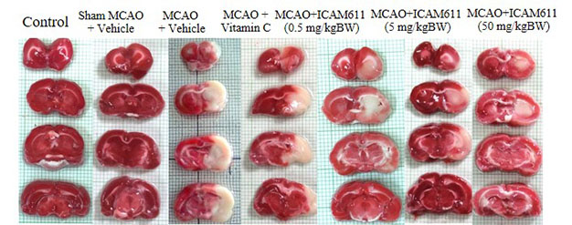
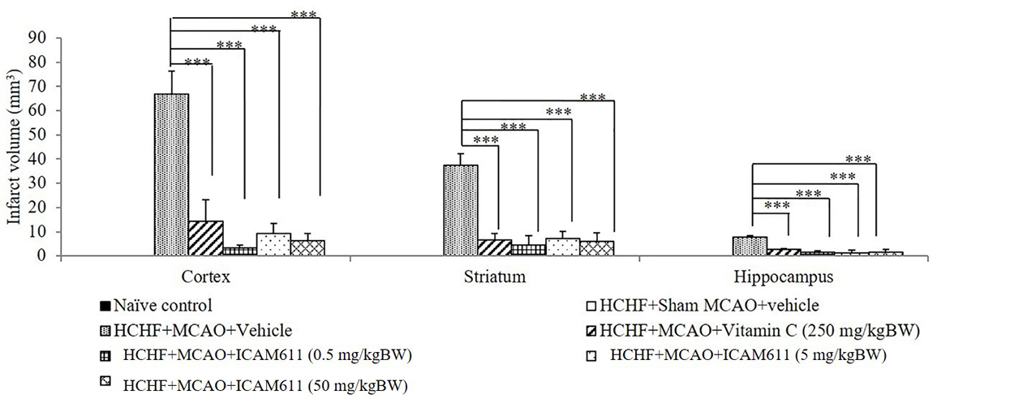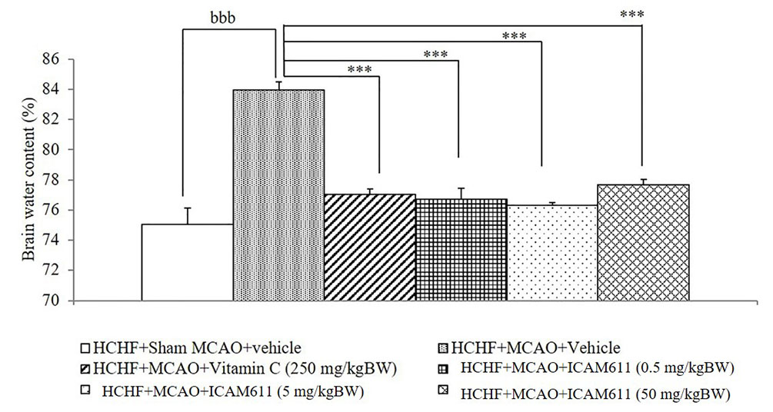

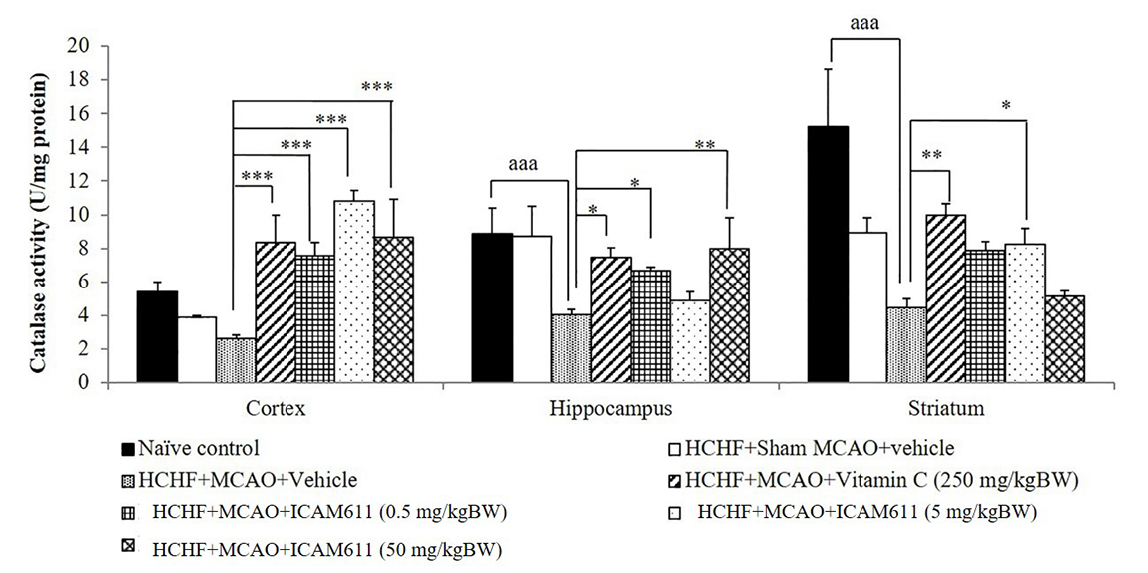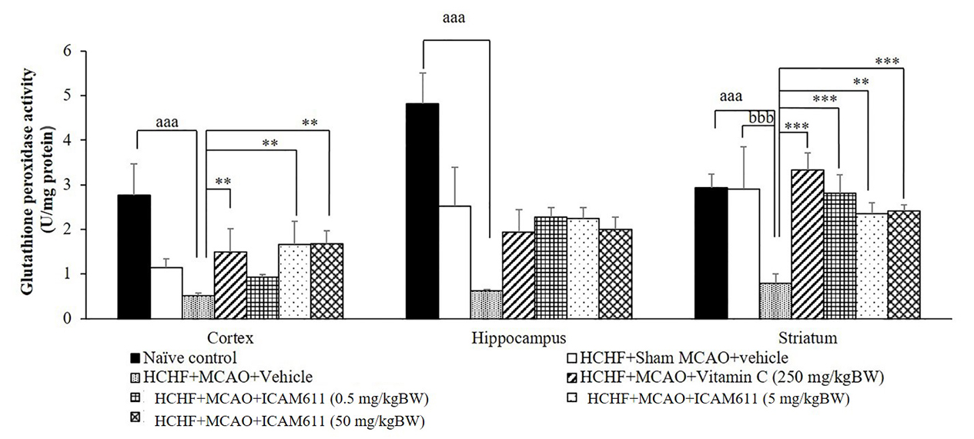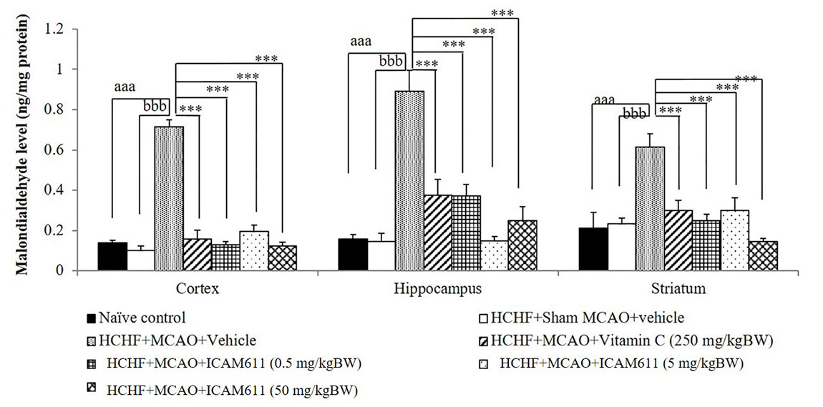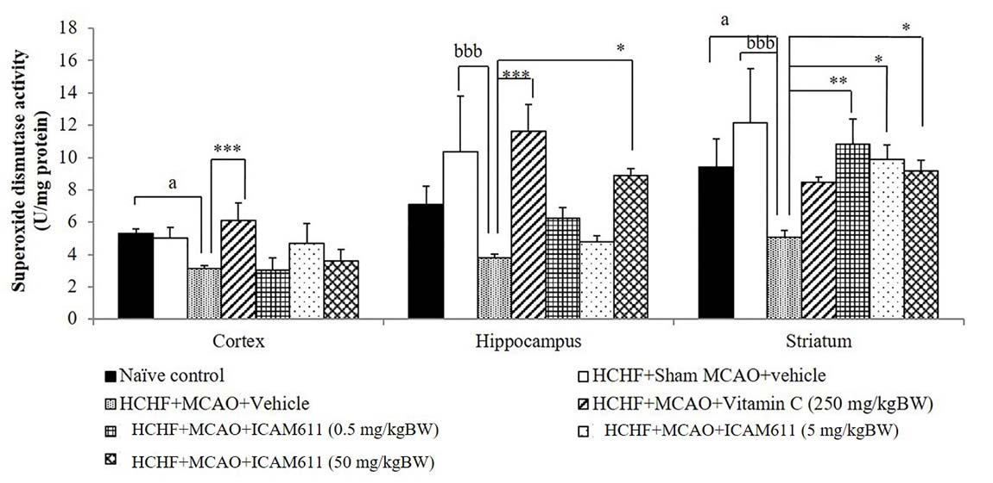Figure 3 Effect of “ICAM611”, a polyphenol-rich supplement, on brain edema and infarcted volume.

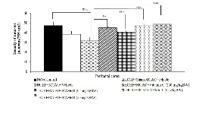
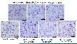
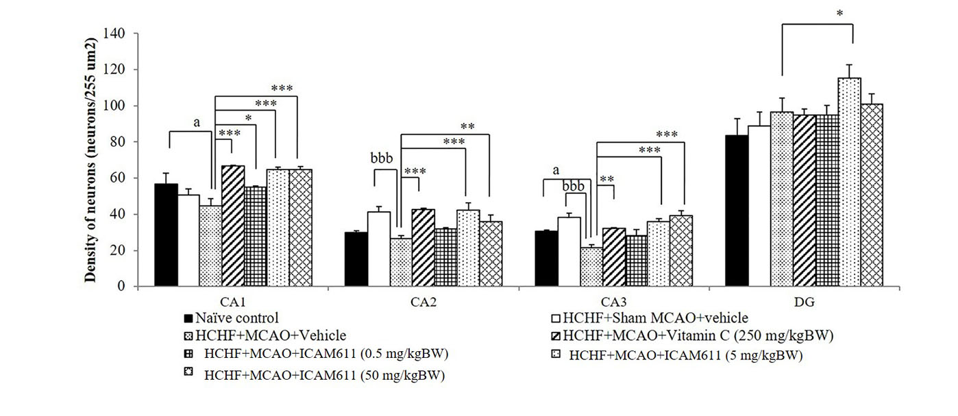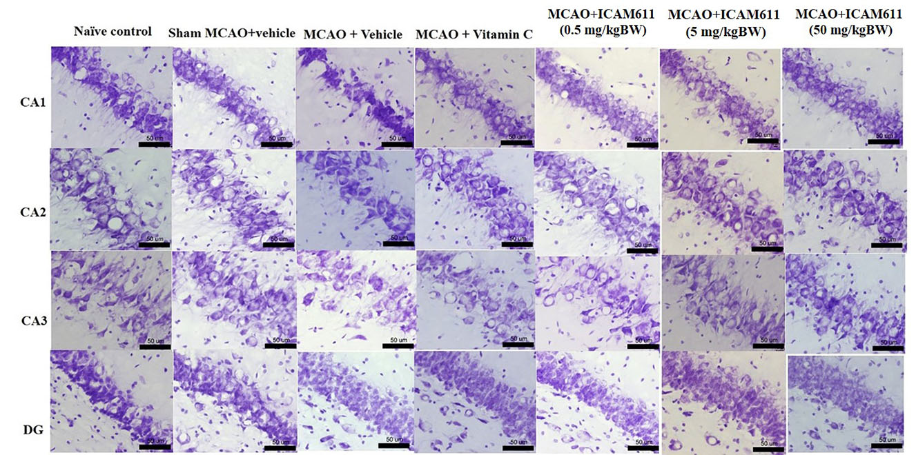Figure 4 Effect of “ICAM611”, a polyphenol-rich supplement, on oxidative stress status.

Figure 5 Effect of “ICAM611”, a polyphenol-rich supplement, on neuron density in prefrontal cortex and hippocampus.
Warin Ohn-on is Ph.D student in neuroscience program of Integrative Complementary Alternative Medicine Research and Development Center, Khon Kaen University, Khon Kaen, Thailand. She has experience in research of the functional food and herbal health product. She has been doing researches on stroke in metabolic syndrome in animal model. The researches are performed including in vitro and preclinical study. She has petty patent concerning functional food.

