AGRI-BYPRODUCTS, AN UNEXPLORED RESOURCE FOR FUTURE PREBIOTICS

Chandan Prasad, PhD
Department of Nutrition and Food Sciences, Texas Woman’s University, Denton, TX 76203

Abstract

Agri-byproducts result from agricultural activities such as cultivation of rice, wheat, barley, corn, sugarcane, banana and other crops as well as food processing and manufacturing. These byproducts are rich source of arabinogalactans, cellulose, hemicellulose and lignin and a variety of other compounds. While some of these byproducts have used for production of fibers, ethanol and chemicals such as furfural, the most go as animal feed, compost or waste. Significant progress in analytical/processing chemistry and biotechnology methods in the last decades has opened the possibility of developing new uses of agri-byproducts commonly referred to as agri-wastes. The cellulosic by-products are well suited to be converted into high-value prebiotics and nutraceuticals (beta-Glucans, Resistant Starch, Glucomannan, Chitosans, Arabinoxylans) capable of enhancing probiotic growth, reducing inflammation, enhancing immune response and arresting cell growth of cancer cells. This presentation will summarize existing data and suggest future directions on identification, characterization, derivatization, biologic testing and function of agricultural byproducts as possible prebiotics and nutraceuticals for human use.

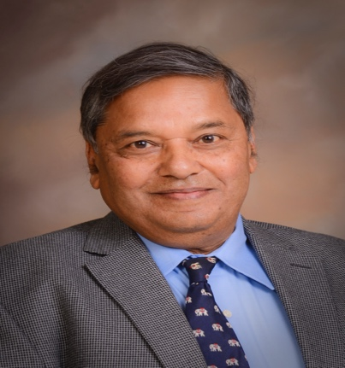
Biography

Chandan Prasad graduated from Louisiana State University in 1970 with a Ph.D. in microbiology/biochemistry. After 8 years at the NIH in Bethesda, Maryland, he joined the faculty of LSU Health Sciences Center (LSUHSC) in New Orleans. He served LSUHSC as professor (medicine and neuroscience), Director of Obesity Research Program, and vice chairman (research) until 2006. He was also the first chair of the laboratory of Nutrition and Brain at the Pennington Biomedical Research Center. He joined Texas Woman’s University (TWU) as Chair of the Department of Nutrition and served in this capacity until 2012. He served TWU as Interim Assistant Provost for Research Promotion from 2012 to 2014. Currently, he is Professor at TWU and Professor (Emeritus) of Medicine at the LSUHSC. The current focus of Dr. Prasad’s research is on inflammation and its role in non-communicable diseases. He has authored more than 200 papers on the subject and holds four U.S. and international patents for treatment of obesity and alcoholism. He is Founding Editor of Nutritional Neuroscience, series editor for Nutrition, Brain, and Behavior, Editor-in-Chief of Current Topics in Nutraceutical Research and Member of the Board of the International Society of Nutrigenetics/Nutrigenomics.
E-mail: cprasad@twu.edu

