Phenolic Compounds and Antioxidant Activity of Ethanolic Extracts of Adzuki Beans according to Cultivar
Ji Hae Lee¹, Koan Sik Woo¹, Hyun-Joo Kim¹, Min Young Kim², Heon Sang Jeong², Yu Young Lee¹, Byong Won Lee¹, Byoung-Kyu Lee¹, Yong-Hee Jeon¹

¹Department of Central Area Crop Science, National Institute of Crop Science, Rural Development Administration, Suwon, Gyeonggi 16429, Republic of Korea
²Department of Food Science and Technology, Chungbuk National University, Cheongju, Chungbuk 28644, Republic of Korea

Abstract (300 word limit)
We analyzed the phenolic compounds in five cultivars of adzuki beans [cv. Geomguseul (GGS), Arari (ARR), Yeonduchae (YDC), Whinguseul (WGS), and Whinnarae (WNR)] and compared their antioxidant abilities and cytotoxic effects. The total polyphenol contents were highest in GGS (20.53 mg GAE/g of extract), and the flavonoid contents were highest in WGS (7.79 mg CE/g of extract). The predominant phenolic compound in the adzuki beans was (+)-catechin; it accounted for 71.84, 96.08, 78.03, 87.66, and 89.31% of the content in GGS, ARR, YDC, WGS, and WNR, respectively. Gallic acid was also ubiquitously found in the adzuki beans; it comprised 2.54, 2.68, 11.24, 4.40, and 10.69% of the total phenolic acids in GGS, ARR, YDC, WGS, and WNR, respectively. The other phenolic acids differed according to the cultivar. GGS contained the most varied phenolic acids, including caffeic acid and biochanin, which were only found in this cultivar. In ARR and WNR, phenolic compounds were not detected or minor amounts were detected, except for gallic acid and (+)-catechin. In YDC and WGS, gentisic acid and phloretic acid were the second most substantial compounds, respectively. The predominant phenolic acids in five cultivars of adzuki bean were (+)-catechin and gallic acid. Antioxidant capacities were determined using DPPH and ABTS radical, and reducing power was positively enhanced according to the total polyphenolic content. In a cell-based assay, adzuki beans showed cytoprotective effects against oxidative stress induced by tert-butyl hydroperoxide and inhibitory effects on the production of reactive oxygen species, except for the cultivar WNR. In conclusion, (+)-catechin was the predominant phenolic compound found in adzuki beans, but there were differences according to the cultivar. Overall, the five adzuki bean cultivars showed different antioxidant activities and cytoprotective effects according to the concentration and composition of phenolic compounds.

Image

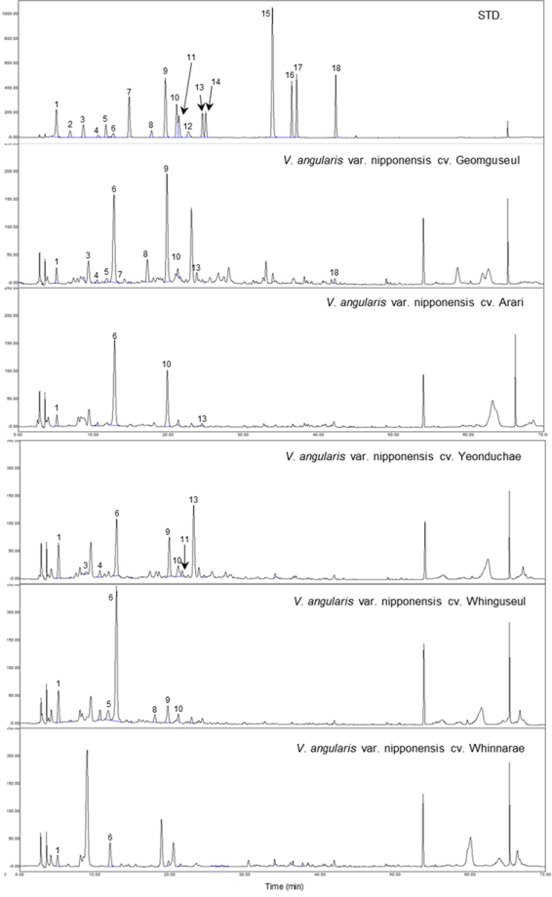

Figure 1. The chromatograms of phenolic acids on standard mixture and ethanolic extracts in adzuki bean according to variety. 1: gallic acid, 2: homogentisic acid, 3: protocatechuic acid, 4: gentisic acid, 5: chlorogenic acid, 6:(+)-catechin, 7: caffeic acid, 8: phloretic acid, 9: ρ-coumaric acid, 10: ferulic acid, 11: veratric acid, 12: naringin, 13: hesperidin, 14: salicylic acid, 15: cinnamic acid, 16: naringenin, 17: hesperitin, 18: biochanin

 Biography (150 word limit)
Dr. Ji Hae Lee
2011.03 ~ 2015.02: PhD course (Korea University)
2015.03 ~ 2016.02: Postdoc (Sungkyunkwan University)
2017.01 ~ Present: Postdoc (National Institute of Crop Science, RDA).
Research topic: Investigation of bioactivities from Food and natural compounds.
Email: jihae@korea.kr

