Antioxidant Components and Antioxidant Activity of Black Soybean with Cooking Method and Mixing Ratio
Hyun-Joo Kim, Koan Sik Woo, Ji Hae Lee, Byong Won Lee, Yu Young Lee, and Byoung Kyu Lee

Department of Central Area Crop Science, National Institute of Crop Science, Rural Development Administration, Suwon, Gyeonggi 16429, Republic of Korea

Abstract (300 word limit)
This study was carried out to compare the phenolic compounds and antioxidant activity of un-hulled and hulled black soybean with addition rate (0, 5, 10, 15, and 20%), and cooking method. The black soybean cultivars were Glycine max (L.) Merr. cv. Cheongja 3, and rice cultivar was Samkwang rice. Cooked rice added black soybean was cooked by general and high pressure cooking method with and without fermented alcohol. The quality characteristics according to different addition ratios of un-hulled and hulled black soybean evaluated the water binding capacity, water solubility, swelling power, and pasting characteristics. The antioxidant characteristics evaluated the total polyphenol, flavonoid contents, DPPH and ABTS radical scavenging activities. Water binding capacity and swelling power decreased as increasing the amounts of un-hulled black soybean, however water solubility increased. Swelling power decreased as increasing the amounts of hulled black soybean, however water binding capacity and water solubility increased. Peak, trough, breakdown, final, and setback viscosity decreased as increasing the amounts of un-hulled and hulled black soybean. The total polyphenol and flavonoid contents were increased as increasing the amounts of black soybean. DPPH and ABTS radical scavenging activities were increased as increasing the amounts of black soybean. Moreover, cooked rice added un-hulled black soybean showed the higher antioxidant effect compare to cooked rice added hulled black soybean. In this study, phenolic compounds and antioxidant activity of cooking black soybean with addition rate and cooking method were expected to be used as basic data on processed products manufactured.

Image
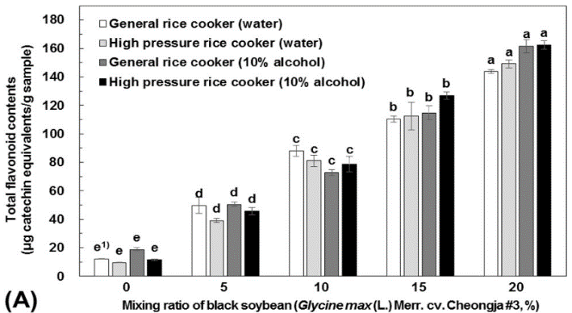
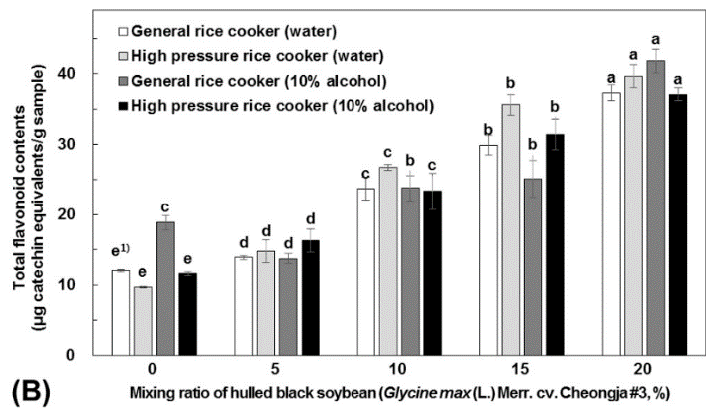

Figure 1. Total flavonoid contents on the ethanolic extracts with different mixing ratio of un-hulled (A) and hulled black soybean (B) and cooking methods.

1) Any means in the same column followed by the same letter are not significantly (p<0.05) different by Duncan's multiple range test.

Biography (150 word limit)
Hyun-Joo Kim was in the joint program of industrial-educational corporation between Korea Atomic Energy Research Institute and Chungnam National University for Master’s of Science and Doctorate degree. She has mainly involved in food technology research using irradiation, cold plasma, high hydrostatic pressure and published research papers regarding functional improvement of polysaccharides. Recently, she has published various research results in the field of processing materials development using crops such as rice, barley and beans.
Email: tlrtod@korea.kr

Notes/Comments:

