The protective effect against diabetic nephropathy of Nelumbo nucifera in streptozotocin rats.

Panakaporn Wannannon, MD, ICAM R&D Center, KKU, Khon Kaen,Thailand
Jintanaporn Wattanathorn, Ph.D, ICAM R&D Center, KKU, Khon Kaen,Thailand
Wipawee Thukham-mee, Ph.D, ICAM R&D Center, KKU, Khon Kaen,Thailand
Supaporn Muchimapura, Ph.D, ICAM R&D Center, KKU, Khon Kaen,Thailand
Terdthai Tong-Un, MD, ICAM R&D Center, KKU, Khon Kaen,Thailand
Table 1Effect of Nelumbo nucifera extract on urine changes.
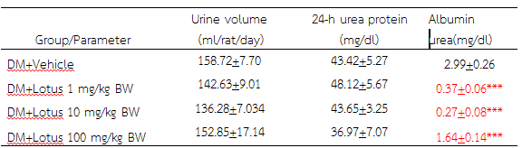

Abstract
Statement of the Problem: Diabetic nephropathy, one of the most serious diabetic complications and the most common cause of end-stage renal failure, is regarded as one of the challenges in this decade. Based on the activities associated with the pathophysiology of diabetic nephropathy such as hypoglycemic, antioxidant and aldose reductase inhibitor activities of Nelumbo nucifera leaves extract, we hypothesized that this extract could prevent diabetic nephropathy. Thus, the purpose of this study is to test this hypothesis. Methodology & Theoretical Orientation: Male Wistar rats weighing 200-250 g were induced diabetic condition by using Streptozotocin (55 mg/kg BW). Rats which showed blood sugar more than 250 mg/dl were recruited for further study. They were orally administered the extract of young leaves of N. nucifera at doses of 1,10 and 100 mg/kg BW once daily for 8 weeks. At the end of study, they were determined blood sugar, albumin urea, the levels of blood urea nitrogen (BUN) and creatinine together with the activities of lactate dehydrogenase (LDH) in serum. The alterations of renal oxidative stress markers and renal histology were also carried out. Findings: All doses of extract used in this study decreased albumin urea and serum creatinine in diabetic rats. They also improved renal histology but no improved renal oxidative stress status was observed. Conclusion & Significance: These data suggested that 50%hydroalcoholic extract of N.nucifera leaves is the potential substance that can be served as the resource for developing the health product prototype targeting at reducing the diabetic nephropathy risk. The principal mechanism of action might not occur via the decreased renal oxidative stress and required further studies.
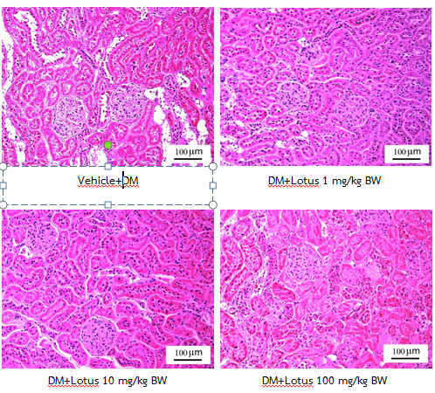
Table 3 Effect of Nelumbo nucifera extract on the renal oxidative stress status.
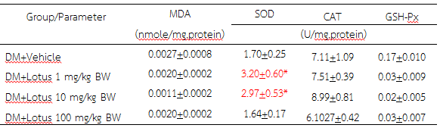
Table 2 Effect of Nelumbo nucifera extract on the changes of serum creatinine, blood urea nitrogen (BUN) and lactate dehydrogenase (LDH)
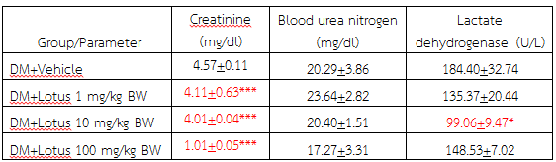

Key words: Nelumbo nucifera, diabetic nepheopathy
Acknowledgement: This study was supported by the National Research Council of Thailand and Integrative Complementary Alternative Medicine Research and Development Center, Khon Kaen University, Khon Kaen, Thailand

 Panakaporn Wannannon is academic and research staff and the committee of the Integrative Complementary Alternative Medicine Research and Development Center, Department of Physiology, Faculty of Medicine, Khon Kaen University, Thailand. She has her expertise in evaluating safety and efficacy of the functional food and herbal health product and also clinical study of the functional health product.
e-mail: wpanak@kku.ac.th

