Microencapsulation of mulberry fruit extract reduced metabolic disorders in animal model of menopause with metabolic syndrome

Jintanaporn Wattanathorn, Ph.D, ICAM R&D Center, KKU, Khon Kaen,Thailand
Supanikar Kawvised, BSc, ICAM R&D Center, KKU, Khon Kaen,Thailand
Wipawee Thukham-mee, Ph.D, ICAM R&D Center, KKU, Khon Kaen,Thailand

Abstract
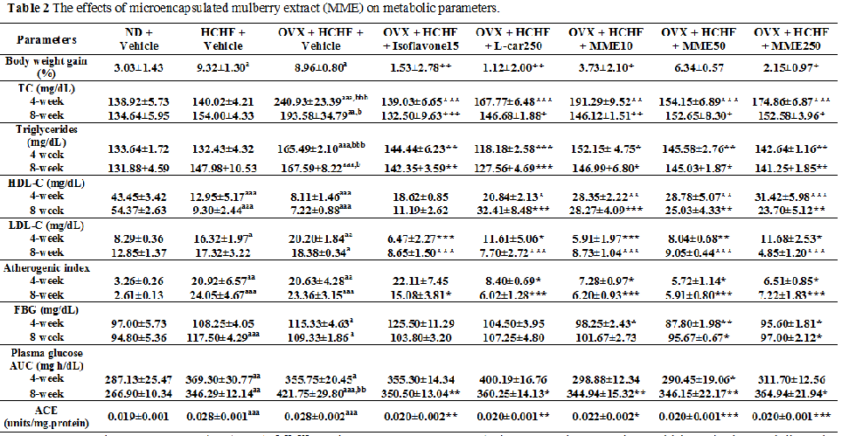

Statement of the Problem: Currently, the therapeutic strategy against menopause related disorders including by metabolic syndrome target at risk factor management is required. Based on the benefits of mulberry fruits together with the encapsulation, we hypothesized that the microencapsulated mulberry extract (MME) could improve metabolic parameters in postmenopausal metabolic syndrome.The purpose of this study is to test this hypothesis. Methodology & Theoretical Orientation: MME at doses of 10, 50 and 250 mg/kg were given to female Wistar rats which were induced experimental menopause with metabolic syndrome by bilateral ovariectomy (OVX) and fed with high carbohydrate high fat (HCHF) diet for 8 weeks. Metabolic parameters, oxidative stress status, histology, and protein expression of PPARγ, TNF-α and NF-kB in adipose tissues were determined. Findings: MME administration could improve metabolic parameters including body weight gain, adiposity index, glucose intolerance, lipid profiles and decrease atherogenic index, ACE, oxidative stress status and inflammation via decreased protein expression of TNF-α and NF-kB. Moreover, MME could attenuate adipose tissue hypertrophy and elevate protein expression of PPARγ. Conclusion & Significance: MME is the potential candidate as anti-metabolic syndrome food supplement for menopausal women. However, further researchers concerning the precise underlying mechanism and clinical trial are essential.
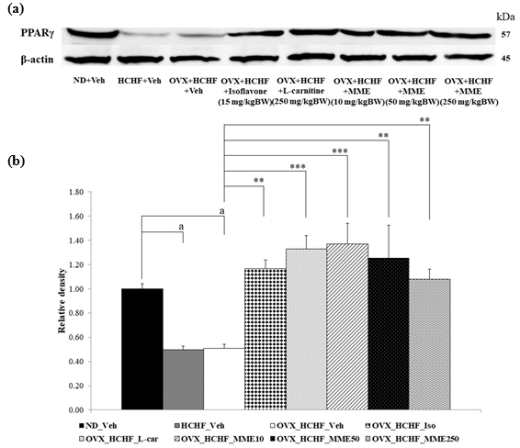
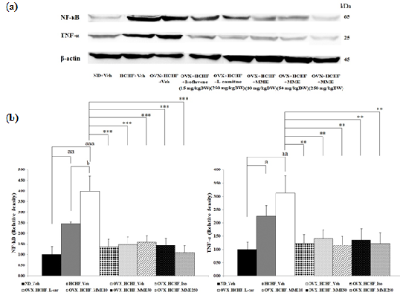
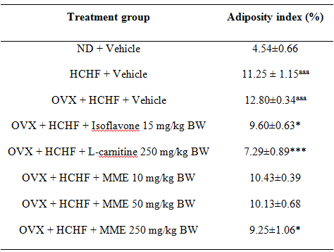
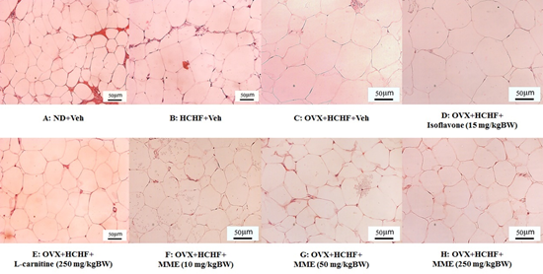

Key words: Mulberry fruit, metabolic syndrome, menopause
Acknowledgement: This study was supported by the National Research Council of Thailand and Integrative Complementary Alternative Medicine Research and Development Center, Khon Kaen University, Khon Kaen, Thailand



Jintanaporn Wattanathorn is the Director of Integrative Complementary Alternative Medicine Research and Development Center, Khon Kaen University, Khon Kaen, Thailand. She has her expertise in developing and evaluating safety and efficacy of the functional food and herbal health product. In addition, the delivery system, nanotechnology are also focused. The researches are performed in all levels including in vitro, preclinical and clinical trial study. She has numerous petty patients concerning functional food.

