The protective effect against cataract and retinopathy of ICAM601, the polyphenol-rich supplement, in streptozotocin rats.

Wipawee Thukham-mee, Ph.D, ICAM R&D Center, KKU, Khon Kaen,Thailand
Jintanaporn Wattanathorn, Ph.D, ICAM R&D Center, KKU, Khon Kaen,Thailand
Supaporn Muchimapura, Ph.D, ICAM R&D Center, KKU, Khon Kaen,Thailand
Panakaporn Wannannon, MD, ICAM R&D Center, KKU, Khon Kaen,Thailand

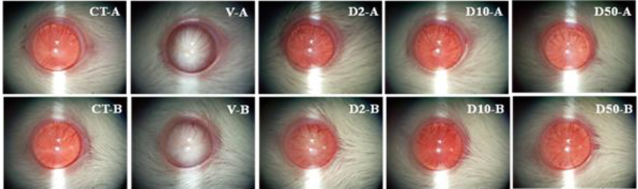
Abstract
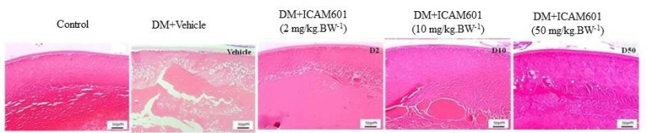
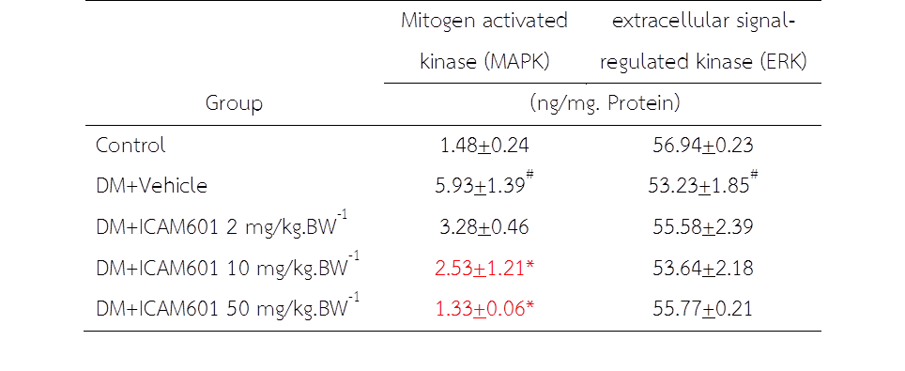
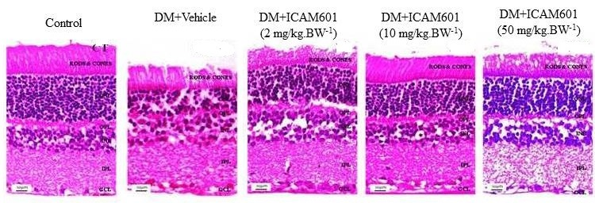
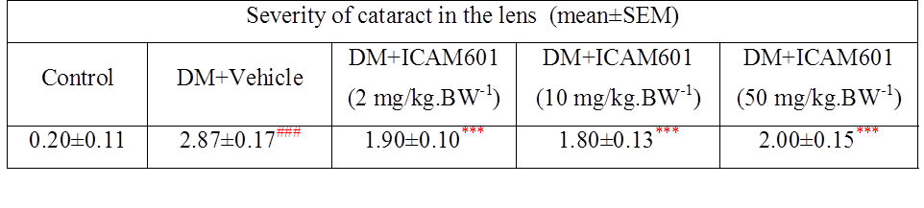
Statement of the Problem: Diabetic cataract and retinopathy, the leading causes of poor vision and blindness, are regarded as one of the major public health problems worldwide. Based on the crucial role of oxidative stress on the pathogenesis of cataract and retinopathy in diabetic condition, the protective effect against aforementioned conditions of the polyphenol- rich supplement was focused. Therefore, the purpose of this study is to determine the anti-cataract and anti-retinopathy potentials of ICAM601, the polyphenol- rich supplement in streptozotocin rats. Methodology & Theoretical Orientation: Male Wistar rats weighing 200-250 g were induced diabetic condition by using Streptozotocin (55 mg/kg BW). Rats which showed blood sugar more than 250 mg/dl were recruited for further study. They were orally administered the ICAM601at doses of 2, 10 and 50 mg/kg BW once daily for 8 weeks. The animals were determined lens opacity, histology of lens and retina, lens oxidative stress status, aldose reductase activity and signal transduction via mitogen activated kinase (MAPK) and extracellular recognition kinase (ERK). Findings: All doses of ICAM601 improved lens opacity and lens histology whereas the increased number of ganglion was observed only in STZ rats treated with either low or medium dose of ICAM601 . No significant changes in lens oxidative stress status and aldose reductase activity were observed but the significant decreased in MAPK was observed in medium and high doses treatment groups. Therefore, MAPK was responsible partly for anti-cataract and anti-retinopathy effects of ICAM601. Conclusion & Significance: These data suggested that ICAM601is the potential candidate for decreasing diabetic cataract and diabetic retinopathy. The mechanism occurs partly via MAPK but the précised understanding is still required further studies.
Key words: Anti-cataract, anti-retinopathy, diabetes
Acknowledgement: This study was supported by the Agriculture Development Agency (ARDA) and Integrative Complementary Alternative Medicine (ICAM) Research and Development Center, Khon Kaen University, Khon Kaen, Thailand


Assistant Professor Dr.Wipawee Thukhammee. Secretary of Integrative Complementary Alternative Medicine Research and Development Center, Khon Kaen University, Khon Kaen, Thailand. Her research interests of the development of the functional food and herbal health product. In addition, the alternative medicine is also focused. The researches are performed in all levels including in vitro, preclinical and clinical trial study. email:wipath@kku.ac.th

