Anethum graveolens mitigates vascular dementia: Role of oxidative stress and eNOS

Supaporn Muchimapura, Ph.D, ICAM R&D Center, KKU, Khon Kaen, Thailand
Jintanaporn Wattanathorn, Ph.D, ICAM R&D Center, KKU, Khon Kaen, Thailand
Wipawee Thukham-mee, Ph.D, ICAM R&D Center, KKU, Khon Kaen, Thailand

Abstract
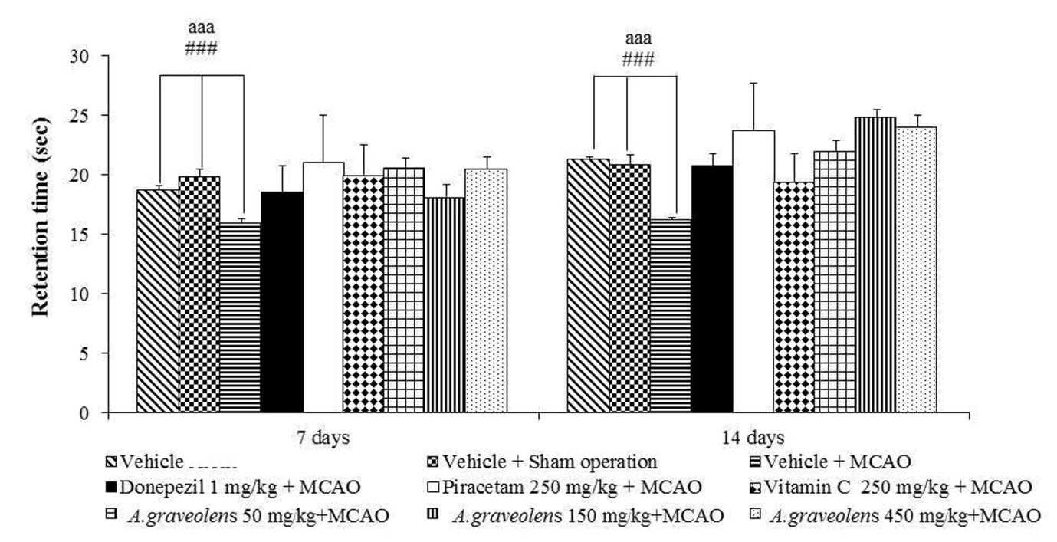
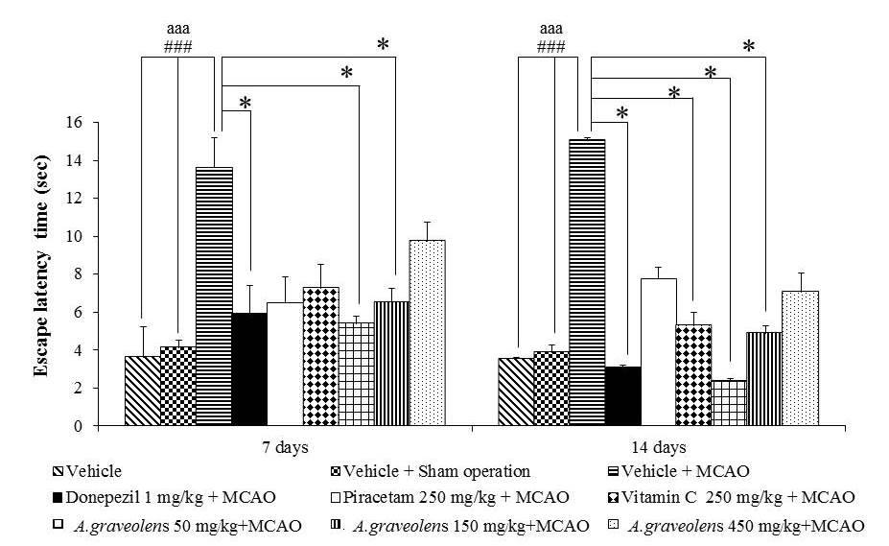
Statement of the Problem: To date, the prevention against vascular dementia (VaD) by neuroprotective agents is required. Based on the crucial roles of oxidative stress on VaD and the neuroprotective against VaD of antioxidants, the protective effect against VaD of Anethum graveolens, an indigenous plant possessing antioxidant activity, was considered. This study was undertaken to determine the effect of A.graveolens extract on spatial memory, brain damage and oxidative stress status in brain areas which play a crucial role on learning and memory. Methodology & Theoretical Orientation: Male Wistar rats , weighing 300-350g, were orally given A.graveolens at doses of 50,150 and 450 mg/kg⁻¹ BW 14 days before and 14 days after the occlusion of right middle cerebral artery (Rt.MCAO). Then, spatial memory, brain infarcted volume, oxidative stress status and eNOS expression were determined. Findings: Low and medium doses of A.graveolens mitigated memory impairment in animal model of VaD following cerebral ischemia. However, all doses of extract could improve brain damage in cerebral ischemic rats whereas the improved oxidative stress status in cortex was observed in medium and high doses treated groups and the improved oxidative stress in hippocampus was observed only in high dose treated group. In addition, the enhanced eNOS expression in cerebral cortex was also observed in cerebral cortex. Conclusion & Significance: These data suggested that A.graveolens is the potential neuroprotectant against VaD. The possible underlying mechanism occurred partly via the improved oxidative stress status and the enhanced eNOS expression in cerebral cortex. However, the precise understanding concerning mechanism of action is required further investigations.
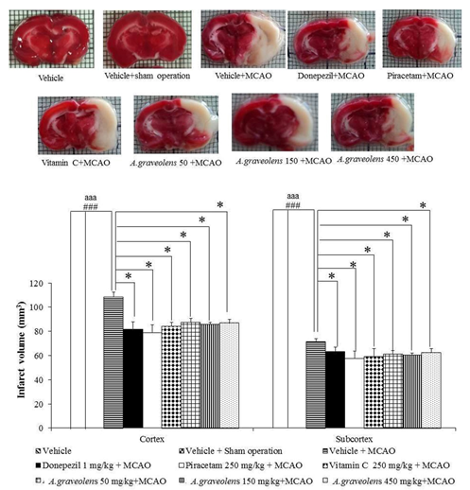
Key words: Anethum graveolens, vascular dementia, oxidative stress
Acknowledgement: This study was supported by the National Research Council of Thailand and Integrative Complementary Alternative Medicine (ICAM) Research and Development Center, Khon Kaen University, Khon Kaen, Thailand

 BIOGRAPHY. Assistant Professor Dr.Supaporn Muchimapura. Vice director of the Integrative Complementary Alternative Medicine Research and Development Center, Khon Kaen University. Head of the Department of Physiology, Faculty of Medicine, Khon Kaen University. Khon Kaen, Thailand. Dr. Supaporn Muchimapura is a Scientist and Vice director of the Integrative Complementary Alternative Medicine Research and Development Center, Khon Kaen University and the Head of the Department of Physiology, Faculty of Medicine, Khon Kaen University, Khon Kaen, Thailand. Her Research interests are Pharmacological Effects and Physiological Effects of Nutraceutical Product, Medicinal Food, Food Supplements and Medicinal Plants. More than fifty research papers about Integrative Complementary Alternative Medicine.

e-mail: supmuc@kku.ac.th

RESEARCH INTEREST
Herbal Medicine, Medicinal Food, Natural product development, Nutraceuticals.

