miRNA: a possible new scenario on nutraceuticals

Roberto Cannataro Galascreen srl University of Calabria, Via Savinio Rende Italy

Abstract

MicroRNA (miRNAs) are small noncoding RNA sequences, expressed in every cells, powerful regulators of protein synthesis and therefore of various biochemical pathways. Each miRNA is paired with different regions of RNA, therefore a miRNA is capable of regulating more than one metabolic pathway. A very important feature is that of being circulating in plasma, but they have been found in practically all biological fluids, saliva, urine, milk to name a few. They are strongly conserved starting from the simplest organisms such as plants; therefore miRNAs are also taken through food, there is some evidence for which they could be assimilated and therefore have a regulatory action. Therefore they could represent an explanation of the beneficial action of some vegetable foods and even more of the beneficial action of milk, they are in fact present in both human milk and other mammals, with very strong analogies. therefore they could represent the future of nutraceuticals, both as products in their own right, but probably even more so to enrich foods that already contain them.

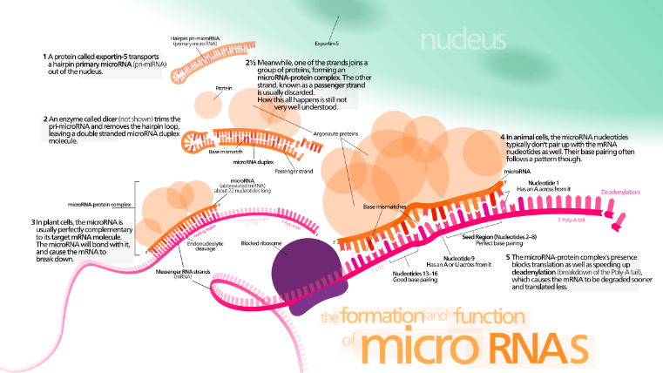
Recent Publications
- Peri M et al (2018) Variation in Immune-Related microRNAs Profile in Human Milk Amongst Lactating Women Microrna 107-114
- Zhang L et al (2019) Dietary microRNA-A Novel Functional Component of Food Adv Nutr 10(4):711-721
- Sundaram GM (2019) Dietary non-coding RNAs from plants: Fairy tale or treasure? Noncoding RNA Res 4(2):63-68
- Wagner AE (2015) Food derived microRNAs Food Func 6(3):714-8
- Cannataro et al (2018) Ketogenic Diet Acts on Body Remodeling and MicroRNAs Expression Profile Microrna (2019) 8, 1-12

 Biography
Roberto Cannataro is nutritionist, food technologist and chemical engineer for over 25 years engaged in the field of nutrition, food supplementation and nutraceuticals, even before the term became common. He collaborates with private companies for the development of new products, he is a teacher in various universities and private structures in the field of nutrition and in particular food supplements. From 2016 he’s CSO of the university spinoof Galscreen who deals with the evaluation of miRNAs and their function and possible application as a marker and as supplements.
Email: r.cannataro@gmail.com

