Cardio-Metabolic Disease Reversal And Nutraceutical
Supplementation

Chandra Manjari, Consultant Therapeutic and Functional Nutrition, Daivam Wellness, Max Healthcare

Introduction:

Metabolic syndrome (MetS) is characterized as a group of cardiometabolic risk factors that raise the risk for heart disease and other health problems, such as diabetes mellitus and stroke.
Nutraceuticals represent an alternative form of medicine compared with the healing traditions that in the recent past were not part of standard medical education. Some of many existing nutraceutical compounds could be used as integrators in a daily diet thanks to their easy availability and to their beneficial properties, such as in polyphenols, omega-3 fatty acids, macroelements and vitamins used as non-pharmacologic treatment (1).
Nutraceuticals had positive effects in reducing cardiovascular risks, both in biochemical parameters and by hormonal modulation, and demonstrated hepato-protective effects. In addition, the presence of phenolic compounds and catechins reduced body weight in adults, being a potential adjuvant treatment for obesity. The inclusion of fish oil in the diet, especially with EPA and DHA, improved the lipid profile, inflammatory markers, and endothelial function (2).
This review aims at establishing a possible relationship between the use of nutraceuticals and prevention and treatment of CVD, in the light of recent evidences and research studies.

Methodology: A comprehensive literature review was carried out through a synthesis of quantitative findings stemming from quantitative research studies and qualitative findings extracted from the qualitative research studies based on the role of nutraceutical supplementation in cardio-metabolic disease reversal.

Results: The nutritional The nutritional supplementation represents a possible strategy for management and prevention of hypertension and other cardiovascular diseases.
The nutraceuticals act not only direct by antioxidant or anti-inflammatory properties but also indirectly, via modulation on various physiological pathways. A lot of the nutraceuticals that was described, such as oil extracts, plants, fruits and vegetables as well as botanical extracts, have shown beneficial effects on the cardiovascular system through substances such as phenolic compounds or polyphenols, lycopene and flavonoids (3).
Current evidence suggests that the application of nutraceuticals may have the potential to increase the effectiveness of therapy (as well as to reduce the residual risk). Many of the nutraceuticals investigated for the prevention and treatment of CVD are well tolerated in patients (4).

Conclusion:
It can be hypothesized that nutraceuticals can play a significant role in the reversal of cardio-metabolic disease reversal.
Drug treatments are of difficult handling, whereas well-characterized nutraceuticals may offer an effective alternative. Specific nutraceuticals have proven to be of benefit, in particular, red-yeast rice, berberine, curcumin as well as vitamin D. All these can improve lipid handling by the liver as well as ameliorate insulin resistance. Functional foods, e.g. plant proteins, improve insulin resistance. Pro- and pre-biotics improve the metabolic handling of energy-rich foods. Nutraceutical can offer a significant help in handling MetS patients being part of lifestyle recommendations (5).

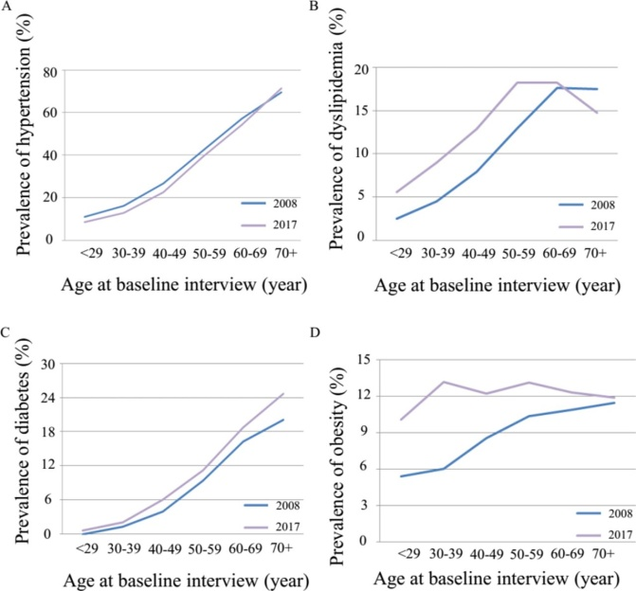

Time trend of cardiometabolic risk factors over a 10-year period (6)
Recent Publications

- Patti AM, Al-Rasadi K, Giglio RV, et al. Natural approaches in metabolic syndrome management. Arch Med Sci. 2018;14(2):422‐441. doi:10.5114/aoms.2017.68717
- Silva Figueiredo P, Inada AC, Ribeiro Fernandes M, et al. An Overview of Novel Dietary Supplements and Food Ingredients in Patients with Metabolic Syndrome and Non-Alcoholic Fatty Liver Disease. Molecules. 2018;23(4):877. Published 2018 Apr 11. doi:10.3390/molecules23040877
- Alves QL, Camargo SB, Silva DF (2019) Role of Nutraceuticals in the Prevention and Treatment of Hypertension and Cardiovascular Diseases. J Hypertens Manag 5:037. doi.org/10.23937/2474-3690/1510037
- Sosnowska B, Penson P, Banach M. The role of nutraceuticals in the prevention of cardiovascular disease. Cardiovasc Diagn Ther. 2017;7(Suppl 1):S21‐S31. doi:10.21037/cdt.2017.03.20
- Sirtori CR, Pavanello C, Calabresi L, Ruscica M. Nutraceutical approaches to metabolic syndrome. Ann Med. 2017;49(8):678‐697. doi:10.1080/07853890.2017.1366042
- Cheng Y, Yin H, Zheng H, et al Time trend of cardiometabolic risk factors over a 10-year period in the office-working population in ChinaBMJ Open 2019;9:e025915. doi: 10.1136/bmjopen-2018-025915



Biography (150 word limit)

Qualified in Hospital Administration, Manjari Chandra has a Master’s degree in Therapeutic Nutrition and Clinical Dietetics. She is a Diabetes Consultant and Educator, Onco-nutritionist, Functional Nutritionist and Weight Management Specialist and has an advanced certification in Intravenous Nutrition Therapy and Chelation. She is a guest speaker and expert panelist at several National Seminars and Continuous Medical Education programs and a keynote speaker at public health conferences at FSSAI, FICCI, ASSOCHAM and ISMA.

Presenting author details :
Full name: Manjari Chandra
Contact number: +91 9910067483
Email id: manjariwellness@gmail.com

Email: manjariwellness@gmail.com

