Preparation and Evaluation of a Novel instant Drug Delivery System (iDDS) for Nutraceutical and Pharmaceutical Active Ingredients
Anuvrat Sharma, PhD, IIT BHU, India

Abstract

The present work is related to the development and evaluation of a novel instant drug delivery system for the Active Ingredients that are used commonly in the nutraceutical and pharmaceutical preparations. This technology can be utilized for the availability of these active ingredients in-vivo much faster than the traditional particulate drug delivery systems. The preparation of these formulations involves the development of an innovative process for the conversion of active ingredient in a molecular form/nano dispersion in a suitable matrix which can be either presented in a final dosage form of tablets, capsules, dry syrups, suspensions etc. This novel active drug matrix has been named as ‘iAgglomerates’. The present delivery system ie iAgglomerates matrix can be used for diversified range of active ingredients which can help in significant clinical outcome of a nutraceutical or pharmaceutical product.
Image
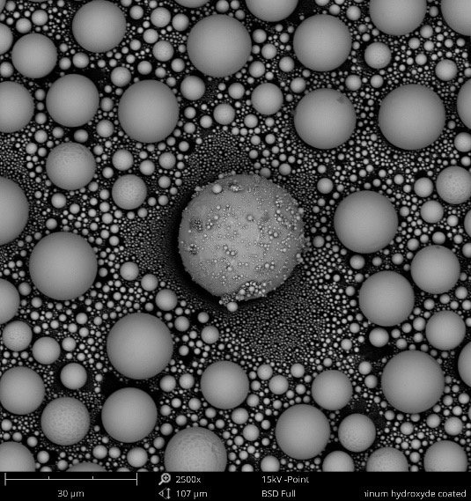
Figure 1Visual Representation of dispersion pattern


Biography
Dr. Anuvrat Sharma is thought leader with a rich experience of more than 25 years in pharmaceutical product design and research. He has been associated with a large of leading pharmaceutical companies in the world in various capacities. He is an innovator and has filed multiple patents and has over 40 publications
Email: dranuvrat@gmail.com

