Negative static therapy: The ‘secret’ to enhance cell absorption of all Nutraceuticals
Beatrice Liu Shiying, B.Soc.Sci. (Hons) National University of Singapore
Entrepreneur of multi-million Wellness Startup, including leading Natural Online Resource www.eatprayflying.com, Singapore

Abstract (300 words)
The role of electrons in cell metabolism and ATP production is well-studied (Krebs cycle). Yet, negative static therapy, an abundant supply of electrons, is not well-researched.
Anti-oxidants are gaining awareness in the wellness industry. Excessive free radicals are recognized as ‘electron-snatchers’ from healthy cells, destabilizing them and creating chain-effect cell damage including DNA damage and ageing. Anti-oxidants become popular as people become aware that excess electrons can neutralize free radicals. Small scale study (Image 1) show a drop in Oxidation-reduction Potential 30 minutes after negative static therapy, indicating anti-ageing potential.
Electrons from negative static therapy neutralizing positive particles (Image 2); hydrogen ions which cause acidification of the body become hydrogen atoms which in turn pass their electrons to oxidized substances and restore them to a reduced state. Oxidized cells can also be repaired with electrons, restoring them to normal healthy cells.
Based on Japanese research, negative static has similar benefits to oral anti-oxidants by providing electrons via skin absorption and inhalation. Electrons can:
- Increase Oxygen Capacity of Red Blood Cells
- Increase Cell Membrane Permeability, facilitating substances exchange
- Regulate immunity
- Modulate Autonomic Nervous System
Focusing on 2) above, functioning of a cell is mediated by the cell membrane through the negative ion (anions/ions with excess electrons) channels in most cases. Activation of the anion channels increase the cell membrane permeability to other ions such as sodium which affect the transport of substances, breakdown of vitamins, proteins and generation of energy (Image 3).
Especially with benefit 2), this sharing hopes to raise awareness of this affordable therapy and prompt further research among intellectuals at International Meeting of Nutraceuticals. If our cells are permeable to absorb better, the positive effects of health foods and supplements would be further experienced by the public, boosting demand for all in the industry.

Image 1

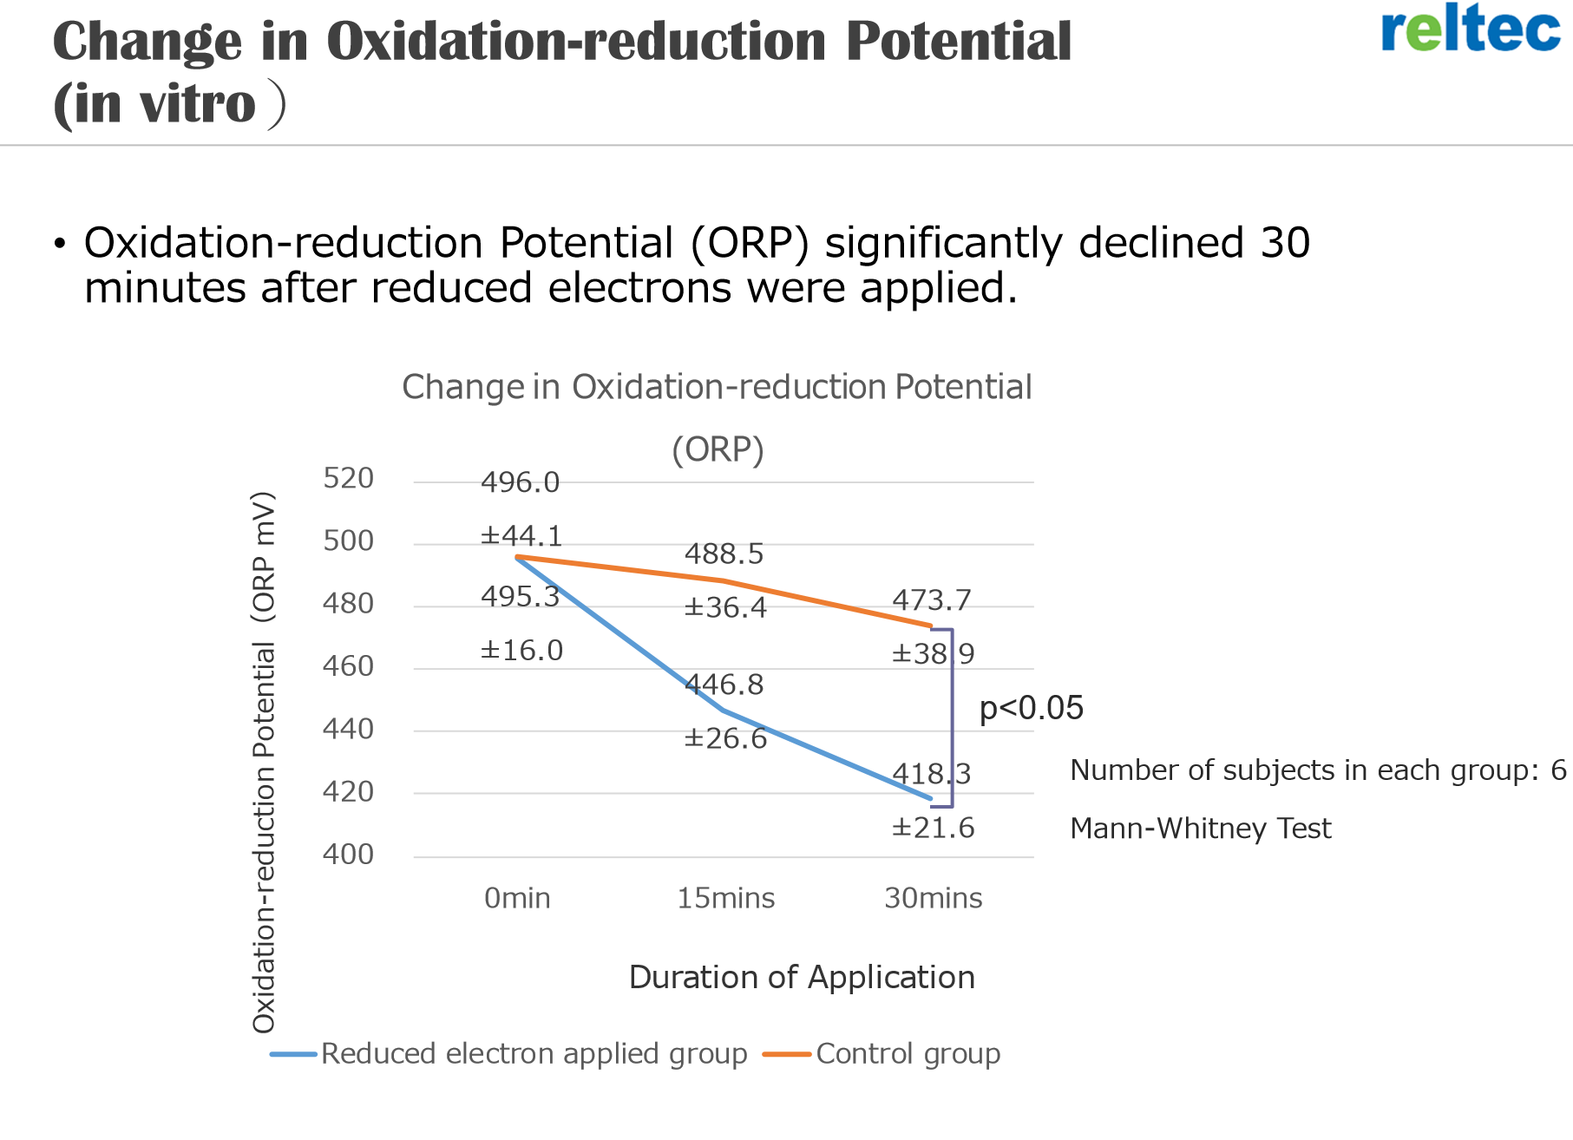
ORP reduction after negative static therapy, signaling less oxidative stress to the body
Source: Reltec Medical Devices Corporation, Japan

Image 2

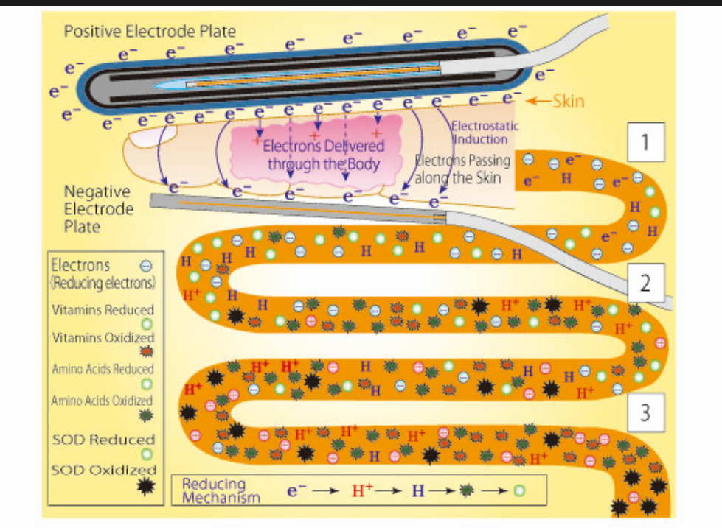
Sample of Negative Static Therapy mechanics in Japan; how electrons from negative static therapy can turn harmful substances into beneficial substances in body
Source: Reltec Medical Devices Corporation, Japan

Image 3

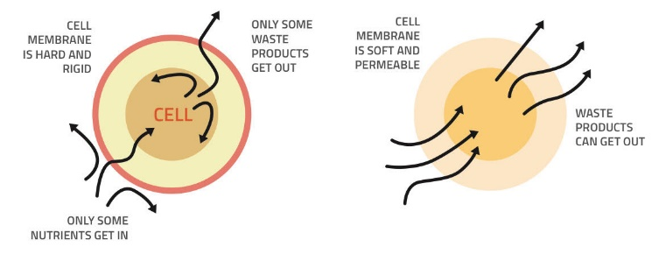

Improved absorption of useful nutrients with increased cell membrane permeability

Biography (150 word limit)
- Beatrice had a stellar corporate life, managing a USD$300 million ASEAN portfolio by the itme she was 26.
- She changed paths due to her mother's remission from Stage 4 Colon Cancer without conventional treatment. In the past 4 years, she established herself as a thought leader in holistic wellness and negative ions.
- She co-founded Kairos Ygeia (Health at an Opportune time) to achieve the vision to make health simple. Kairos Ygeia already crossed USD1,000,000 revenue in 2017!
Email: beatrice@eatprayflying.com

