New approaches for the Development of Functional Botanical Ingredients for Innovative Products
Jat Rana, Ph.D*., Kylie Mitchell, Ph.D. and
George Polson, Ph.D.
Innophos Holdings, Inc.
259 Prospect Plains Road, Building A
Cranbury, NJ 08512, USA

Abstract:

Botanical products are generally intended for improving or to care for human health has evolved independently in different countries worldwide as drugs, food supplements, or substances for therapeutic use derived from raw material of whole plants or parts of them. With accumulated experience and knowledge, the relationship between efficacy of ingredient and certain diseases or symptoms was gradually established.

In this presentation we will present the holistic benefits of Vaccinium macrocarpon (Cranberry extract) with host of antioxidant nutrients that help fight infections and boost your overall health. Cranberries are already popular as a juice and fruit cocktails. The majority of human studies have focused on Cranbury’s efforts on Urinary Tract Infection (UTI). However, the recent focus has been on several studies on Cranberry which explored the role of its Polyphenols and Proanthocyanidins, oligomeric flavonoids. These phytochemicals are responsible for anti-oxidant, anti-inflammation, cardio vascular, oral health and other biological activity of Cranberry.

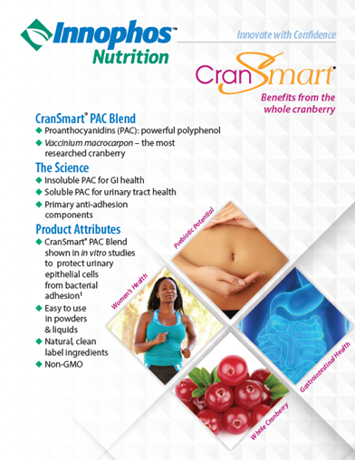

 Biography
Dr. Jat Rana, who grew up in a small village in the foothills of the Himalayas in India, has a double Major in Chemistry and Botany. He has Masters of Science in Applied Organic Chemistry, Ph.D. in Organic Chemistry from Birmingham University, England (UK). Post-doctoral fellow at the University of Glasgow Scotland (1981) and USDA Research fellow at University of Minnesota, Minneapolis (1985). Production Manager at the Sigma-Aldrich Corporation in St. Louis, MO (1985-1996). Principle Senior Research Scientist at Amway (1996-2017). In 2017 Dr. Rana joined the Innophos Nutrition group as a Director, Technical Services and Application Development, where he continues to provide his expertise in innovative botanical ingredients. Active member of Society of Cosmetic Chemists (SCC), International Association of Analytical Communities (AOAC), Member of American Chemical Society (ACS), and Asian Congress of Nutrition (ACN). He has chaired and presented at many Scientific Sessions at the National and International events.
Email: jatinder.rana@innophos.com

Notes/Comments:

- Oral Presentation can be 30-45 minutes
- Needs an official letter of Invitation
- Opportunity to chair sessions

