Preparation of fast-dissolving quercetin nanoformulations
Wai Kiong NG, PhD, Institute of Chemical & Engineering Science, A*STAR, Singapore
Yuancai Dong, PhD, Institute of Chemical & Engineering Science, A*STAR, Singapore
Jun Hu, PhD, Institute of Chemical & Engineering Science, A*STAR, Singapore

Abstract
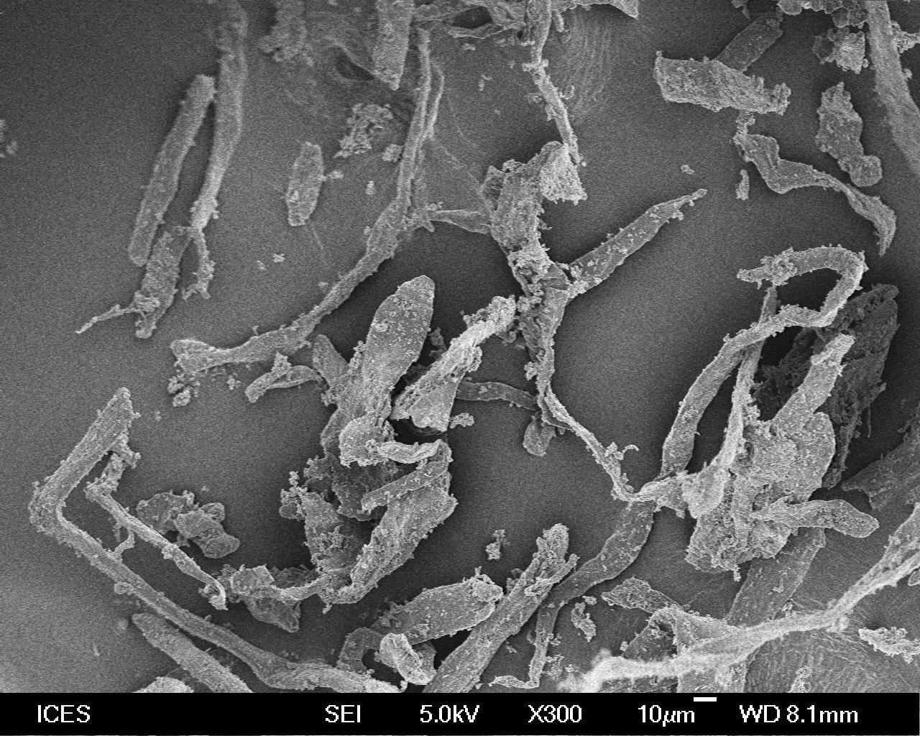
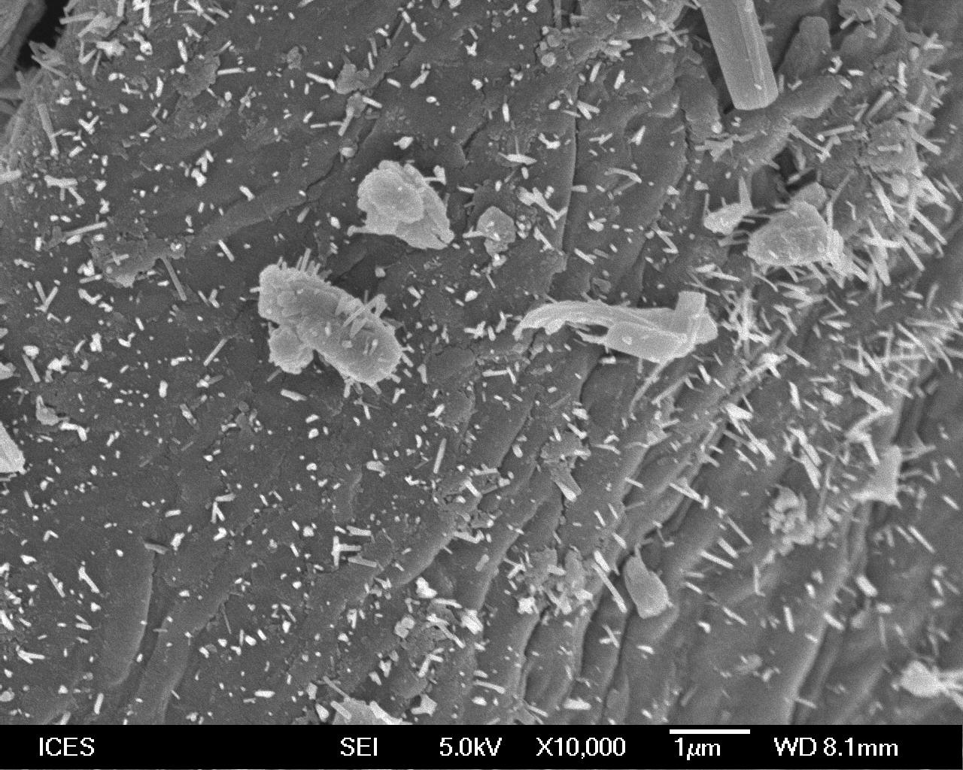
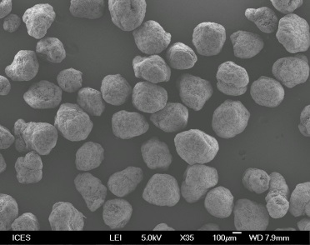
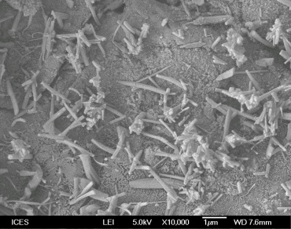
Quercetin is a plant-derived polyphenol for both nutraceutical and pharmaceutical applications. It is well known for its antioxidant, anti-cancer, anti-obesity, anti-inflammatory and anti-microbial properties. However, quercetin is predisposed with a poor dissolution rate that resulted in low and inconsistent oral bioavailability. Nanosizing, i.e. reduction of the compound particles size to the submicron range, is an effective strategy to increase the dissolution and thereby bioavailability. In this work, quercetin nanoformulation was fabricated by two approaches: (1) antisolvent precipitation in the presence of cellulose fiber followed by spray drying; or (2) spraying (Wurster mode) of the quercetin solution onto microcrystalline cellulose particles (Avicel® PH-200) by a lab-scale fluid bed coater (VFC-LAB Micro FLO-COATER®). For antisolvent precipitation/spray drying technique, sub 100 nm particles together with small rod-like particles and their agglomerates are formed on the surface of cellulose fibers; while fluidized bed coating technique produced quercetin nanofibers with the width of 100-200 nm and length of 1-2 µm on the cellulose particle surface. The obtained quercetin nanoformulation exhibited good flowability and higher dissolution rate as compared with the raw compound. The developed quercetin nanoformulations could be used as supplements or functional ingredients for food development.
Quercetin nanoformulation by antisolvent precipitation/spray drying
Quercetin nanoformulation by fluidized bed coating

Image

Biography
Dr Dong Yuancai completed his PhD from Department of Chemical & Biomolecular Engineering of National University of Singapore. He is currently a scientist in Institute of Chemical & Engineering Science, Agency for Science, Technology and Research (A*STAR), Singapore. His researches are mainly focused on pharmaceutical and nutrition formulations. He has published more than 25 papers in reputed journals.

Email: dong_yuancai@ices.a-star.edu.sg

