Influence of abiotic stress on accumulation of xanthophylles and lipids in Haematoccus and Scenedesmus microalgae
Doria E, PhD; Buonocore D, PhD; Dossena M, PhD, Temporiti M, Nielsen E, Professor.
Department of Biology and Biotechnology University of Pavia, Italy.

Abstract
Carotenoids possess a very important antioxidant activity and consequently they have important nutraceutical properties including enhancement of immune responses and protection against various diseases, among which are certain types of cancer. The global carotenoid market value was $1.5 billion in 2014. This market is expected to reach nearly $1.8 billion in 2019, with a compound annual growth rate (CAGR) of 3.9%. Moreover, synthetic carotenoids are sold for between $250 and $2,000/kg, whereas natural carotenoids are sold for between $350 and $7,500/kg. For all these reasons it is resulting very important to explore the possibility to use microalgae to produce relevant amounts of ketocarotenoids in a sustainable way. In this work we investigated in particular the Astaxanthin accumulation and esterification degree in an Argentinian Haematococcus pluvialis strain, grown at moderate and high light stress under autotrophic and mixotrophic conditions. The content of total lipids and neutral lipids was also analysed under the same culture conditions and the correlation between the accumulation of Astaxanthin and that of lipids was established. Finally the Lutein production and its accumulation efficiency in Scenedesmus obliquus strain was analysed by comparing the effect of different environmental conditions, obtained causing abiotic stress (oxidative, osmotic, edaphic) in the culture medium, known to be able to induce a greater Lutein accumulation efficiency.

Image

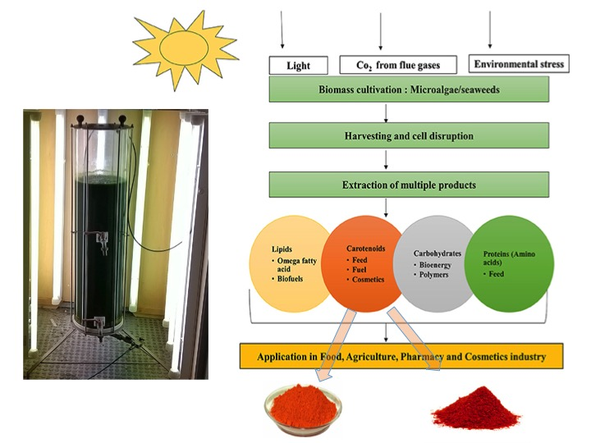

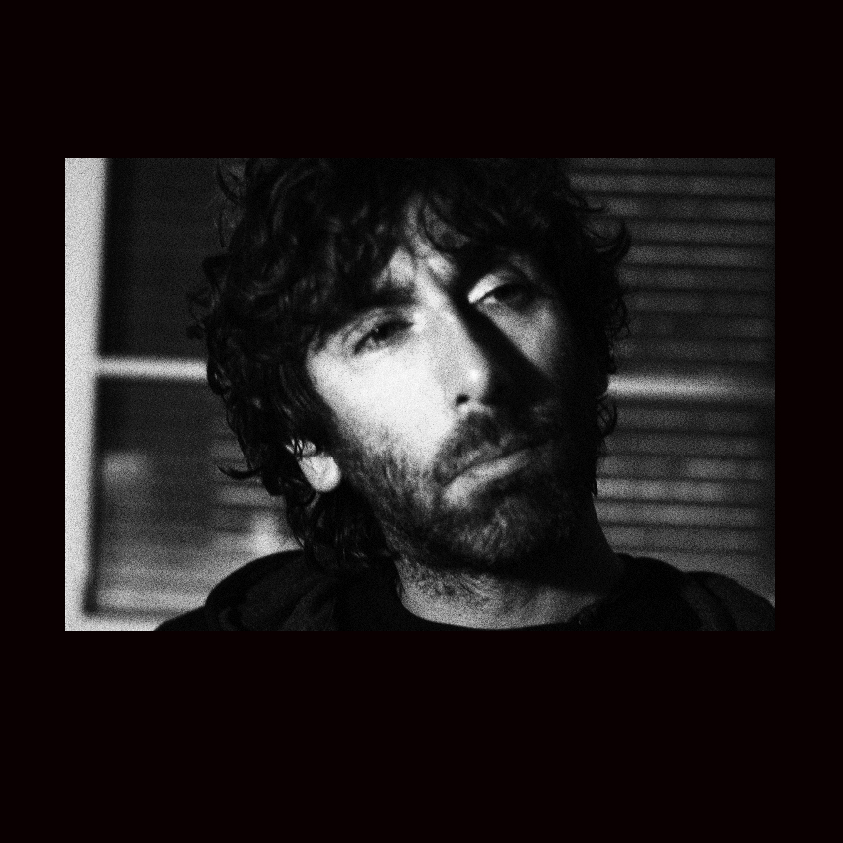 Biography
Enrico Doria obtained Master degree of Biological Science and PhD degree in Genetics and Biomolecular Science at the University of Pavia (Italy). He is plant biologist, expert in plant biochemistry and physiology, nutritional improvement of crops, nutrition, extraction and analysis of phytochemicals and bioactive compounds from plants and microalgae. He has been Grantholder of EGovTN-Erasmus Mundus project fellowship at the Institut des Regiones Arides in Tunisia e post-doc researcher at the Vaal University of Technology in South Africa where he has dealt with aromatic plants and nutritional improvement for local populations. Currently he is working at the Pavia University on several projects, from recovery of nutraceutical compounds from vegetables and fruits waste, to the nutritional improvement of the orphan cereals, to microalgae for nutrients extraction. He is author of more than 20 scientific papers in peer-reviewed international journals.

Email: enrico.doria@unipv.it

