Effect of 8 weeks of n-3 fatty-acids supplementation on oxidative stress and inflammation in Athletes of middle and long distance running
Buonocore D, PhD; Verri, M, PhD; Arnica, S; Doria E, PhD; PhD, Dossena M, PhD.
Department of Biology and Biotechnology “L. Spallanzani”,
University of Pavia, Italy.

Abstract
Background. Long-chain n-3-polyunsaturated fatty acids (PUFAs), eicosapentaenoic acid (EPA) and docosahexaenoic acid (DHA), may alter oxidative status and immune function after exercise. The aim of the study was to determine the effects of n-3 supplementation on Athlete of middle and long-distance running on oxidative/antoxidative status and immune function. Methods. Twenty nine subjects, males and females, age 17-30 year old divided in two groups: 1) (n=21) Trained Athletes (middle distance runners: 800m, 1500m, 3000m steeplechase; long distance runners: 5000m, 10000m, marathon); 2) (n= 8) Sedentary subjects. All subjects were randomly assigned to 4 g/day of n-3 supplementation, rich in EPA and DHA, for 8 weeks. Blood, saliva and urine samples were collected pre- (T0) and post- (T1) supplementation. The hematological parameters (trygliceride, total cholesterol, HDL, CPK, LDH, HGH, IGF-1), oxidative parameters (MDA, 8-OHdG, PCO), antioxidant parameters (GPx, SOD, CAT, DPPH scavenger), overreaching index (testosterone and cortisol) and inflammation marker (TNF-α) were measured. Results. The results evidenced that MDA, cortisol and TNF- α levels significantly decreased after treatment in both Athletes and Sedentary subjects but the variation was greater in Athletes than in Sedentary control subjects. Conclusion. 4 g / day of n-3 PUFAs rich in EPA and DHA for 8 weeks was effective to prevent and counteract the onset of oxidative stress and inflammation induced by acute and strenuous physical training.

Image
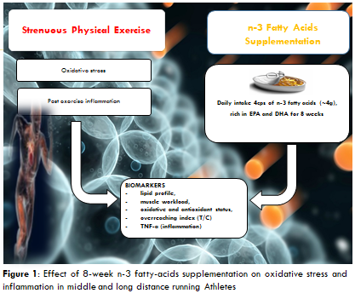

 Biography
Daniela Buonocore obtained Master degree of Science in Molecular Biology and Genetics, II level University Master in Regulatory Affairs, II level University Master in Human Nutrition and PhD degree in Biomedicine Sciences, University of Pavia (Italy). Her work project was based on “Effect of 8-week n-3 fatty-acids supplementation on oxidative stress and inflammation in middle and long distance running Athletes”. Since 2009 until the date she received post graduated grants at Laboratory of Pharmacobiochemistry, Nutrition and Nutraceutical, University of Pavia working on in vitro and in vivo safety and efficacy of different plant extracts. Actually, the conducted research deals with the biological activity of free radicals, particularly reactive oxygen species (ROS) and a wide range of antioxidant molecules in reference to biological systems and nutrition. She is author of about 30 scientific papers in peer-reviewed international journals.
Email: daniela.buonocore@unipv.it

Notes/Comments:

