Extraction and Evaluation of Nutraceutical Molecules in
Wastes of Fruits and Vegetables

Buonocore D, PhD; Doria E, PhD; Boncompagni E, PhD; Verri, M, PhD; Arnica, S; Dossena M, PhD; Nielsen E, Professor.
Department of Biology and Biotechnology “L. Spallanzani”,
University of Pavia, Italy.

Abstract
Fruit and vegetable wastes not only have no commercial value, but also require expensive operations of removal and disposal, representing a significant cost for the manufacturers of plant products. However, this material may represent an important resource of commercially worth phyto-molecules endowed with various nutraceutical properties. In the present work, the possibility of using fruit and vegetable waste materials as a source of bioactive compounds was explored and verified. Several nutraceutical compounds, like sulphoraphane, ursolic acid, phloridzin and other flavonoids of high economic interest, were extracted and quantified from various waste plant materials deriving from the production phase (“first-gamma products”) or discarded during the preparation of fresh ready-to-cook or ready-to-eat packaged products (“fourth-gamma products”). Obtained results showed that, despite the precarious and uncontrolled conditions which plant wastes products are subjected, the levels of the examined bioactive compounds are present in relevant amount, also in the parts of the plant that are discarded during the preparation of the ready-to-eat/cook products.
Image
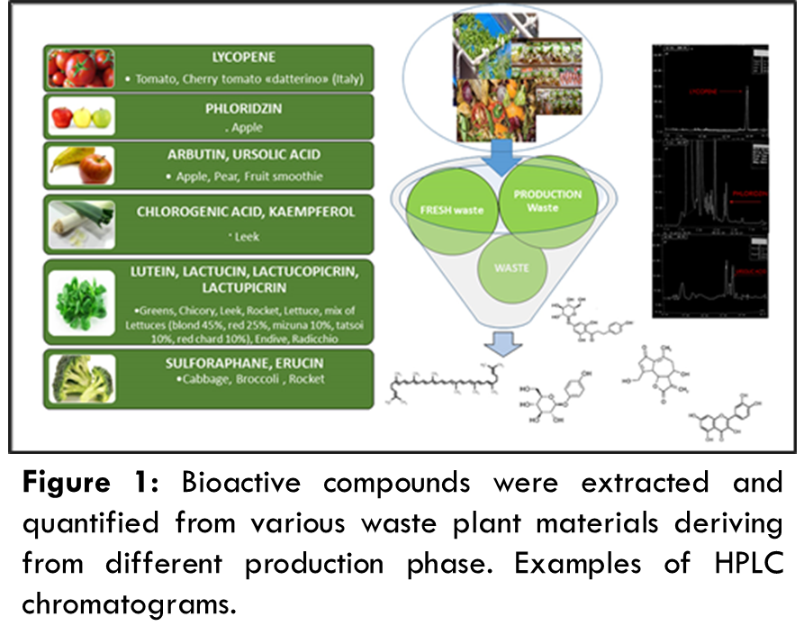

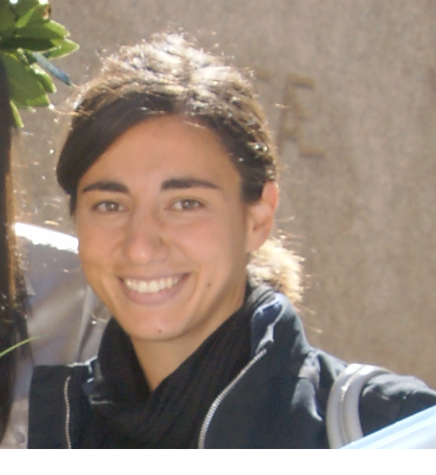 Biography

Daniela Buonocore obtained Master degree of Science in Molecular Biology and Genetics, II level University Master in Regulatory Affairs, II level University Master in Human Nutrition and PhD degree in Biomedicine Sciences, University of Pavia (Italy). Her work project was based on “Effect of 8-week n-3 fatty-acids supplementation on oxidative stress and inflammation in middle and long distance running Athletes”. Since 2009 until the date she received post graduated grants at Laboratory of Pharmacobiochemistry, Nutrition and Nutraceutical, University of Pavia working on in vitro and in vivo safety and efficacy of different plant extracts. Actually, the conducted research deals with the biological activity of free radicals, particularly reactive oxygen species (ROS) and a wide range of antioxidant molecules in reference to biological systems and nutrition. She is author of about 30 scientific papers in peer-reviewed international journals.

Email: daniela.buonocore@unipv.it

Notes/Comments:

