Advance Cloud Computing Health Management System (ACCHMS) for Heterogeneous Distributed Systems
Javed Ali
j.ali@seu.edu.sa¹
College of Computing Informatics, Saudi Electronic University, Saudi Arabia
Zeeshan Sartaj
Mobily Telecommunication, Madinah Munawrah, Suadi Arabia
zeeshansartaj@hotmail.com
Mohammad Hammad
m.hammadpk@gmail.com

Abstract: We proposed an advance health management solution based on recent cloud computing technologies. This solution is a comprehensive web-based solution that assists organizations in seamlessly automating their related documents according to their specific business cycles and secure communication in a flexible and user-friendly manner. It consists of various components that serve the organization's structure and business life cycle. These components are fluently integrated with a centralized repository for securing, archiving, retrieving and managing data remotely. Moreover, our proposed solution supports all advanced file formats of attachments, and it is also featured with a competent search engine and retrieval tools that can fetch exact information within few seconds, over and above, security profiles, auditing and records management ensures document integrity and corporate control. The system also allows communications through multiple channels. The proposed solution may be deployed over recent advanced cloud computing technologies where different users will access the solution remotely.

Keywords: Cloud Computing, Health Management, Hospital, Patient

Introduction
The main goal of cloud computing is to provide easier access to distributed resources, combining them to improve performance by avoiding the problems of large-scale computation. Therefore, cloud computing can provide virtualization, scalability, interoperability, quality of service and development models in the public, private or hybrid form of the cloud. Advance Cloud Computing Health Management System (ACCHMS) provides online real time information about the health information in highly equipped large hospital systems. The main purpose of this solution is to reduce the manual work. This solution is capable of managing health information and healthcare data, generating various reports for record-keeping according to end user requirements for distributed heterogeneous systems. There is an administrator to control patients and doctors to manage the operations. The user’s status and information is maintained in the database. The user’s information may be retrieved remotely by the privileged users from the database. The valid users are also allowed to view their account information.

Proposed solution is a web-based solution and a single repository for all documents and information; thus, eliminating redundancies, providing online access to all resources, and saving time and efforts in storing and retrieving documents. Proposed solution supports all forms of electronic documents, email, and attachments, and has a powerful search engine and retrieval tools making information easily available for retrieval, editing, and collaboration across the entire enterprise.

Moreover, proposed solution consists of various components that serve the enterprise’s structure. These components are seamlessly integrated with a centralized repository for securing, archiving, retrieving, and managing data [27]. The check-in, check-out, versioning, security profiles, audit trails, and records management module, ensure document integrity and corporate control. The system also allows for notification through multiple channels including e-mail and messages.

ACCHMS goes beyond standard functionality by providing the additional dimensions of knowledge management, intelligent search agents, advanced notification features, and multi-channel access functionality. The backbone of the system is based on a strong, secure, and reliable RDBMS, interfaced with a powerful, user-friendly administration system that is capable of handle large and complex databases. Security is one of the most important features of proposed solution; it ensures that only authorized users log on to the system and activates the system's pages that conform to their privileges.
There should be a detailed privacy regulations on the services and practices of e-Health so that patients can feel highly protected while disclosing their health-related information[28].

Literature Review:

Koufi et al., proposed “Cloud Emergency Medical Services”. They depicted their system components, infrastructure, platform and software as a services. They show performance of prototype implementation system on a cloud computing infrastructure and on multiple data centers in the cloud computing environment [1]. Fujita et al., implemented “Cloud Cardiology” which enable “a cloud server to share electrocardiogram simultaneously inside and outside the hospital”. Unfortunately, the proposed solution couldn’t provide secured web-server for a telemedicine application that provides a health information exchange platform in the internet [2]. Rao et al., offered a solution that can’t facilitated tele-medicine services for rural areas [3]. “Noncontact ECG monitoring” describe a mobile cloud-based healthcare service which was proposed by Fong and Chung [4].

Wang et al., introduced a hybrid cloud computing environment to store data from personal health electrocardiogram (ECG) sensors and to perform processing tasks. The main cloud computing function of this proposed solution is to accelerate computation intensive processing tasks by using the cloud server and thus extending the mobile devices battery life [5].

Hiden et al. “ a platform as a service which itself was built on an infrastructure as a service environment” this is a description on e-Science central development. The article illustrated extensively beyond the set of cloud services provided covering data storage services but also illustrating service execution, workflow enactment and security [6].

Kakadis presented a further theoretical description of multiple aspects of cloud computing with a medical imaging special focus. The three major application areas, security the major challenges are computing intensive image processing, sharing/workflows and archiving. On a conceptual level it remains as it is with visionary approach and doesn’t extend into the implementations aspects [7].

Doukas received patient information and images from a central server using Android client implementation which altogether runs in an Amazon virtual machine and measured download times of images via 3G and (Wide Local Area Network) WLAN. In addition, it is mentioned the server being in the internet yet it was not mentioned any further details regarding cloud-features or issues on data protection [8].

Botts et al: “Health ATM” is a pilot study that is a cloud-based personal health infrastructure offering instant access to personal health information for under-served population groups such as the people who doesn't have a health insurance. It views the cloud computing as a way to offer broad access to health data for population groups but they couldn’t explain its implementation detail as a highly scalable cloud architecture as the significant target of this paper are on both level of acceptance and usability of a personal electronic health records system in under-served populations [9].

A cloud -based personal health infrastructure named Health ATM was proposed by Botts et al. to help individuals who has no medical assurance. The producers look at cloud computing as a method to grant access to health data to community groups, but they couldn’t define the details of how this extraordinarily scalable cloud architecture was carried out [10].

Takeuchi et al. demonstrated a practical cloud-based system to save personal lifestyle and health data using smartphone devices. They implemented data-mining technologies in a cloud infrastructure to extract independently important information such as human behavior patterns but it is not illustrated how data access in the cloud will be managed [11].

Siddiqui et al. characterize the meaning of a Telecare Medical Information System (TMIS) which implicates medical services for patients and medical specialists such as a faraway monitoring of physiological signals. The users was able to access the TMIS using their smartphone and thus the smartphone ought to be featured with authentication capabilities to assure data security and data privacy. The authors recommended a three-factor authentication (3FA) based on a dynamic cloud computing environment to allow the remote user authentication [13].

In addition to the technology for data gathering, storage and access, medical data analysis and visualization are critical components of remote health monitoring systems. Accurate diagnoses and monitoring of patient’s medical condition relies on analysis of medical records containing various physiological characteristics over a long period of time. Dealing with data of high dimensionality in both time and quantity makes data analysis task quite complex for users. Although the use of data mining and visualization techniques had previously been addressed as a solution to the challenges these methods have only recently gained attention in remote health monitoring systems [12].

Comuzzi and Van Gorp argue the model of MyPHR (Personal Health Record) Machines where cloud solution is used to distribute health-related data and the solution software to view and analyze it in a personal health record system. After uploading their medical data to MyPHR Machines patients can access them again from remote virtual machines that contain the health software to visualize and analyze them without transformation. The patients may share their health related views remotely [14].

Xu et al. worked on originating a computerized cloud-based stress disorder-monitor screening that enables patients who suffer from Post-Traumatic Stress Disorder (PTSD) to observe their progress during the treatment. According to the authors the claimed TPM (Tele-PTSD Monitor) system should be accessible through the Internet or via Public Switched Telephone Networked [15].

Chiang and Su described Intelligent Aging-in-place Home care Web Services (IAServ) which is an e-platform to provide healthcare services for elderly people at their homes. This e-platform aims to prevent institutionalization of the users. Although the authors provide an attractive architecture approach that include a knowledge proceeding layer and agent environment along with explicitly mentioning the use of cloud computing services several times the solution still unclear where exactly a cloud computing system is used in the architecture of IAServ [16].

Jalali et al. defined cloud computing as a solution to work with data of huge number of inhabitants by forming a conceptual idea of the use of virtual private clouds for public health reporting [17].

Moreover Ahn et al. submit a theoretical article on a method to create a cloud-based mobile health platform concentrating on energy efficiency [18].

Yoo et al. designated a more cautious tactic by building a private cloud inside Seoul National University Bundang Hospital (Korea) depending on virtualization technology, a virtual desktop infrastructure and around four hundred virtual machines, which supported an overall and easy access to each of the hospital’s information systems from all equipment throughout the hospital. For accomplishment they fulfilled a five year cost-benefit analysis and expressed that their idea attained its break-even point in the fourth year of the transaction [19].

According to Ratnam and Ramayah as the Malaysian government launched a pioneer alteration to use electronic hospital information and management systems (HIMS) cloud computing could be the ideal option to lower the ascending costs of data storing and sharing. Despite that the authors do not characterize this cloud system delicately, they indicate that a cloud platform using Microsoft Windows Azure was employed as prototype architecture [20].

Yao et al. created a community Cloud-based Medical Service Delivery Framework (CMSDF) to enable the exchange of resources between a giant general hospitals with its associated smaller aid establishments–so referred to as Grassroots aid establishments being the tiniest body level of medical institutions in China as well as in community health service centers or rural clinics. In the prototype CMSDF a cloud-based Virtual Desktop Infrastructure is in hand and managed by an outsized hospital that is ready to share its medical code as Software as a service (SaaS) with the Grassroots aid establishments. According to the author for the 34 cooperative sanatoriums that participated, 89.9% of investment and maintenance value were saved as a result of the smaller facilities [21].

Rodrigues et al. specifically address the risks of hosting electronic health records on cloud servers. The researchers conducted a review of papers about security and privacy problems that totally different cloud computing suppliers presently use for the development of their platforms. They emphasize that shifting health resources to cloud systems needs the thought of many necessities relating to privacy associate in confidentiality of patient information and mention that an external company was required to audit the cloud platform provider’s security mechanisms [22].

Regola and Chawla discuss possibilities to store and share analysis health knowledge and knowledge from electronic health records in a cloud structure to achieve an HIPAA (Health Insurance movability and responsibility Act) compliant surroundings. For them, cloud computing offers the advantage of providing researchers with large computing resources. Data security will be achieved by providing proprietary cloud solutions wherever researchers will produce their own networks and virtual servers [23].

A cloud-based Neuro-Linguistic Programming (NLP) service is delineated by Christoph et al, in which free text is known before place into the cloud. While the proposed solution reveals the mystery that the cloud community, the Open Nebula-based implementation is said to run conjointly privately or public eventualities. The main benefits of victimization cloud computing is in lowering the price for process information (no direct investment, pay per use) and the managed services which allows the employment of complicated, computing intensive services by data suppliers with tiny IT departments [24].

Shen et al. describe generic standards-based services that is transferred as virtual machines to other hospitals in order that clinical pathways will be learned from order sets documented in EHRs. They mention that data mining models and results may be shared between completely different hospitals over a cloud-based server. Nevertheless the authors equal cloud computing with the web normally [25].

Proposed Model

Proposed solution is a comprehensive n-tier web based solution. It’s hierarchy consists of several dynamic layers that can be distributed into three physical layers during the implementation at the data center; these layers are:

User Interface: it contains the system’s pages, their layout and design, and all features related to the interface.
Logical components: These components responsible for operating the system to enable it perform the necessary functionalities required by the system’s services, including applications and services needed for integration.

Data: It’s the most secured layer; it includes all the system and users’ data; it could be in the form of a database or physical files.

Each of these layers could contain other layers which help in increasing the ability to modify these components easily, and increasing the security and confidentiality of data transferred within these layers, and integrating with other systems. For instance, the Logical Components layer contains other internal layers: The Data Access Layer which organizes the process of accessing the database and information records, facilitates the integration process on the level of the database, and unifies the databases of the integrated system or when the need arises to provide the needed connection to integrate with the other systems without the need to direct connection with the database and modification of the other system’s parts.

The solution is modular, during the design; it was taken into consideration the importance of the connection between all system layers. This design yields a flexible and scalable platform that can be effectively operated through the servers installed at the datacenters to serve users remotely.

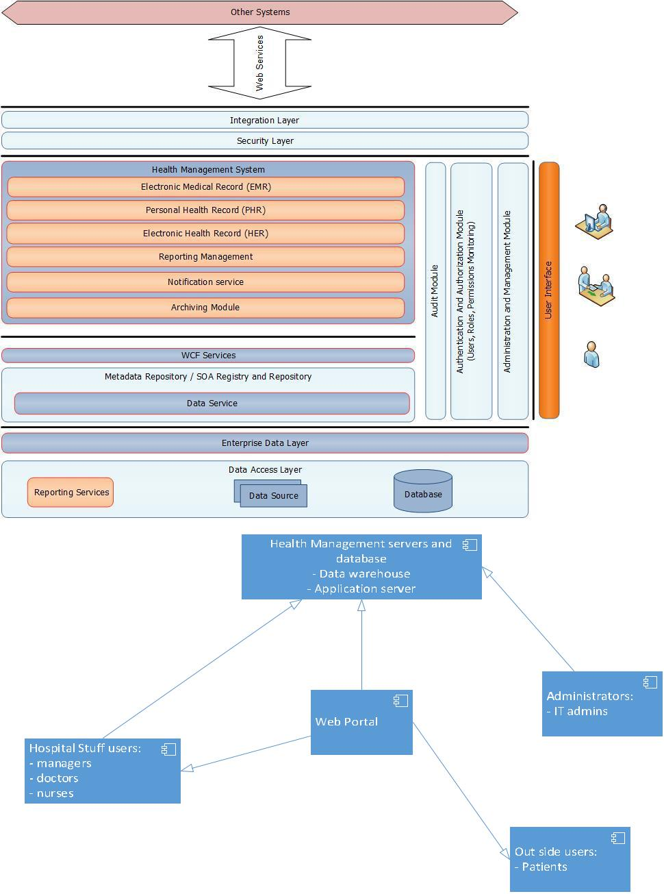

The most important feature of the solution is to provide a comprehensive cloud based Health Management System (HMS) that meets the needs to help transform to eventually improve and support the overall management and delivery of the health management process. The transformation will be facilitated through the solution.

The ACCHMS provides flexible and reliable advance technology services to manage the work remotely and control its own procedures and follow-up of the healthcare process. It eliminates errors resulting from poor communications. Maximum level of security and protection of information and data to ensure the appropriate access to the information by authorized users. It’s also provided remote access to information to the authorized users. A variety of real time reports and information can be achieved to help different levels of healthcare process engagement and decision makers.
The proposed model intends to protect from viruses that may cause a serious negative impact to the functioning of a cloud computing, therefore threat detection and prevention mechanism is required to avoid this impact. Network and data security may be achieved by authorizing only subscribers to connect to network and access services.
In addition to the above features the proposed model is capable to achieve the below listed services also:
Real-time analysis. To handle the emergency situations, sudden disease detection, or vital signs monitoring, the changing data reflects individual health status in real time. Therefore, these data need to be processed rapidly, and the analysis results are expected to return quickly for responding to unfortunate situations. With the memory analysis framework, such as heart rate, blood pressure, and other relevant data, will be kept in memory for improving the analysis efficiency.

Seamless connection to Cloud Computing storage: The ACCHMS allows users to retrieve, modify and upload medical content by utilizing Web Services [26]. The content resides remotely into the distributed storage but may be accessed to the user as the resources are located locally in the device.

Conclusion:

In this paper, we considered security and privacy issues in ACCHMS for highly equipped hospitals and is capable to provide easy and effective storage of information related to patients, doctors and management. We addressed an often neglected problem: the security of platforms. We showed how privacy domains can be used to extend the protection of cloud based systems from (existing) network security solutions to a more comprehensive infrastructure, including the client.

The system provides centralized repository and data warehousing for patient’s behavior information.
This system uses an EMR/ PHR system with cloud computing to reduce the burden of organizing and improving the functions of existing hospital monitoring systems.

References:

- Koufi V, Malamateniou F, Vassilacopoulos G. Ubiquitous access to cloud emergency medical services. In: Proceedings of the 2010 10th IEEE International Conference on Information Technology and Applications in Biomedicine (ITAB); The 10th IEEE International Conference on Information Technology and Applications in Biomedicine (ITAB); November 3-5, 2010; Corfu, Greece. New York, NY: IEEE; 2010.
- Fujita H, Uchimura Y, Waki K, Omae K, Takeuchi I, Ohe K. Development and clinical study of mobile 12-lead electrocardiography based on cloud computing for cardiac emergency. Studies in health technology and informatics. 2013;192:1077.
- Rao GSVRK, Sundararaman K, Parthasarathi J. Proceedings of the 2010 14th International Conference on Intelligence in Next Generation Networks (ICIN) Berlin, Germany: IEEE; 2010. Dhatri-A Pervasive Cloud initiative for primary healthcare services.

- Fong EM, Chung WY. Mobile cloud-computing-based healthcare service by noncontact ECG monitoring. Sensors (Basel, Switzerland) 2013;13(12):16451–73. doi: 10.3390/s131216451.

- Wang X, Gui Q, Liu B, Jin Z, Chen Y. Enabling smart personalized healthcare: a hybrid mobile -cloud approach for ECG telemonitoring. IEEE J Biomed Health Inform. 2014;18(3):739–45. doi: 10.1109/JBHI.2013.2286157.
- Hiden H, Woodman S, Watson P, Cala J. Developing cloud applications using the e-Science Central platform. Philos Trans A Math Phys Eng Sci. 2013;371(1983):20120085. doi: 10.1098/rsta.2012.0085.

- Almashaqbeh G, Hayajneh T, Vasilakos AV, Mohd BJ. QoS-aware health monitoring system using cloud-based WBANs. J Med Syst. 2014;38(10):121. doi: 10.1007/s10916-014-0121-2

- Kagadis GC, Kloukinas C, Moore K, Philbin J, Papadimitroulas P, Alexakos C, et al. Cloud computing in medical imaging. Med Phys. 2013;40(7):070901. doi: 10.1118/1.4811272.

- Doukas C, Pliakas T, Maglogiannis I. Mobile healthcare information management utilizing Cloud Computing and Android OS. Conf Proc IEEE Eng Med Biol Soc. 2010;2010:1037–40.

- Botts NE, Horan TA, Thoms BP. HealthATM: personal health cyberinfrastructure for underserved populations. Am J Prev Med. 2011;40(5 Suppl 2):115–22. doi: 10.1016/j.amepre.2011.01.016

- Takeuchi H, Mayuzumi Y, Kodama N, Sato K. Personal healthcare system using cloud computing. Stud Health Technol Inform. 2013;192:936
- B. Rao, “The role of medical data analytics in reducing health fraud and improving clinical and ﬁnancial outcomes,” in Computer-Based Medical Systems (CBMS), 2013 IEEE 26th International Symposium on, June 2013, pp. 3–3.

- Siddiqui Z, Abdullah AH, Khan MK, Alghamdi AS. Smart environment as a service: three factor cloud based user authentication for telecare medical information system. J Med Syst. 2014;38(1):9997. doi: 10.1007/s10916-013-9997-5

- Van Gorp P, Comuzzi M. Lifelong personal health data and application software via virtual machines in the cloud. IEEE J Biomed Health Inform. 2014;18(1):36–45. doi: 10.1109/JBHI.2013.2257821

- Xu R, Mei G, Zhang G, Gao P, Pepe A, Li J. TPM: cloud-based tele-PTSD monitor using multi-dimensional information. Stud Health Technol Inform. 2013;184:471–7

- Su CJ, Chiang CY. IAServ: an intelligent home care web services platform in a cloud for aging-
in-place.Int J Environ Res Public Health. 2013;10(11):6106–30. doi: 10.3390/ijerph10116106
- Jalali A, Olabode OA, Bell CM. Leveraging Cloud Computing to Address Public Health Disparities: An Analysis of the SPHPS. Online J Public Health Inform. 2012;4(3) doi:

10.5210/ojphi.v4i3.4325.
- Ahnn JH, Potkonjak M. mHealthMon: Toward Energy-Efficient and Distributed Mobile Health
Monitoring Using Parallel Offloading. J Med Syst. 2013;37(5):9957. doi: 10.1007/s10916-013-9957-0.

- Yoo S, Kim S, Kim T, Baek RM, Suh CS, Chung CY, et al.
- Economic analysis of cloud-based virtualization
implementation at a hospital. BMC Med Inform DecisMak. 2012;12:119. doi: 10.1186/1472-6947-12-119
Ratnam KA, Dominic PD, Ramayah T. A structural equation modeling approach for the adoption of cloud computing to enhance the Malaysian healthcare sector. J Medicine.
- Yao Q, Han X, Ma XK, Xue YF, Chen YJ, Li JS. Cloud-based hospital information system as a service for grassroots healthcare institutions. TheScientificWorldJOURNAL. 2014;38(9):104
- Rodrigues JJ, de la Torre I, Fernández G, López-Coronado M. Analysis of the Security and Privacy Requirements of Cloud-Based Electronic Health Records Systems. J Med Internet Res. 2013;15(8):e186. doi: 10.2196/jmir.2494.

- Regola N, Chawla NV. Storing and using health data in a virtual private cloud. J Med Internet Res.2013;15(3):e63. doi: 10.2196/jmir.2076.

- Christoph J, Griebel L, Leb I, Engel I, Kopcke F, Toddenroth D, et al. Secure Secondary Use of Clinical Data with Cloud-based NLP Services. Towards a Highly Scalable Research Infrastructure. Methods Inf Med. 2014;53(6)

- Shen CP, Jigjidsuren C, Dorjgochoo S, Chen CH, Chen WH, Hsu CK, et al. A data-mining framework for transnational healthcare system. J Med Syst. 2012;36(4):2565–75. doi: 10.1007/s10916-011-9729-
- Leonard Richardson, Sam Ruby, and David Heinemeier Hansson, Restful Web Services, Paperback, O'Reilly Media, May 2007, ISBN: 0596529260.
- Salman Iqbal, Miss Laiha Mat Kiah, Babak Dhaghighi, Muzammil Hussain, Suleman Khan, Muhammad Khurram Khan, Kim-Kwang Raymond Choo, On cloud security attacks: a taxonomy and intrusion detection and prevention as a service, J. Netw. Comput. Appl. 74 (2016) 98–120.


Javed Ali is presently working as Assistant Professor in the College of Computing Informatics at Saudi Electronic University, Madinah Munawarah, Kingdom of Saudi Arabia. He received B. Sc.(Hons), M.C.A. and Ph.D. from Aligarh Muslim University, Aligarh. He has 5 years of teaching experience of reputed International and National Universities viz Glocal University, Uttar Pradesh, India, ACN College of Engineering and Technology. His research interest includes parallel and distributed computing, expert systems, cloud computing and Internet of Things. He has published about 14 research papers including ISI in Journals/Conferences of International repute. He received state-level scientist award by the government of India.

