Research on the effect of applying robot in pediatric hospitalized patient education

Huan-Fang Lee¹, Wenli Ge², Li Ma³, Zhanwang Yuan³, Hsin-I Lee⁴
¹Department of Nursing, College of Medicine, National Cheng Kung University, Tainan, Taiwan
²Northwest Women and Children's Hospital, Shaanxi, China
³Nursing Department, Northwest Women and Children's Hospital, Shaanxi, China
⁴Institute of Management, National Taiwan University of Science and Technology, Taipei, Taiwan

Keywords: Robot, Pediatric patient education, Health knowledge, Health attitude, Health behaviour

I. Abstract Body
Patient education plays an important role in health care, especially in pediatric nursing, which has high risk and workload. In recent years, patient education forms tend to be diversified, such as multimedia, network platforms and mobile terminal applications. However, the existing pediatric patient education mainly focuses on children’s caregivers. In fact, it is very important to give full play to the role of children themselves. From the perspective of changing children's behaviour, this study innovatively utilizes robot in patient education in a provincial-level leading women and children's hospital in China. According to the Theory of Reasoned Action (TRA), after being educated, an individual's cognitive framework changes, which can promote the transformation of behaviour intent - a combination attitude toward performing certain behaviour, ultimately leading to a change in behaviour. The robot education of this study combines lovely robot appearance and professional education content full of children's naiveness and fun, and is carried out by interactive videos that children are willing to accept. This is a complete process of direct education to children, transferring cognitive beliefs and changing attitudes, thus influencing their behaviors. This study observes the changes of health knowledge, attitude and behaviour of two groups of hospitalized children who receive robot patient education and traditional patient education within two months. It is found that robot education could significantly improve the health knowledge and attitude of children, and could better change their health behaviour and successfully achieve the purpose of education. In addition, robot education receives higher satisfaction of patients.

II. Image
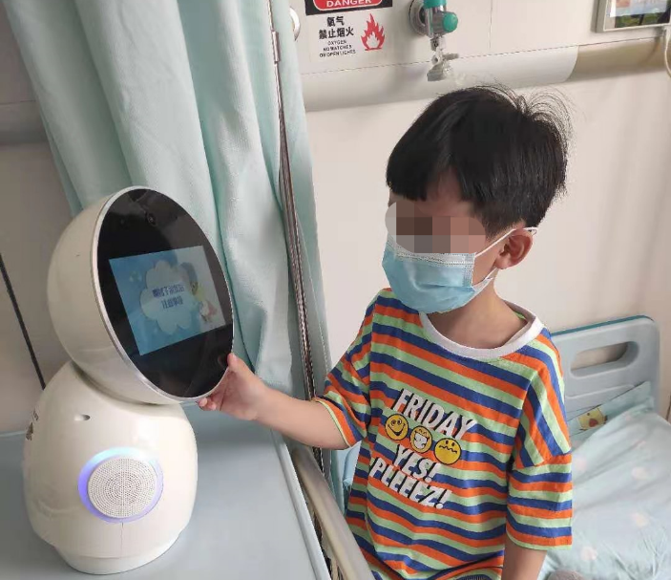
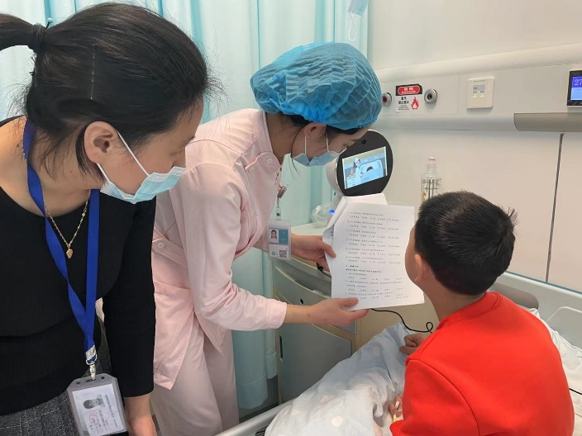
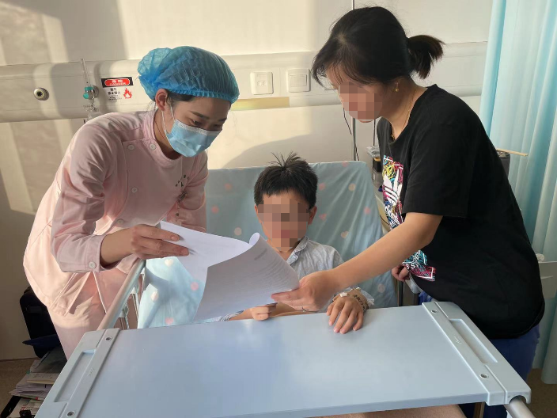
III. Reference:
- Albanese-O’Neill, A., Schatz, D.A., Bernhardt, J.M., Elder, J.H. 2016. Educational needs and technological preferences of fathers of youth with type 1 diabetes. Diabetes Educ. 2016(42):209-219.
- Berardinelli, L.M.M., Guedes, N.A.C., Ramos, J.P., Silva, M.G.N. 2014. Educational technology as a strategy for the empowerment of people with chronic illnesses. Rev Enferm UERJ, 22(5):603–609.
- Clifton, D.C., Benjamin, R.W., Brown,A.R., Ostrovsky, D.A., Narayan, A.P. 2018. A Tablet-Based Educational Tool: Toward More Comprehensive Pediatric Patient Education Clinical Pediatrics, 57(10):1176–1182.
- Corcimaru, A., Morrell, D.S., Burkhart, C.N. 2017. The Internet for patient education on atopic dermatitis: friend or foe? Am Acad Dermatol, 76(6):1197–1198.
- Davis, L., Allison, V., Kreashko, L.M. 2018. Developing, implementing, and evaluating personalized education for pediatric patients diagnosed with asthma on an observation unit. PediatrHealthCare, 2019(33):72-79.
- Feghhi, D.P., Komlos, D., Agarwal, N., Sabharwal, S. 2014. Quality of Online Pediatric Orthopaedic Education Materials. The Journal of Bone and Joint Surgery, 96(23): e194.
- Fernandes, S.C., Arriaga, P., Esteves, F. 2014. Providing preoperative information for children undergoing surgery: a randomized study testing different types of educational material to reduce children’s preoperative worries. Health Educ Res, 29(6):1058–1076.
- Fishbein, M., & Ajzen I. 1975. Belief, Attitude, Intention And Behavior. Addison-Wesley.
- Klingensmith, G.J., Aisenberg, J., Kaufman, F., Halvorson, M., Cruz, E., Riordan, M.E., Varma, C., Pardo, S., Viggiani, M.T., Wallace, J.F., Schachner, H.C., Bailey, T. 2013. Evaluation of a combined blood glucose monitoring and gaming system (Didget®) for motivation in children, adolescents, and young adults with type 1 diabetes. Pediatric Diabetes, 14: 350–357.
- Lelorain, S., Bachelet, A., Bertin, N., Bourgoin,M. 2017. French healthcare professionals’perceived barriers to and motivation for therapeutic patient education: a qualitative study, Nurs, Health Sci, 19 (2017) :331–339, doi:http://dx.doi.org/10.1111/nhs.12350.
- Liang, Y., Tian, J., Shen, C.P., Xu, F., Wang, H., Li, P., Guo, Y.P., Wei, F.L. 2017. Therapeutic patient education in children with moderate to severe atopic dermatitis: A multicenter randomized controlled trial in China. Pediatric Dermatology, 2017:1-6.
- Moreira, A.C.A, Silva, M.J., Darder, J.J.T., Coutinho, J.F.V., Vasconcelos, M.I.O., Marques, M.B. 2018. Effectiveness of an educational intervention on knowledge-attitude-practice of older adults’ caregivers. Rev Bras Enferm, 71(3):1118–1126.
- Naftel R.P., Safiano, N.A., Falola, M.I., Shannon, C.N., Wellons, J.C., Johnston, J.M. 2013. Technology preferences among caregivers of children with hydrocephalus. J Neurosurg Pediatr, 11(1):26–36.
- Niemitza,M., Schraderb, M., Carlensb, J., Hengstc, M., Eismannc, C., Goldbecka, L., Griesec, M., Schwerk, N. 2019. Patient education for children with interstitial lung diseases and their caregivers: A pilot study. Patient Education and Counseling, 102(6): 1131-1139.
- Nordfeldt, S., Angarne-Lindberg, T., Nordwall, M., Krevers, B. 2013. Parents of adolescents with type 1 diabetes—their views on information and communication needs and internet use. A qualitative study. PLoS One, 8(4):e62096.
- Pinnock, H., Epiphaniou, E., Pearce, G., Parke, H., Greenhalgh, T., Sheikh, A., Griffiths, C.J., Taylor, S.J. 2015. Implementing supported self-management for asthma: a systematic review and suggested hierarchy of evidence of implementation studies. BMC Med, 13(127): doi:http://dx.doi.org/10.1186/s12916-015-0361-0.
- Roberts, C.A., Geryk, L.L., Sage, A.J., Sleath, B.L., Tate, D.F., Carpenter, D.M. 2016. Adolescent, caregiver, and friend preferences for integrating social support and communication features into an asthma self-management app. Asthma, 2016(53):948-954.
- Saritha, K.M., Minsoo, K.M.D. 2018. Video-based education in pediatric atopic dermatitis. Am Acad Dermatol. 79:AB312.
- Sheppard, B.H., Hartwick, J., & Warshaw, P.R. 1988. The theory of reasoned action: A meta-analysis of past research with recommendations for modifications and future research. The Journal of Consumer Research, 15(3): 325-343.
- Wollenberg, A., Barbarot, S., Bieber, T., et al. 2018. Consensus-based European guidelines for treatment of atopic eczema (atopic dermatitis) in adults and children: part I. J Eur Acad Dermatol Venereol, 32(5):657–82.
- Wu, Y.P., Aspinwall, L.G., Nagelhout, E., Kohlmann, W., Kaphingst, K.A., Homburger, S., Perkins, R.D., Grossman, D., Harding, G., Cassidy, P., Leachman, S.A. 2016. Development of an educational program integrating concepts of genetic risk and preventive strategies for children with a family history of melanoma, J. Cancer Educ, (2016) :1–8.
- Yrjana, J.M.S., Bloigu, R., Kulmala, P. 2018. Parental confusion may result when primary health care professionals show heterogeneity in their knowledge, attitudes, and perceptions regarding infant nutrition, food allergy, and atopic dermatitis. Allergol Immunopathol(Madr), 46(4):326–33.
- Zhao, M.T., Liang, Y., Shen, C.P., Wang, Y., Ma, L., Ma, X.H. 2020. Patient Education Programs in Pediatric Atopic Dermatitis: A Systematic Review of Randomized Controlled Trials and Meta-Analysis. Dermatol Ther, https://doi.org/10.6084/m9.figshare.11913318.

IV. Biography:
Huan-Fang Lee (First author)
Huan-Fang Lee is an associate professor of Department of Nursing, College of Medicine, National Cheng Kung University. She majors in nursing administration, evidenece-base health care, and critical care. She has published more than 35 papers in reputed journals and 65 in conferences. She has also been the reviewer in many international journals.

Wenli Ge (Corresponding Author)
Wenli Ge is the vice president of Northwest Women and Children's Hospital, a leading women and children's hospital of Shaanxi province in China. She is also the vice president of Shaanxi Nursing Association and the deputy director of Shaanxi Nursing Quality Control Center. She has participated in 5 provincial scientific research projects.

Li Ma
Li Ma is the director of nursing department of Northwest Women and Children's Hospital, a leading women and children's hospital of Shaanxi province in China. She has been engaged in clinical midwifery work for 14 years and nursing management work for 22 years. She has presided over and participated in a number of scientific research projects of Shaanxi Science and Technology Department and Shaanxi Health Commission. She is honorary chair of Obstetrics and Gynecology Committee of Shaanxi Nursing Association and chairman of Maternal and Infant Committee of Shaanxi Maternal and Child Health and Eugenics and Postnatal Care Association.

Zhanwang Yuan
Zhanwang Yuan has been working in nursing department of Northwest Women and Children's Hospital, a leading women and children's hospital of Shaanxi province in China and was awarded the honor of "Hospital Level Excellent Nurse". She has participated in the scientific research project of Shaanxi Science and Technology Department.

Hsin-I Lee
Hsin-I Lee has completed his PhD from Institute of Management, National Taiwan University of Science and Technology, Taipei, Taiwan. His research is focused on knowledge management and Change Management. He also approved by Ministry of Economic Affairs to diagnosis and introduce KM consulting to organizations in government, healthcare, television and petrochemical manufacture industries over 15 years.

V. Presenting author details

Full Name: Hsin-I Lee
Contact number: +86-15001855268
Linked In account: https://www.linkedin.com/in/runningleo/
Session name/ number: video presentation/webinar
Category: Poster presentation

