Verification of the impact of storage by the rhythm phrase to be repeated

Kazue Sawami, RN PhD, Mitsuo Kimura, RN M.S, Tetsuro Kitamura, PT, Nara Medical University, Japan Chizuko Suishu, RN Prof, Shubun University, Japan

Abstract

【Introduction】Alzheimer’s Disease (AD) accounts for a high percentage of dementia at over 60%. As dementia incidence doubles every 5 years from 65 years old onwards, developing a countermeasure is an urgent issue. As a countermeasure, the effectiveness of cognitive function training tasks such as dual-task (performing two tasks simultaneously) and n-back task (a delayed recall task for items shown n steps earlier) have been verified. Furthermore, it has been verified lyrics accompanied with sound or rhythm are stored easily by the memory, but difficult to remember when without sound or rhythm. It was hypothesized that combining rhythmic music with repeated memory tasks would improve memory performance. It was also predicted that stress associated with memory tasks would be alleviated by the relaxing effect of music.

The purpose of this study is to verify a new training method combining rhythmic music and repeated memory tasks. An intervention study was conducted over 3 months, and compared results from the intervention group and the control group.

【Method】Screening test for mild cognitive impairment: Montreal Cognitive Assessment (MoCA test) and; Stress check: Measured α-amylase levels of saliva taken from the sublingual gland. Analysis was conducted by a corresponding t-test, comparing the control group and intervention group results.

【Results】In comparison to the control group, cognitive function was significantly improved and distress was reduced in the intervention group.

【Conclusion】Repeated memory tasks combined with rhythmic music were effective both in improving memory capacity and reducing stress.
Image
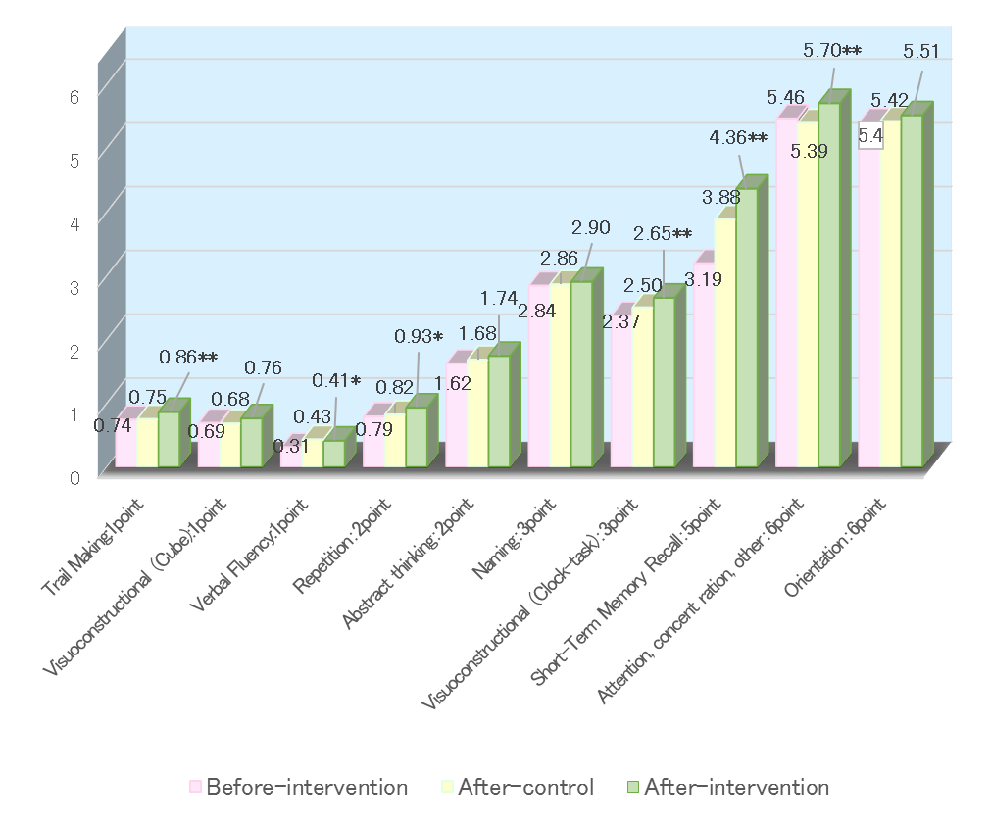
Comparison before and after the intervention and control of the mean value of MoCA test.
Corresponding paired t-test, n = 79.
**Significant at 1% level, *Significant at 5% level
Recent Publications (minimum 5)
- Sawami K, Kimura M, et al., (2017) Achievement of Brain Training Course for the Elderly. J Health Educ Res Dev, 5:1-4. Awards: World Academic Championship - 2017 in Nursing
- Sawami K, Nakagawa H, et al., (2017) Relationship between cognitive function, vascular age and stress. IJCC 1:83-89.
- Sawami K, Kimura M, et al., (2017) Relationship between Mental Health Stress Levels and Cognitive Function. J Addict Res. 1:1-6.
- Sawami K, Nakagawa H, et al., (2017) Intellectual effects of delayed playback task and rhythmic activities. Ment Health Addict Res.2:1-6.
5. Sawami K, Nakagawa H, et al., (2017) Verification of Preventive Effect of Dual-Task and N-Back Task-Incorporated Music Therapy against Dementia. Neurochem Neuropharm Open Access. 3:1-5.

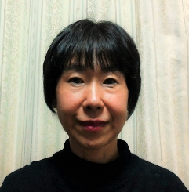 Biography
Name: Kazue Sawami. I got my PhD in Health Sciences. Currently I work at Nara Medical University's gerontological nursing science.
Research Interest: Research focuses on verifying the effectiveness of efforts to prevent dementia. In the intervention, music therapy, rhythm exercise, sandplay of miniature garden and brain training task are combined. We are amazed at the potential of the elderly. We are re-recognize the valuable life of the elderly every day. We want to show the value and potentiality of a wonderful elderly by research. Our clinical trial information can be viewed：https://upload.umin.ac.jp/cgi-open-bin/ctr/ctr_view.cgi?recptno=R000028956. Our research results, has been published in the following. http://www.g-nursing.com/katsudou.php

Email: sawami@naramed-u.ac.jp
Notes/Comments

