To Explore the efficacy of Therapeutic Play in the Treatment of Preschool Children with Respiratory Therapy
Lu Jia-fen, Head Nurse , Saint Paul's Hospital,Taiwan
Jane Yah-Lun, Head Nurse , Saint Paul's Hospital,Taiwan

Abstract (300 word limit)

Question statement: Respiratory tract infection is the primary cause of the death of children under five years of age. The disposal will be spray treatment, but the child patients usually resist clinically. Thus it affect the treatment result. Before treatment, therapeutic play , instructions and technical operations, can be useful for preschool child patients to transfer pressure and fear, to increase acceptance, and to understand practical usefulness. Purpose : To explore the acceptance of respiratory therapy of the preschool child patients, to improve the effective discharge of sputum of the hospitalized children, and to evaluate the effect of therapeutic play on preschool child patients' respiratory therapy. Methodological and theoretical orientation: This study was Quasi-Experimental Design, Enrolled 3-6-year-old pre-school young children of the Division of Pediatrics wards in a certain regional hospital as the subjects, divided into two groups (experimental group and control group) to a total of 40 people. The control group did not use the therapeutic play; the experimental group was added the "guiding play" type of therapeutic play. Taking into account the development characteristics of hospitalized children, and therefore to use self-designed LED blowing device and some real medical supplies for therapeutic play before the treatment. Afterwards, we can realize the usefulness of practical uses by persuading parents to fill out " Child Temperament Scale" and "Nursing Guidance Satisfaction Questionnaire" .result: The use of therapeutic plays improve the effectiveness of respiratory therapy. In the experimental group, the interventional measures can significantly improve the correlation coefficient of child temperament and emotional regulation (p <.05) and Nursing Guidance Satisfaction reaching 97.1% Conclusion: The use of therapeutic play can improve the effectiveness of treatment, can also reduce the hospital hospital pressure and fear, thereby enhancing the quality of clinical care and care and professional ability.
Image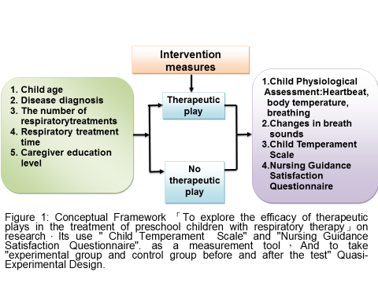
Recent Publications (minimum 5)
- Chen Qianqi, Chen Qianfang, Zhuang Xiaoling (2016) · Use of therapeutic Therapeutic Play to care for a kidney disease syndrome Group of pre-school care experience ·VGH Nursing; 33 (3), 320 – 326
- Zhang Yiqing, Cai Jialing (2009). The use of therapeutic games to assist a preschooler with bronchial pneumonia in the treatment of thoracic physical therapy. Chang Gung Nursing, 20 (2), 243-252.
- Zhong Huiying, Cai Jialing (2012). The use of therapeutic games to assist a pre-school bronchial pneumonia in the implementation of thoracic physical therapy results. NTUH Journal of Nursing, 6 (1), 76-88.
- Buss, K. A., &Goldsmith, H. H. (1998).Fear and anger regulation in infancy: Effects on the temporal dynamics of affective expression. Child Development, 69(2), 359-374
5. Carrick, N.,& Quas, J. (2006).Effects of discrete emotions on young children's ability to discern fantasy and reality.Developmental Psychology, 42(6), 1278-1288.

 Biography (150 word limit)

Lu Jia-fen worked at the St. Paul's Hospital, specialized in pediatric and acute illness. Had served as leader of pediatric ward, obstetric ward, gynecology ward, maternity ward, baby room, and now work at the emergency field. She is enthusiastic about the pediatric clinical care and developing clinical medical aids with academic field. The uses of therapeutic plays to reduce pressure and fear of child patients , helping receiving treatment, and to improve the quality of nursing care and profession. Related academic articles are verified by Taiwan Nursing Institute and by Taiwan Evidence-Based Medicine Association.


Biography (150 word limit)

Jane Yah-Lun worked at the St. Paul's Hospital, specialized in neonatology, pediatric critical care and serves as breastfeeding seeded lecturer. Had served as leader of baby room, pediatric intensive care unit, and now works at the newborn area. She is enthusiastic about the neonatology and promoting the clinical care of breast milk. Ever used multimedia teaching aids into the nursing guide to enhance the interest, concentration, learning impression and memory of the nurses. And thus improve the learning outcomes and caring quality. Related academic articles are verified by Taiwan Nursing Institute and by Taiwan Evidence-Based Medicine Association.
.
Email:m62083@mail.sph.org.tw

Notes/Comments:

