Application of Comprehensive Nursing Intervention to Improve Mather’s Breastfeeding skill in China
Hong-xia DAI, RN PhD, MACAU, China

Abstract (298 words)
Statement of the Problem: The exclusive breastfeeding rate was declined in recent year in China. Most of Chinese couples have only one baby, mothers are unfamiliar with breastfeeding skill. Some researchers reported that application of the instrument of LATCHES to evaluate maternal breastfeeding skill. However there are rarely related studies in China. This research used the instrument of LATCHES to evaluate the effects of application of ‘comprehensive nursing intervention’ on mothers’ breastfeeding skill in China. Methodology & Theoretical Orientation: The study was a prospective clinical experimental research. 313 postnatal women were recruited from three hospitals in Guangzhou by cluster sampling method. The control group received general care with oral education about breastfeeding without handbook and telephone follow-up. The treatment group received ‘comprehensive nursing intervention’, which composed of a practical handbook, individual education of breastfeeding skills through face-to-face and one-on-one methods at bed-side within 24 hours postpartum. The participants accepted a telephone follow-up related to breastfeeding at 5 weeks postpartum. They completed two questionnaires on LATCHES-breastfeeding charting system on the third day and 6 weeks after delivery. The ICC of LATCHES is 0.808, Cronbach’s α is 0.826. LATCHES assess mothers’ latch, audible swallowing, type of nipple, comfort (breast/nipple), hold (positioning), excretion and satisfaction. Total 12 items, grade range from 12 to 36. The higher grade means good breastfeeding skills. The SPSS 20.0 software, T test and X² test were used. Findings: At 6weeks postpartum, the exclusive breastfeeding rate of the treatment group (52.7%) was higher than the control group (29.7%), p values were 0.034. The LATCHES mean grade of the treatment group at 6 weeks postpartum (33.01±2.38) were higher than the control group (31.00±3.09), p<0.001. Conclusion & Significance: Comprehensive nursing intervention of exclusive breastfeeding and individual education improved exclusive breastfeeding rate and mother’s breastfeeding skill at 6 weeks postpartum.
Tables
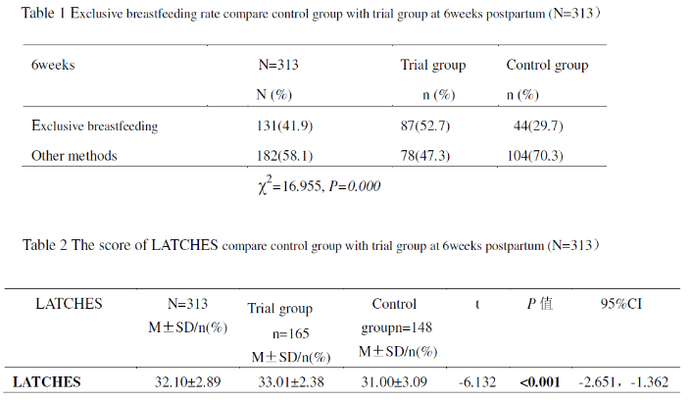
Recent Publications (minimum 5)

Zhu Bingquan, Zhang, Jian, Qiu Liqian, etal(2015).Breastfeeding Rates and Growth Charts-the Zhejiang Infant Feeding trial.

International Journal of Environmental Research and Public Health, 12(7):7337-7347.

Yang Zhenyu, Lai Jianqiang, Yu Dongmei, etal(2016). Breastfeeding rates in China: a cross-sectional survey and estimate of benefits of improvement .The Lancet, 388:S47-S47.
- Jensen, D., Wallance,S., Kelsay,P., LATCH: A breastfeeding charting system and Documentation tool[J]. Journal of Obstetrics, Gynecological and Neonatal Nursing, 1994,23:27 –32.
- YU Su-chai (2016). Study of systematic feedback nursing intervention on breastfeeding skills. Journal of Huaihai Medicine, 34(01):43-45.
- Yu, Chuan ,Binns, Colin W,etal(2016).Comparison of breastfeeding rates and health outcomes for infants receiving care from hospital outpatient clinic and community health centres in China.Journal of Child Health Care, 20(3):286-293.

Biography (150 word limit)
Dr. Dai Hong-Xia is currently an Assistant Program Coordinator and lecturer of the School of Health Sciences at Macao Polytechnic Institute. Dr. Dai was educated at Sun Yat-sen University in china and graduated with a Doctor Degree of Medicine (M.d) in clinical nursing before spending 11 years serving in the hospitals in China. Dr. Dai attended Macao Polytechnic Institute since 2007 and she has been embarking on an academic career, which has embraced teaching undergraduate nursing programme, cohort postgraduate specialist nurse (PgDSN) students and research. Dr. Dai’s research has embraced nursing education, teaching and learning, clinical nursing, health education, breastfeeding and operation room nursing. She has published over 20 academic research papers recently years.
Email: hxdai@ipm.edu.mo
Notes/Comments:

