MANDATORY IMMUNIZATION IN THE REPUBLIC OF SERBIA (POMORAVLJE DISTRICT) WITH THE FOCUS ON THE MMR VACCINE
Lazar Stevanovic, Bachelor in health sciences

Abstract

Topic: What is the percentage of children vaccinated compared to the number planned for vaccination in 2016?

Initial hypothesis: We have been witnessed and still are of numerous discussions among experts (scientists) and layman people about the efficiency and harmfulness of vaccines, especially MMR vaccines which was considered and still is thatit causes autism. Research goal: Determine the coverage of mandatory immunization, especially the MMR vaccine, in the Pomoravlje district. Research methodology: The research was conducted at the Public Health Institute in Cuprija from 03.09.- 20.09.2018. The period from 01.01.2016.- 31.12.2016. As an research instrument I used documentation sheet, observation, analysis and a survey. Findings: there are variations in the percentage of vaccinated children from certain vaccines in certain towns in the Pomoravlje district, but the overall percentage of vaccines is satisfying in the district. Conclusion: Although mass media and social networks (where people have access to a great deal of information) have raised a great deal of concern about the correctness of the MMR vaccine, as well as others that may have unintended consequences, the number of vaccinated MMR vaccines is satisfying and it’s not below 91% for each town in the district.
Image
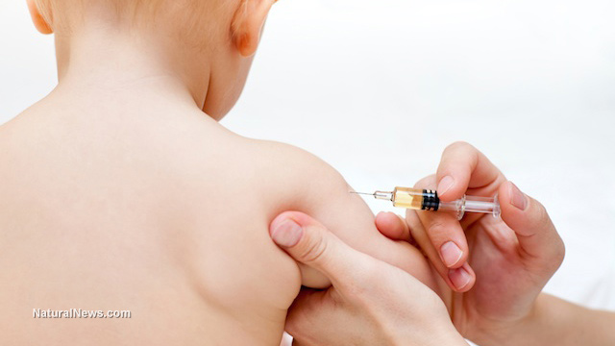
Recent Publications
- Psychosocial aspects of malignancies, proceedings of abstracts. A symposium of head nurses and midwives, nurses and midwives from nursing practice and professors. National Symposium with International Participation, pg. 37
- Nicotinism in adolescence, Proceedings of the Promotion of Knowledge. Congress of Serbian health workers of the first category with international participation. Association of Health Workers of Serbia XI: 192-193
- Thyroid cancer - case report; proceedings of abstracts. First International Student Conference
- Decubitus and nursing interventions in the care and treatment of decubital wounds. Professional Health Journal "Health Worker" 1: 16-19

Biography
Lazar Stevanovic, health worker at the Neonatology Institute in Belgrade, Serbia. Also, final year student on his second healthcare studies at the Faculty of health sciences. Full of enthusiasm and a desire for progress, he attended two continuing educations abroad (Egypt and Switzerland). He worked as an assistant lecturer during his first studies and taught 4 subjects, he was president of the student Parliament and secretary of the Red Cross Field Youth Unit.
Email: lazar2395@gjkbmail.com

Notes/Comments:

