Tracking The Trajectory of Exercise Adherence Over Time and Examining the Effect of Theory-lead Intervention for Knee Osteoarthritis in Older Adults ：A Cluster Randomized Trial
Limin Wang, RN PhD, Peking University, School of Nursing, Beijing, China
Hongbo Chen, RN PhD, Peking University, School of Nursing, Beijing, China
Han Lu, RN PhD, Peking University, School of Nursing, Beijing, China
Jieru Chen, RN, Peking University, School of Nursing, Beijing, China
*Shaomei Shang, RN MD, Peking University, School of Nursing, Beijing, China

Abstract
Statement of the Problem: Knee osteoarthritis (KOA) is a common joint disease in people over 60 years old. Exercise therapy is one of the most effective non-pharmacological treatments for knee osteoarthritis, but low exercise adherence needs to be improved. The purpose of this study is to track the trajectory of exercise adherence over time and to examine the effect of the transtheoretical model-lead home exercise intervention (TTM-HEI) program on exercise adherence, symptoms and knee function in older adults with KOA. Methodology & Theoretical Orientation: The transtheoretical model (TTM) is a widely-used multistage of action and behaviors. The study combined the model with physical activity and conducted a 24-week transtheoretical model-lead home exercise intervention program for older adults with KOA with a two-arm, cluster randomized trial design in 2018. At weeks 4, 12, 24, 36, and 48 after the program started, exercise adherence measured by an 11-point numerical self-rating scale was accessed; KOA symptoms (pain intensity and joint stiffness) and knee function (lower limb muscle strength and balance) were measured at baseline, week 24, and week 48. Findings: Tracking the trajectory of exercise adherence over time in two groups using latent growth model (LGM), we found TTM-HEI could effectively maintain participants’ exercise adherence with 5.563 (SD=0.997) comparing with 3.159 (SD=1.313) in control group at week 48 and keep members relatively consistent and better growth rate of exercise adherence with increased 2.175 units compared with control group (unstandardized coefficient of slope on group B2 =2.175) and lower 1.62 units of variances of slope. Besides TTM-HEI could also relief KOA symptoms and improve knee function much better than control group. Conclusion & Significance: Exercise adherence shows big variance between individuals over time under no supervision and TTM-HEI program could maintain individuals’ good exercise habit by setting goals and tailoring the schedule

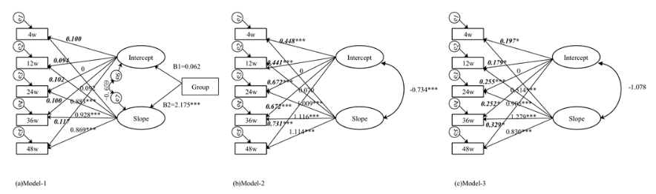

Main estimated parameter diagrams using three models.
(a) Model 1: conducting group as a covariate (0: control group, 1: intervention group); (b) Model 2: control group and (c) Model 3: intervention group.
The path loading of the intercept is shown by bold italic font and the path loadings of the slope is shown by regular front.
***p<0.001, **p<0.01, *p<0.05.
Recent Publications
- Chen, H. B., Zheng, X. Y., Huang, H. J., Liu, C. Y., Wan, Q. Q., & Shang, S. M. (2019). The effects of a home-based exercise intervention on elderly patients with knee osteoarthritis: a quasi-experimental study. BMC MUSCULOSKELETAL DISORDERS, 20(1), 160-111. doi:10.1186/s12891-019-2521-4


Limin Wang, RN, PH. D, Peking University, School of Nursing
Limin Wang is interested in the geriatric nursing and rehabilitation nursing and has participant several meaningful researches about nee osteoarthritis in the elderly. The present study is a main about how to improve the life quality of elderly with KOA and help them cope with KOA in the long time. There is about 23.35 million people aged 60 or above years old with symptom KOA in China and the prevalence is about 11.1%-18.5%. They suffer from severe pain and limited function in remaining life. Our team are to improve the quality life of the patients by the intervention and we also would like to collaborate with other teams or scholarships from the world.
Email: liminwangbjmu@163.com

