Convenient Clinic: a new approach in Primary Care Development in Vietnam
Bao Tran, MBA, City International Hospital, Ho Chi Minh City, Vietnam

Abstract (300 word limit)
Pharmacity Clinic is the first convenient care model in Vietnam and also in Indochina Region. The first one has been launched in December, 2019 thanks to the partnership between Pharmacity, the leading retail pharmacy group in Vietnam and City International Hospital. The model is based on a GP clinic model: One GP and an additional nurse, added later on, to do blood collection, follow-up and paperwork and liaise work to refer back to the hospital. The purpose of this collaboration is to develop a primary care network across the country and integrate with the parent hospital, City International Hospital as a hub-spoke model.

Image
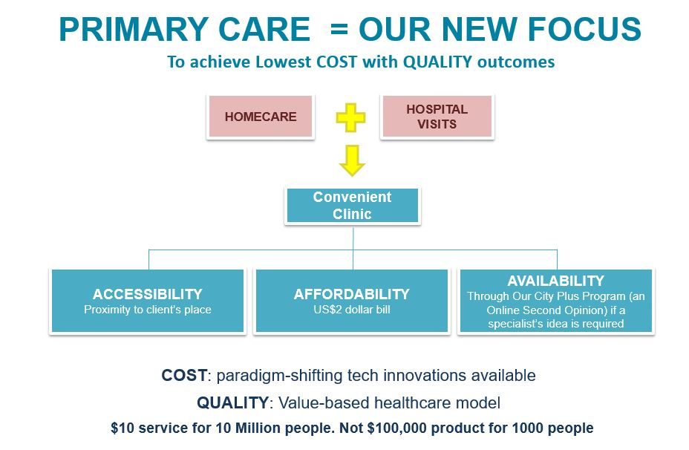
Recent Publications (minimum 5)
N/A

Biography (150 word limit)
Mr Tran Quoc Bao is an engaging leader with proven qualifications and results in most aspects of hospital operations, investment and strategic development. He has experience and ability in generating sustainable value system across diverse finance, business development and operating health care models in Vietnam.
Mr. Tran Quoc Bao has been the Planning and Marketing Director of City International Hospital since March, 2018 and is tasked to conceptualize and executive an exciting growth plan for City International Hospital in the form of a holistic care system.

Email: bao_tq@cih.com.vn

Notes/Comments:

