Exploring factors related to unplanning readmission of elderly patients in Taiwan
Hui-Yen Lee, BSN RN, Department of Nursing, Yuan's General Hospital, Kaohsiung, Taiwan
Hsiu-Yun Wei, BSN RN, Department of Nursing, Yuan's General Hospital, Kaohsiung, Taiwan
Guey- Jen Lin, BSN RN, Department of Nursing, Yuan's General Hospital, Kaohsiung, Taiwan

Abstract
Background: Unplanned hospital readmissions increase healthcare costs and have been considered a marker of poor healthcare performance. The elderly face a higher risk of unplanned readmission due to elderly-specific characteristics such as deteriorating body functions and the relatively high incidence of complications after treatment of acute diseases. The aim of this study was exploring the factors that relate to the unplanned readmission of elderly within 14 days of discharge at our hospital in southern Taiwan. Methods: We retrospectively reviewed the medical records of patients aged ≥65 years who had been re-admitted between January 2018 and December 2018.The comorbidity score was calculated using previous used method. Related factors that affected the rate of unplanned readmission within 14 days of discharge were screened and analyzed using the chi-squared test and logistic regression analysis. Results: This study enrolled 829 subjects aged more than 65 years. The numbers of unplanned readmission patients within 14 days were 318 cases, while those did not belong to the unplanned readmission were 511 cases. In 2018, the rate of elderly patients in unplanned 14 days readmissions was 38.4%. The majority patients were females (166 cases, 52.2%), with an average age of 77.6 ± 7.90 years (65-98). The average value of comorbidity score was 4.42±2.76. Using logistic regression analysis, we found that the gastric or peptic ulcer (OR=1.917,P<0.002), diabetes (OR=0.722,P<0.043), hemiplegia (OR=2.292,P<0.015), metastatic solid tumor (OR=2.204,P<0.025), hypertension (OR=0.696,P<0.044), and skin ulcer/cellulitis (OR=2.747,P<0.022) have significantly higher risk of 14-day readmissions. Conclusion: The results of the present study may assist the healthcare teams to understand the factors that may affect unplanned readmission in the elderly. We recommend that these teams give efficient approach in their medical practice, provide timely health education for elderly, and integrative healthcare for chronic diseases in order to reduce unplanned readmissions.

Recent Publications

- Lee, J. F., Song, S. Y., Tang, Y. L., Wu, H. Y. (2011) Exploring the causes of unplanned readmission within fourteen days discharge. PCJHM, 201006.0003, doi:10.29681 Lee, J. F., Song, S. Y., Tang, Y. L., Wu, H. Y. (2011) Exploring the causes of unplanned readmission within fourteen days discharge. PCJHM, 201006.0003, doi:10.29681
- Lin, H. C., Lee, C. L., Chang, C. M (2016) Exploring Understanding of Advance Directives among the Elderly ICU Residents and Their Families at a Medical Center in Central Taiwan. Taiwan Geriatr Gerontol. 11(1), 50-65
- Pai, S. F., Chang, K. H., Lim, S. N., Tsai, M. C., Chang, H. J (2017) Risk Factors Associated with Hospitalization in Elderly Patients Receiving Home Care Nursing. Head nurse of home health care. 21 (1),DOI:10.6317/LTC.21.533
- Shih, S. F., Liu, H. H., Chen, Y. J., Hsiao, T., Lin, Y. H. (2017) Creating Elder-Friendly Environments in Hospitals and Communities: Research on Discharge Planning Service. Journal of Gerontechnology and Service Management, doi:10.6283/JOCSG.201711_5(3).241
- Yeh, S. T., Wu, S. C (2010) An analysis of overstay by hospital patients. Journal of Healthcare Management, 11(2), doi:10.6174/JHM2010.11(2).131

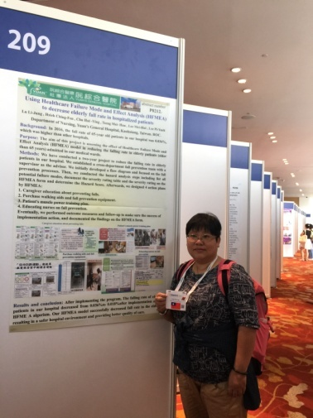Biography
Registered Nurse：Lee Hui-Yen
2005 Bachelor degree, Nursing Department, MEIHO University, Pingtung, Taiwan. ROC
2001〜2005：Head Nurse, Department of Nursing, Yuan’s General Hospital,
2006〜2007：Head Nurse of Colorectal Surgery Department of Nursing, Yuan’s General Hospital
2008〜present：Head Nurse of Supply center, Yuan’s General Hospital
Member of Taiwan Nurse Association

Email: y0374@yuanhosp.com.tw

