Patient Safety Section – Speak Up for Patient Safety

Abstract (300 word limit)

In an effort to focus on a Culture of Safety and Quality, Ramsay Sime Darby Healthcare (RSDHC) commenced a “Speak Up For Patient Safety” program in January 2019. SUFPS is an innovative and evidence-based programme, based on the Vanderbilt University (USA) program delivered with the assistance of the Cognitive Institute. The program addresses in a positive way any behaviour which undermines a culture of safety through peer-to-peer conversations and equipping staff with assertiveness training. To achieve a successful outcome there was a major focus on informing, educating and engaging key stakeholder groups.

Image

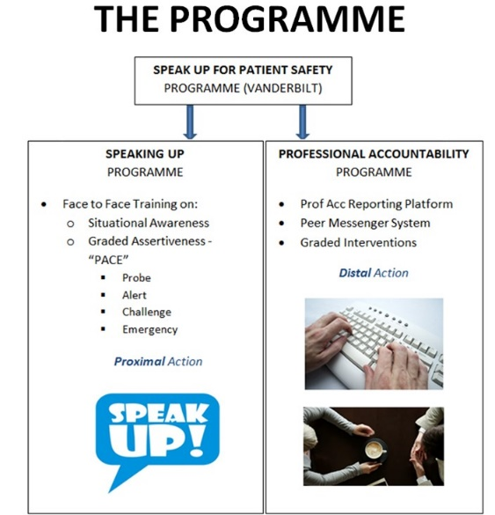

Recent Publications (minimum 5)
Nil

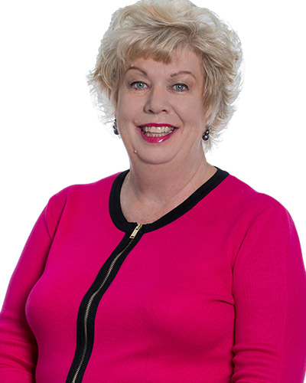Biography (150 word limit)
Erin Lloyd currently works as the Group Head for Nursing, Quality and Risk for Ramsay Sime Darby Healthcare (RSDH). She is a Registered Nurse, Midwife, has a Bachelor of Nursing and holds a Masters of Health Management. She has worked for Ramsay Health Care (RHC) since 1996 in various roles including Nurse Unit Manager, Hospital Quality Manager and Medical Services Manager. In 2007, she commenced working for RHC in Indonesia and in July 2013 with the joint venture between Ramsay and Sime Darby, this changed to RSDH.
Erin’s keen interest in patient safety/accreditation materialized in 2011 when Bintaro Hospital (Indonesia), became the fourth hospital in Indonesia, to obtain the US Joint Commission International Accreditation. The subsequent accreditation & re accreditation, of all the three Indonesian Hospitals and two Malaysian hospitals have been extremely rewarding. Secondly, the development of strong quality teams has also been another milestone in her work and lastly the upskilling of nursing staff from diploma to degree nurses and the professionalization of nursing have been very satisfying.
Erin moved to Kuala Lumpur, Malaysia in July 2015 to commence working across both Indonesia and Malaysia. This has provided more challenges, especially dealing with multiple cultures and increased responsibility. In any effort to respond to the increasing rate of nurse turnover and to further improve Asian Nursing Practice, Erin along with her colleagues made a conscious decision in 2016 to commence the journey towards “American Nursing Magnet Accreditation.”

Email: erin.maree.lloyd@ramsaysimedarbyhealthcare

