Prescription errors in a basic pharmacy of the Federal District
Anna Cecília Soares Santos ¹, ¹Nursing Professor at Estácio FATERN. Natal, Brazil.
Cris Renata Grou Volpe², RN PhD, UniversityofBrasilia, Brazil,
Diana Lúcia Moura Pinho ², Luciano Ramos de Lima ², Marina Morato Stival²,Nursing Professor atCollegeofCeilandia,
Valdiane Dutra Oliveira ⁶

Abstract (300 word limit)
Objective: to analyze electronic and manual prescriptions regarding the occurrence of polypharmacy and potential types of medication errors in the context of primary care. Method: a descriptive, transversal and retrospective study, based on the evaluation of prescriptions filed at the pharmacy of the Basic Health Unit of the Federal District. Results: The total of the evaluation criteria proposed in this study were: illegibility (98.2%), abbreviations (97.7%), pharmaceutical form (57.6%), concentration (32.4%), polypharmacy was identified in 46% of users and this was directly related to the age of the user. when analyzing the age and its relationship with polypharmacy, 51% of users in polypharmacy were more than 50 years old, users between 61 and 70 years of age, polypharmacy in their prescriptions corresponding to 20.4% of the total. It is noted that the greater the age the greater the risk of polypharmacy, being, the increase of age directly associated with the polymedication. Regarding the prevalence of chronic diseases, DM was present in 453 (65.6%) users, HBs represented 659 (95.4%), and 205 (29.7%) users had CAD and 439 (63.5% ) to DLP. Chronic noncommunicable diseases (CNCD) were positively associated with polypharmacy. The chronic diseases with the highest risk for the presence of polypharmacy were: HAS, increasing the risk of polymedication by 5.47 times and DLP increasing the risk of polypharmacy by 6.40 times.
Keywords: Polypharmacy; Primary Health Care; Prescription erros; Enfermería en Salud Comunitaria.

Recent Publications (minimum 5)
- Harper C (2009) The neuropathology of alcohol-related brain damage. Alcohol Alcohol 44:136-140.
- Heilig M, Egli M (2006) Pharmacological treatment of alcohol dependence: Target symptoms and target mechanisms. Pharmacology and therapeutics 111:855-876.
- LiX, SchwachaMG, ChaudryIH, ChoudhryMA (2008)Acutealcohol intoxication potentiates neutrophil-mediated intestinal tissue damage after burn injury. Shock 29:377.
- Room R, BaborT, Rehm J (2005) Alcohol and public health. Lancet
365: 519-530.
5. Sullivan EV, Zahr NM (2008) Neuroinflammation as a neurotoxic mechanism in alcoholism: Commentary on “Increased MCP- 1 and microglia in various regions of human alcoholic brain”. Experimental neurology 213:10-17.
Table 2 Information on drug prescriptions in primary care, Brasília, 2017.
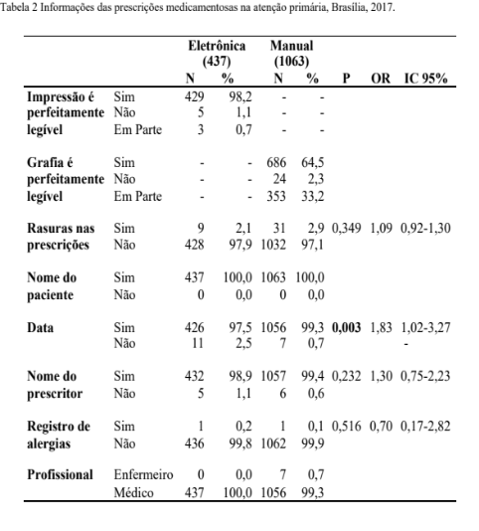



Biography
Cris Renata Grou Volpe is currently teaching at the University of Brasilia -UNB, Master of Health Sciences University of Sao Paulo and a PhD in Nursing at the Graduate Nursing Program (UNB). It has experience in nursing, with emphasis on fundamental nursing, medical and gerontology acting on the following topics: nursing in adult health and elderly, medicine, nursing in public health, semiotics / semiotics and nursing process.
Author details Full name: Cris Renata Grou Volpe Contact number: 55 61 81273892 Email: crgrou@unb.br
Category: Poster presentation
Facebook Id: Cris Renata

