Abstract for International Conference on Health Nursing Education & Practice
Title: An initiative of e-solution for nursing sector in Bangladesh
Theme: New Technology in Nursing Education (Track 8)
Sub Theme: Information and Communication Technology
Author: 1. Ms. Tandra Sikder, DG, DGNM, MOHFW, 2. Dr. Lubana Ahmed, Canadian Project Director, CowaterSogema International Inc., 3. Dr. Monira Parveen, Canadian Field Manager, HRH Project, CowaterSogema International Inc, GAC, 4. Md. Mahbubur Rahman, IT Specialist, HRH Project, CowaterSogema International Inc, GAC

Keywords: e-solution-Electronic Solution, ICT-Information Communication Technology, HRH project-Human Resources for Health project, BNMC-Bangladesh Nursing and Midwifery Council, NEMS-Nurse-Midwife Education Management System, DGNM-Directorate General of Nursing and Midwifery, MoHFW-Ministry of Health and Family Welfare, NIs-Nursing Institutes, PMIS-Personnel Management Information System

- Abstract
In Bangladesh, about 18,000 students are admitted every year into 322 nursing institutes and colleges. BNMC have system to keep all students’ info into student’s registration database. There is demand for digitalization of nursing education specially the examination management for improving record keeping. HRH project designed an electronic NEMS for better education management for Nursing Institutes in consultation with DGNM, BNMC and MOHFW. Key developmental steps were followed to develop the NEMS software. NEMS is mainly divided into seven modules- Faculty, Student, and Exam result, Library, Hostel, Laboratory and Inventory. The NEMS software will support continuously to track information of nurse-midwife that will be compatible with the BNMC database and PMIS software. Objectives of this initiatives to improve ICT based nursing education management system with a phased introduction of web-based NEMS to nursing institutes under the MoHFW. The key approach of this paper will describe and share the methodological aspects with regard to database management, preparation of database reports, data security, privacy and queries, and network management. Keeping all the necessary requirements in mind, this web based NEMS has been designed and developed with the objective that the system is technically easy and fast to access on web with limited skills and interest. The software is mainly divided into seven dynamic modules- Faculty, Student, and Exam result, Library, Hostel, Laboratory and Inventory. This is the first kind of ICT based web intervention to replace the manual system at the institute level of nursing education sector.
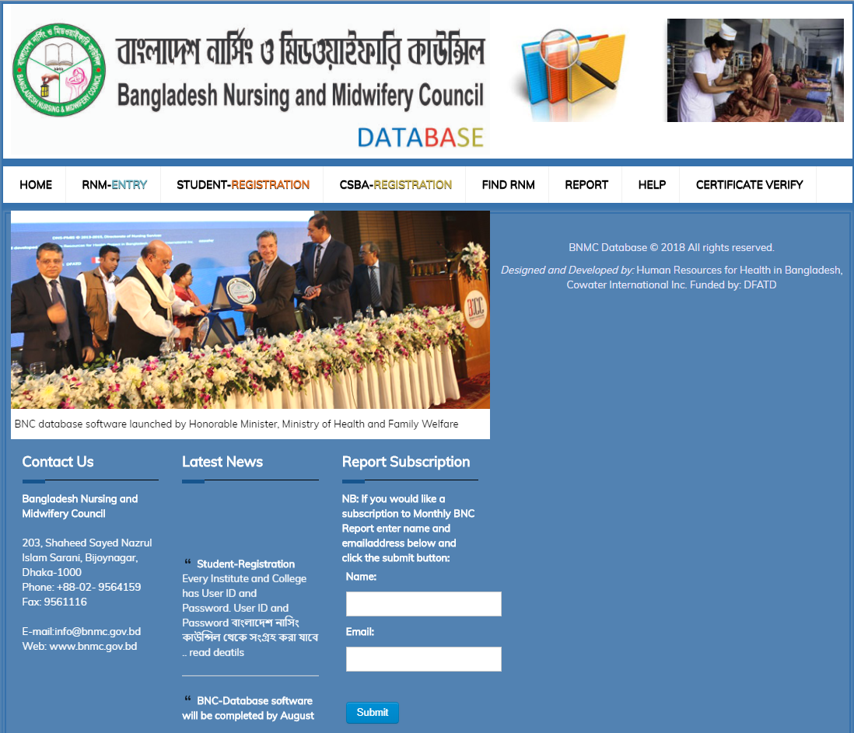
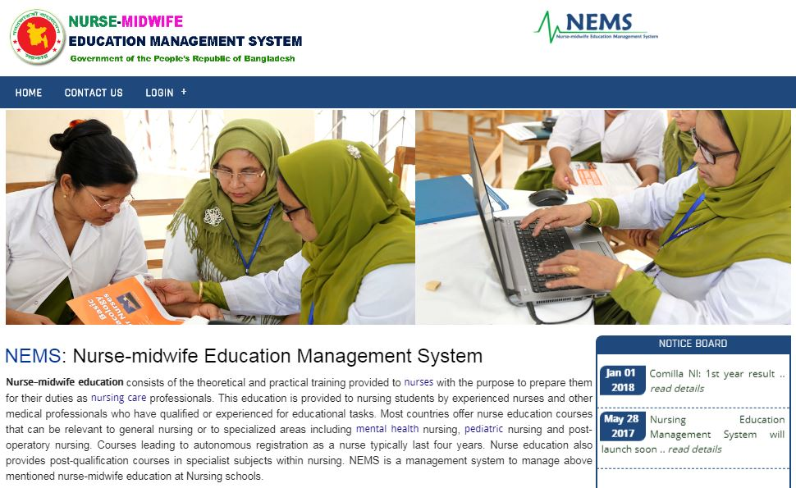
- Image:

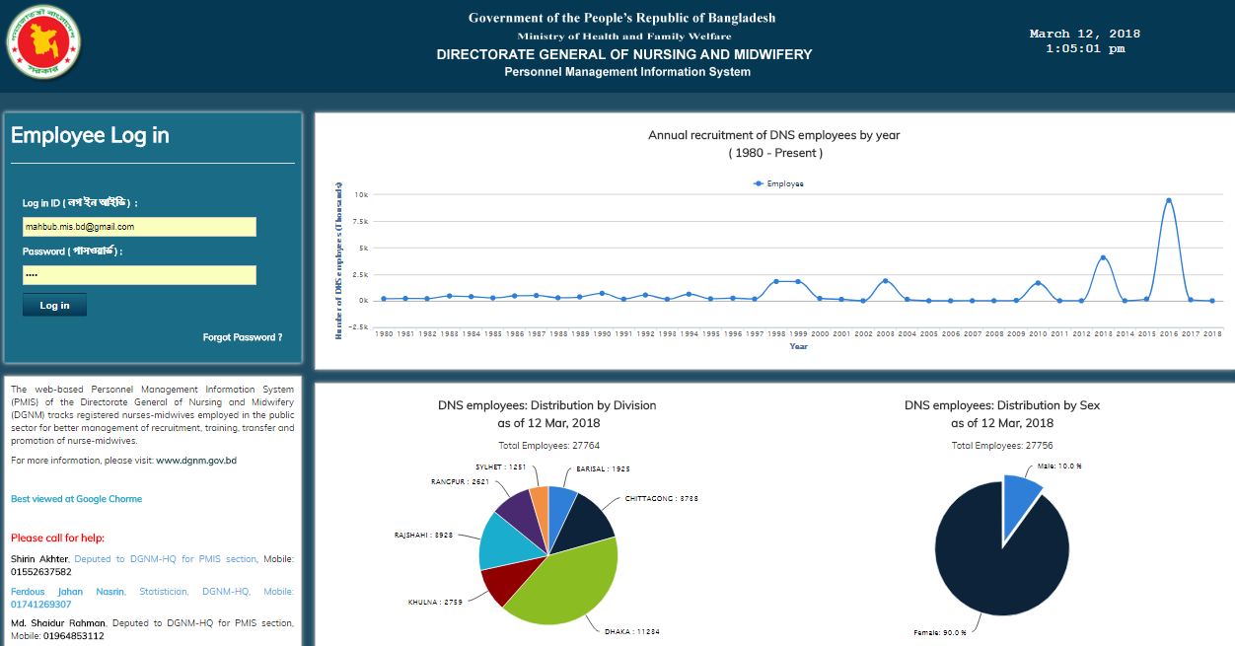

- Reference
- Website link: www.dgnm.gov.bd www.bnmc.gov.bd
- NEMS software link: www.nems.bnmc.gov.bd
- BNMC database link: www.bncdb.bnmc.gov.bd
- PMIS software link: www.pmis.dgnm.gov.bd

- Biography:
Dr. Monira Parveen, completed her Graduates from Dhaka Medical College under the University of Dhaka. She worked for different international organization at senior level position. She is Canadian. She is now working as a Canadian Field Manager at CowaterSogema Internal Inc. based in Dhaka, Bangladesh.
Md. Mahbubur Rahman, completed his MS from Dhaka University, He worked as a consultant for different international organization. Presently, he worked as an IT Specialist at CowaterSgema International Inc.
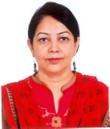
- Presenting author details
Dr. Monira Parveen
01711548550
Passport # : HK018129
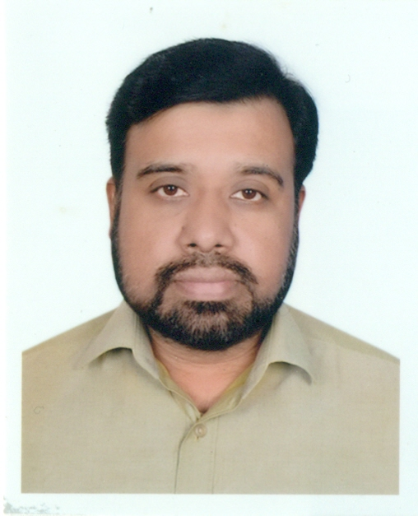
Md. Mahbubur Rahman
01716643689
Passport # : BT0075636

