Illness Perceptions and Hemoglobin A1c among Type 2 Diabetes patients
Li-Yun Lee, RN Ms, CMUB Hospital, Taiwan
Yu-Ju Yu, RN Ms, CMUB Hospital, Taiwan

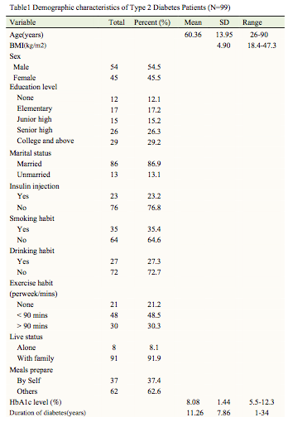
Abstract (300 word limit)
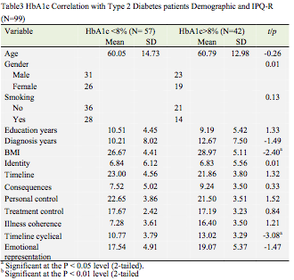
Aim: Diabetes is a chronic , potentially life-threatening illness which affects many aspects of an individual’s life. This study explored Illness Perception and Hemoglobin A1c in type 2 Diabetes patients. Methods: Research was conducted using a cross-sectional study. Patients (n=99) were recruited from the outpatient department of a metabolism clinic in a teaching hospital in southern Taiwan. Eligible subjects assessed using the Illness Perception Questionnaires (IPQ-R), Hemoglobin A1c (HbA1c) testing and background Information Form. Stepwise regression was applied to explore the predictors of Hemoglobin A1c percentage. The data analysis was conducted with descriptive statistics, t-test, chi-square and linear regression. All calculations were made using SPSS for Windows, version 20.0(Chicago, IL, USA).
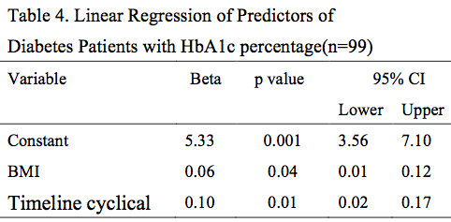
Results: Among the Ninety-nine type 2 Diabetes patients participated in this study. The results showed that patients had 54 male and 45 females, mean age was 60.36years, had 35 smokers and 64 non-smokers, meals prepare by Self was 37.4%, Exercise habit over 90 minitues per week was 30.3%, HbA1c percentage was 8.08%. The Body mass index and the illness perception - Timeline cyclical subscale scores were the most significance factors in HbA1c percentage.
Conclusions: Type 2 Diabetes patients experienced illness perceptions. Body mass index and Timeline cyclical affect HbA1c percentage. Illness perceptions changes can impact on glycaemic control.
Implications for Practice: Study findings can provide of illness perceptions in eastern population. Future research may further intervention to improve the illness perceptions and HbA1c percentage control of the disease.

Image

Recent Publications (minimum 5)
1. Clark, M. (2005). Healthcare professionals’ versus patients’ perspectives on diabetes. Journal of Diabetes Nursing, 9, 87–91.
2. Hart, P. L.,(2010). Illness representations, emotional distress, coping strategies, and coping efficacy as predictors of patient outcomes in type 2 diabetes. Nursing and Healthcare of Chronic Illness, 2, 225–240. Doi:10.1111/j. 1752-9824. 201-0.01062.x
3. Leysen,M., Nijs, J.,Meeus, M.,Wilgen, C. P., Struyf, F.,Vermandel, A.,...& Roussel, N. A.(2015). Clinimetric properties of illness perception questionnaire revised (IPQ-R) and brief illness perception questionnaire (Brief IPQ) in patients with musculoskeletal disorders: A systematic review, 20(1), 10–17. DOI: http://dx.doi.org/10.1016/j.math.2014.05.001
4. Patel,N. R., Chew-Graham, C., Bundy, C., Kennedy, A., Blickem, C. & Reeves, D.(2015). Illness beliefs and the sociocultural context of diabetes self- management in British South Asians: a mixed methods study. BMC Family Practice, 16, 58.DOI: 10.1186/s12875-015-0269-y
5. Sharry, M, J., Moss-Morris, R., Kendricj, T.(2011).Illness perceptions and glycaemic
control in diabetes: a systematic review with meta- analysis.28(11),1300-1310. doi:
10.1111/j.1464-5491.2011.03298.x.

Biography (150 word limit)
I am from Taiwan and have been working as a nurse in the hospital for nearly 20 years. In my opinion, I have chosen to continue my doctor's degree in diploma and improve my ability in clinical nursing research. Currently interested in clinical studies of chronic diseases and cancer.
Email: leeliyun0325@yahoo.com.tw

Notes/Comments:

