Title: Getting to the CORE of it, How people in crisis are receiving timelier Mental Health Intervention
Chris Watkins Dip PMHN, B.Sc.PN, MN MH
Clinical Nurse Consultant / Mental Health Police Co-Responder

The secondary response Co-Responder Unit (CoRe), is unique in Queensland, Australia, but is based on a model that has been implemented internationally, due to it’s proven outcomes, not only for consumers and carers, but for health services.
CoRe was created to address a situation where police officers have become the newest front line mental health workers; despite the fact they are not clinicians. Police officers, by virtue of their 24 hour emergency service provision, are frequently called upon to be first responders to a mental health crisis (many studies indicate as high as 90% of mental health crisis incidents are dealt with by police). They do this with little training or support in mental health.
The CoRe model puts clinicians squarely out in the community connecting with consumers, other service providers, and Emergency Services on a level not previously experienced. Clinicians are more accessible, providing timely assessment and referral in a least restrictive environment.
CoRe allows clinicians to provide improved care in the form of early intervention and rapid assessment in a mental health crisis situation, in an effort to avoid escalation and minimise harm, identifying targeted supports, and reducing presentations to Emergency Departments.
CoRe has created an innovative partnership that provides enhanced access to information and expertise on mental health, (for consumers and for emergency services personnel), with a strong collaboration between Queensland Health and Queensland Police Service, a redesign of services to ensure right care, right time and right place, that has led to proven superior outcomes for consumers
The Co-Responder team is made up of a designated Queensland Police Officer and a specialised Mental Health Clinical Nurse Consultant who travel together in an unmarked police car. It is a “secondary response” vehicle, attending “000” incidents in the community at the request of a “first response” police unit.

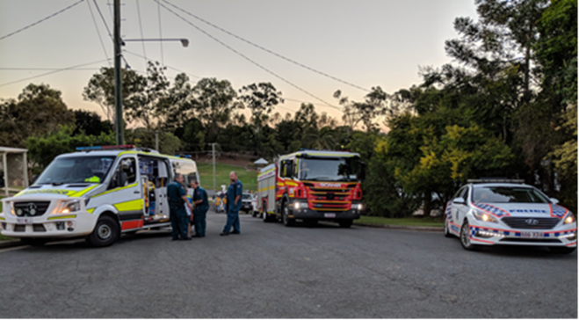

Data has supported stated aims
Program has been made permanent & extended
Consumers are experiencing improved access to services and enhanced outcomes
Police are being released more quickly to general duties
Reduced demand on Emergency Department
Expanded police knowledge & changing attitudes
Greater collaboration between services
Essential component to the success of the project, is the expertise and skill of the nurses and police involved.

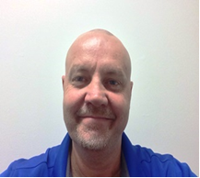
Chris is a 30 year veteran of Psychiatric Nursing having worked both in Australia and Canada and brings a global perspective to Psychiatric Nursing. He has a degree in Psychiatric Nursing from Douglas College, British Columbia, Canada and completed his Masters of Mental Health through Monash University, Australia. Chris also teaches in the Nursing program at the University of Southern Queensland., Ipswich Campus. He is currently a Clinical Nurse Consultant working with Queensland Health and the Queensland Police Service in a joint frontline role delivering crisis assessments in the community. He is passionate about helping and providing timely care to vulnerable people and takes great pride in being a role model and ambassadoor for the delivery of timely and compassionate mental health care.
Email:Christopher.Watkins@health.qld.gov.au

