Strengthening Health Care by the Pedagogical Concepts of Mahatma Gandhi and Paulo Freire – Basic Education and Conscientizacao
Mann B, PhD, MPH, MSc, Germany

Abstract
Statement of the Problem: The lack of education means exploitation of children, child labor, population explosion, unsanitary conditions and lower standards of living (Asha; McGuire). The WHO defines health as complex and more as the absence of illness. How is it possible to build up spiritual, personal, social and oecological care? Methodology & Theoretical Orientation: An inter subjective ethnographic study in India using hermeneutic dialogue was utilized during participant observation, in-depth interviews and focus groups. Offers the salutogenesis model of health the chance to integrate different views of the growing of health (Monica-Eriksson) by empathy, self-efficacy, learning resourcefulness, will to meaning, inner strength as well as by the basic education and conscientizacao? Findings: Mahatma Gandhi developed Basic Education in the context of satyagraha, a-himsa and sarvodaya. Llife-long, social and integral education are complex targets correlated with hygienic behaviour, ability to read and write, maintain the native language and doing craftwork. Paulo Freire elaborated the idea of Conscientizacao, understood as a critical consciousness. Concrete targets are the conflict ability, being historic, creative, dialogic and human-transitive. Basic Education and Conscientizacao should make it possible for people to support inner strength as well as to discuss the problems of their environment. Conclusion & Significance: “Bringing hope through education” (Asha) and strengthen empowerment (A. Sen) will improve the basics of health promotion (Ottawa –Charta 1986).

Recent publications
- Asha (1991) registered 501(c)3 non-profit organization based in the United States.
- Fawcett, J. (1996) Pflegemodelle im Überblick. Bern
- Freire, P. (1970) Pedagogy of the Oppressed. New York, Continuum.
- Freire, P. (1973) Education for critical consciousness. New York, Seabury Press.
- Gandhi, M. (1970) Basic Education – Ist Natur and Problems. Ahmedabad
- McGuire, J.W. (2010), Wealth, Health and Democracy, Cambridge
- Mann B (1995) The Pedagogical and Political Concepts of Mahatma Gandhi and Paulo Freire. ISPSWPE Vol. 8. Hamburg
- Mittelmark, M.B., Sagy, S., Eriksson, M., Bauer, G., Pelikan, J.M., Lindström, B., Espnes, G.A. (Eds.) The Handbook of Salutogenesis. 2017
- Sen A (2003) The importance of basic education. The Guardian. Tue 28 Oct

Image

Paulo Freire and Mahatma Gandhi
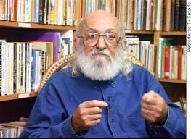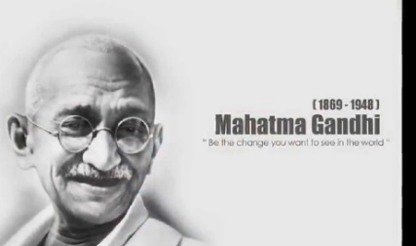

Biography
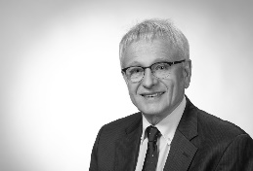
Bernhard Mann, PhD, MPH, MSc, is Professor of Health and Social management (em.) and has his expertise in evaluation the health and wellbeing. His research creates new pathways for improving the healthcare of the youth and the health management of the elderly and the handicaps. His experience in research, evaluation and teaching at several universities in Germany is focused in Health and Medical Sociology, Health and Social Management and in Public Health. His research was founded by the government of Germany. He was keynote speaker at the World Congress of Public Health in Osaka/Japan 2017.
Email: bmann@uni-.koblenz.de

