CONTEMPORARY TRACHEOSTOMY CLINICAL MANAGEMENT
LO, Chun Kit, RN, United Christian Hospital, Hong Kong

Abstract
Background:
Tracheostomy is regarded as a “high-risk, low-incidence” care. Mismanagement leading to airway occlusion could be fatal. In nursing, tracheostomy is usually introduced as airway management. More deeply knowledge like tracheostomy tube or its emergency management are not included. The handover communication and observation were found inadequate. The quality of tracheostomy care is aimed to be improved.

Methods:
Database searches were conducted from CINAHL, British Nursing Index and Medline. Publications dated 2008–2017 were applied. The keyword “Tracheostomy” was searched by title. ‘Adult’ and “nursing” were the related terms.
Results:
8 methods to improve the standard of tracheostomy care were identified: (a)Tracheotomy record, including information of indication and type of tracheostomy and the tracheostomy tube can improve the handover communication between shifts and during intra/inter-hospital transfer. (b)Observation chart based on the tracheotomy record to remind staffs in basic care and assessment of tracheotomy site can help detecting or avoiding emergency. (c)Regular standardized in-service tracheostomy training including emergency management to update staffs’ knowledge is necessary. Stimulation-lab training method is recommended in this issue. (d)A dual lumen tubes with subglottic suction tracheostomy tube should be used in patient to avoid tube blockage and ease the clinical decision in cuff deflation by measuring the amount of sputum. (e)Velcro ties tracheostomy holder showed lesser potential in skin abrasion than twill tape should be encouraged. (f)A multidisciplinary approach in tracheostomy care including swallowing, nutrition, mobilize secretion and communication should be coordinated formally. (g)Staffs should be equipped and identify alternative means to facilitate patient communication to relieve frustration from tracheostomized patient due to loss of verbal communication. (h)Weaning and decannulation protocol should be built up to facilitate the tracheostomy progression.

Conclusions:
Items (a),(b),(c),(e) & (g) are implementing in a respiratory ward(Figure 1) and showing great improvement in care. Evaluation will be finished in February 2018.

Image
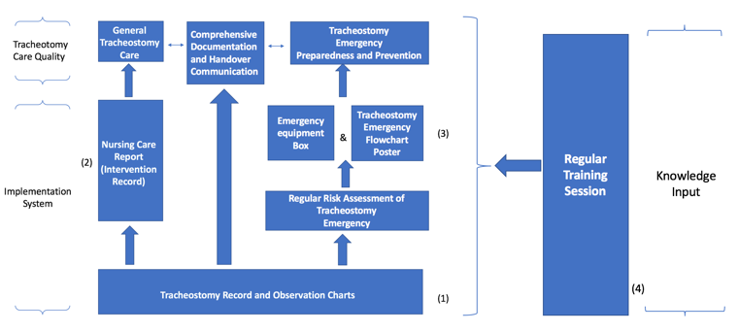
Reengineered Work Process (Figure1)
Recent Publications

- Choate, K., Barbetti, J., & Currey, J. (2009). Tracheostomy decannulation failure rate following critical illness: A prospective descriptive study. Australian Critical Care, 22(12), 8—15.
- Dennis-Rouse, M.D., & Davidson, J.E. (2008). An evidence-based evaluation of tracheostomy care practices. Critical Care Nursing Quarterly, 31(2),150-160.
- Freeman, S. (2011). Care of adult patients with a temporary tracheostomy. Nursing Standard, 26(2), 49-56.
- Hospital Authority (2016). Executive summary of the investigation report on the management of the tracheostomy of a patient (deceased) in Kowloon Hospital. Retrieved 4 March 2017,from www3.ha.org.hk/qeh/pdf/Executive%20Summary%20(Eng).pdf
- Paul, F. (2010). Tracheostomy care and management in general wards and community settings: literature review. Nursing in Critical Care, 15(2), 76-85.

 Biography
Lo Chun Kit will complete his master nursing study and then plan to start his doctoral program(Nursing) in 2018.He is from Hong Kong and a registered nurse in United Christian Hospital. He has completed a presentation at the 22nd Asian Pracific Society of Respiology(APSR) Congress 2017 in Sydney.
Email:tpck9072@hotmail.com

Notes/Comments:

