ASSESSMENT OF THE TIME ELAPSED BETWEEN BONE SCAN AND CHEMOTHERAPY DOSEFOR BREAST CANCER

ABSTRACT

Bone scan is the accepted initial imaging modality for skeletal metastases. Some patients use chemotherapy in the initial stages before and after surgery for breast cancer patients according to the international protocol, this study aimed to evaluate the time elapsed between bone scan and chemotherapy dose. It is a retrospective study designed and conducted in the Nuclear Medicine Department, Radiation and Isotopes Center of Khartoum. (RICK) which included 50male and female cancer patients with age ranged between 25-90 years, weighing 40-90kg were used in the study. All patients were diagnosed as breast cancer according to the histopathology report and were received all chemotherapy treatment. The results of this study revealed that the most common drugs used for adjuvant and nanadjuvant chemotherapy and there are a direct linear relationship between the acquired counts and the elapse time after chemotherapy , the coefficient of this relationship indicates that the count will be increased by 0.018 mega counts per day starting from 0.81 mega counts.ther is a direct positive relationship between the patient weight (kg) and the administered dose (mci) ,when the weight of the patient increase must be increasing the doses. This study concluded thatthe suitable time of bone scan post chemotherapy is one month and chemotherapy would lead to more influence on the bone scan.

INTRODUCTION

Bone scintigraphy is one of the most frequently performed of all radionuclide procedures. Radionuclide bone imaging is quick, relatively inexpensive, widely available, and exquisitely sensitive and is invaluable in the diagnostic evaluation of numerous pathologic conditions. The procedure is performed with technetium-99m–labeled bisphosphonates. These compounds accumulate rapidly in bone, and by 2–6 hours after injection, about 50% of the injected dose is in the skeletal system. The uptake mechanisms of bisphosphonates have not been completely elucidated. Presumably they are adsorbed to the mineral phase of bone, with relatively little binding to the organic phase. The degree of radiotracer uptake depends primarily on two factors: blood flow and, perhaps more importantly, the rate of new bone formation (Genantet al., 1974; Galasko, 1975).

Important point to consider before diagnosing a flare reaction on bone scan is the period that has elapsed between the pretreatment scan and the beginning of therapy. If there is substantial delay, even as short as 3-6 weeks, between the first scan and onset of treatment, interval progression of metastases could go unrecognized. For correct interpretation of serial scans, the pretreatment scan should be obtained as close to the onset of therapy as possible. The overall accuracy of the radionuclide bone scan for monitoring bony metastases from carcinoma of the prostate is excellent. In our review of scans obtained 3 months after initiation of treatment, this early scan provided misleading information in 6% of studies, showing apparent deterioration in the face of clinical improvement. It is emphasized, however, that this phenomenon is exceptional. (Pollen et al., 1981) second study related it is concluded of the radionuclide bone scans 1 month after the initiation of treatment for advanced cancer of the prostate occasionally shows apparent details of bone to determine the incidence and clinical significance, serial bone scans were reviewed in 33 patients with carcinoma of the prostate and bony metastases, who were receiving chemotherapy treatment for the first time. was seen clearance (60%) of 33 bone scans obtained 1months after initiation of treatment (Pollen et al., 1981).

MATERIALS AND METHODS

Study design

This study is a retrospective study designed and conducted in the Nuclear Medicine Department, Radiation and Isotopes Center of Khartoum. (RICK) which included 50male and female cancer patients with age ranged between 25-90 years, weighing 40-90kg were used in the study. All patients were diagnosed as breast cancer according to the histopathology report and were received all chemotherapy treatment according to the international chemotherapy protocol, and data collection excluding any patient have problem or pathology neither bone metastases such as problem in Ca, k, contents and all bone pathology The collected data used the following variable age, count, weight, which ….. etc expected to score the objectives after analysis was analyzed by Excel software as shown on the master table blow.

Table 1. Shows data collection

Patient no | Dose administration mci | count | Time between bone scan and chemotherapy | gander | Wight

MATERIALS AND METHODS

Bone scintigraphy,was done using 740-850 mBq of freshly prepared Tc-99m HDP (Mallinckrodt Medical BV, Petten, the Netherlands) was drawn in a tuberculin syringe, and 0.9% normal saline was added to obtain 3 ml of total volume. The radiopharmaceutical was injected through a vein, and the patient were hydrated with 500 ml of Water for an hour following injection of the radiopharmaceutical. The full and empty syringe counts were obtained to calculate the net dose given. The imaging was performed 2–4 h after injection of HDP. The time delay between radiopharmaceutical injection and imaging was noted for every patient during pre- and post-therapy bone scintigraphies. We used nucline spirit (DHV)variable angle dual head SPECT and whole body gamma camera. The serial number: DH -503066-VO is according to the applicable requirements of the directive 93\42 EEC Medical Devices Directive (MDD), Manufacturer: Mediso Ltd. And single head SPECT gamma camera with a field of view of 40cm suited for all studies of the nuclear medicine from MIE (medical image electronic) produce gamma camera systems since 1981). Chemotherapy was given as a single high dose infusion according to one of the cycle (McAfee JG al Reba RC et Majd M, 1995). The final calculated dose in patient equivalent to the dose of humans was 16 mg/kg. The formula 0.15 kg - 0.025/sqm) was used for the conversion ((McAfee JG al Reba RC et Majd M,1995). The patients were hydrated with 500 ml of water for an hour to decrease renal toxicity because kidney damage may be the dose limiting factor for chemotherapy (Fonseca et al., 1992). The bone scintigraphies were obtained 2-3 h, termination of chemotherapy as described earlier.

RESULT AND DISCUSSION

The trend of the graph in Figure 1 showed that where are a direct linear relationship between the acquired counts and the elapse time after chemotherapy. The coefficient of this relationship indicates that the count will be increased by 0.018 mega counts per day starting from 0.81 mega counts.Therefore the count reaches the appropriate level after one month which is equal to 1.5 mega counts from the observation. These results were agreed with (Pollen et al., 1981) and from the observation of the researcher the counts rate reach the acceptable level after 28 days as shown in Figure 1.

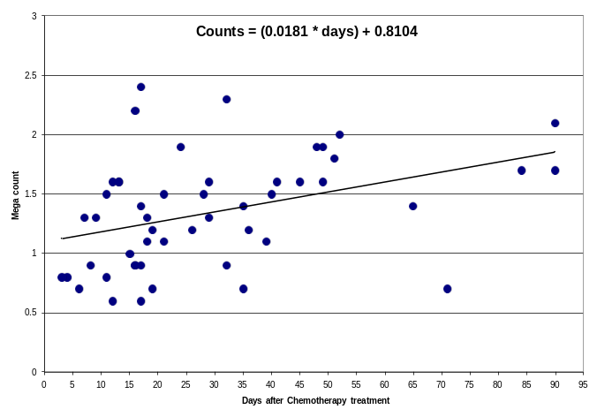

Figure 1. Plot scattered diagram shows the relationship between the time of chemotherapy (y axis) (days) and the counts (M counts) in (x axis)

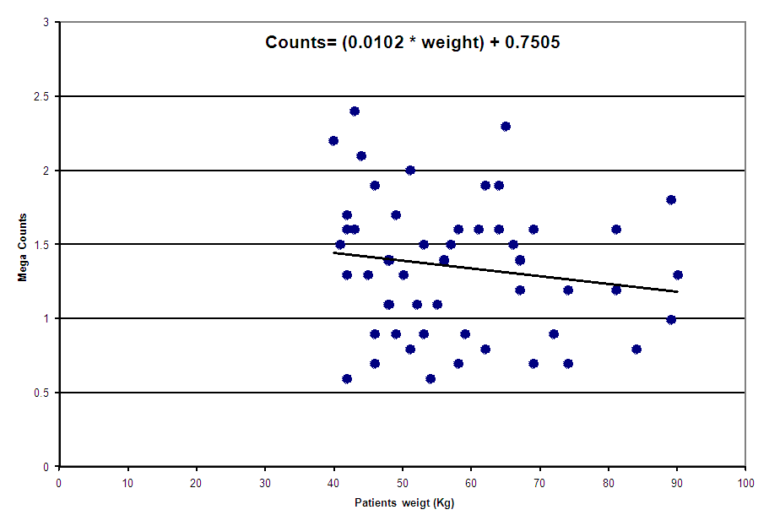

Figure 2. Plot diagrams shows the relationship between the weight of the patients (Kg) and the counts detected (M counts)

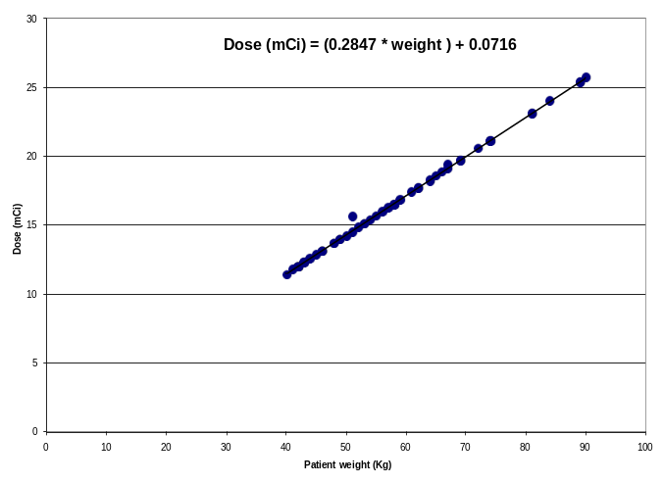

Figure 3. Plot scatter diagrams shows the relationship between the dose (mCi) in (y axis) and the weight of the patients (Kg)

Table 2. Frequencies statistic of patient data

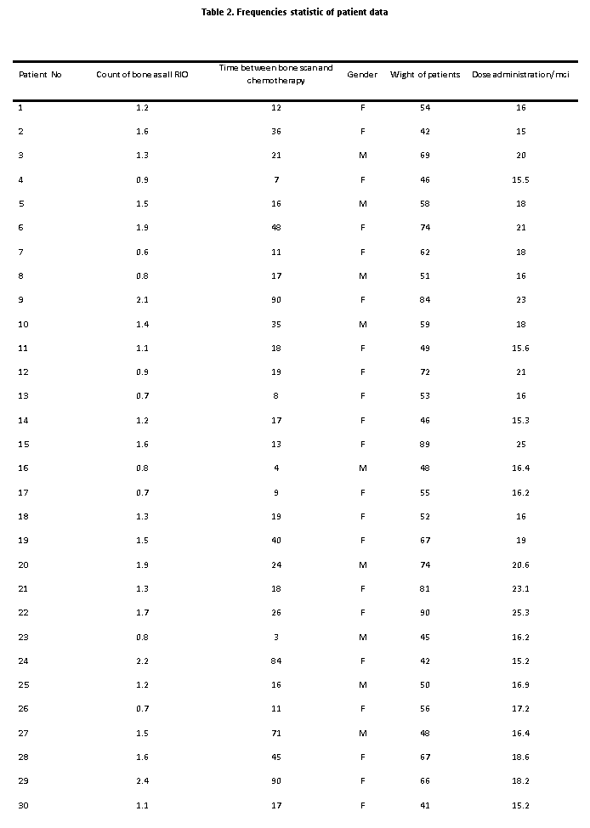

Table 3. Frequencies statistic of patient data

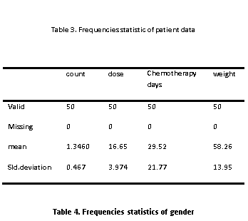

Table 4. Frequencies statistics of gender

 | Frequency | Percent | Valid percent | Cumulative percent
Valid male | 5 | 10.0 | 10.0 | 10.0
Female | 45 | 90.0 | 90.0 | 90.0
Total | 50 | 100 | 100 | 100

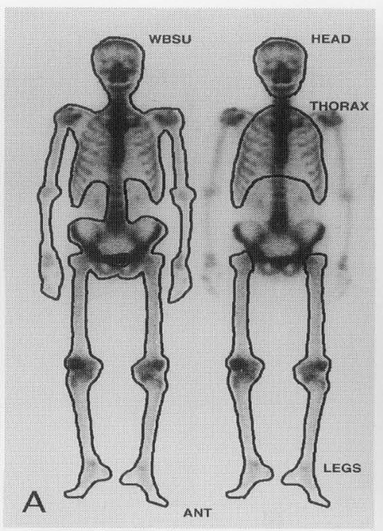

Figure 4. Explain the bone count by RIO

The trend of the graph in Figure 2 shows that when the weight of the patient increase must be increasing the doses, that to get the optimum counts for detecting to show the bone scan clearly, because if the dose is low and the weight of the patients is high result in increasing scattered counts which is not detected. The study also showed that ther is a direct positive relationship between the potent weight (kg) and the administered dose (mci). The trend of the graph indicate that the administered dose increased as a result of the weight increment, whose the coefficient shows that the dose increased by 0.285 mic\kg starting from 0.072mci for zero weight ,this result agreed with the equation that used to the calculated dose fore patient (weight of patient *normal dose/normal weight). The trend of the graph in Figure 3 shows the confirmative result with the calculated equation used in department is that the counts which detected must be increase in patients with high weight due to avoid the scattered counts to get the best counts for clear bone scan and that as the researcher mentioned in Figure 2 require to increase the dose in patient of overweight

*******

Conclusion

The suitable time of bone scan post chemotherapy is one months. The Results of research show that chemotherapy would lead to more influence on the bone scan and this refers to the decrease in the level of absorption of bone material and each piece is attributed to those who.

- Biochemical effect within the cells
- Direct impact of the chemical in the formation of blood cells and circulatory system that lead to an imbalance in the rate of absorption of bone cell material pharmaceutical there are secondary causes such as loss of appetite for the patient and the presence of vomiting and diarrhea in some cases all of those reasons hinder the absorption of pharmaceutical material adequately staged to turn, lead to the emergence of bone scan required.

REFERENCES

Biodistribution of 99mTc-MDP. Invest Radiol 1983;18:470–8.
Chabner, B.A. 1990. Clinical strategies for cancer treatment: the role of drugs. In: Chabner BA, Collins JM (eds) Cancer chemotherapy. Principles and practice. Lippincott, Philadelphia, pp 1–15
Fonseca, E., Grau, J.J., Sastre, J., García-Gómez, J.M., Rueda, A., Pastor, M., et al. 1992. Induction chemotherapy with cisplatin/ docetaxel versus cisplatin/5-fl uorouracil for locally advanced squamous cell effect of therapy on the bone and calcium metabolism. Nippon Naibunpi Gakkai Zasshi, 68:1294–9.
Galasko, C.S.B. 1975. The pathological basis for skeletal scintigraphy. J Bone Joint Surg Br., 57:353-359. Medline
Genant, H.K., Bautovich, G.J., Singh, M., Lathrop, K.A., Harper, P.V. 1974. Bone-seeking radionuclides: an in vivo study of factors affecting skeletal uptake. Radiology, 113:373-382. Link
McAfee, J.G., Reba, R.C., Majd, M. 1995. The musculoskeletal system. In: Wagner HN, Jr, Szabo Z, Buchanan JW, eds. Principles of nuclear medicine. 2nd ed. Philadelphia, Pa: Saunders, 986-1012.
Pollen, J.J., Gerber, K., Ashburn, W.L., Schmidt, J.O. 1981. Nuclear boneimaging in metastatic cancer of the prostate. Cancer, 47:2585-2594)
Suliburk, J.W., Helmer, K.S., Gonzalez, E.A., Robinson, E.K., Mercer, D.W. 2005. Ketamine attenuates liver injury attributed to endotoxemia: role of cyclooxygenase-2. Surgery, 138:

