Zr alloy protection against high-temperature oxidation: double-layered coating with active and passive functional properties
Irena Kratochvílová*¹, Petr Ashcheulov¹, Radek Škoda², Jaromír Kopeček¹, Jan Macák³, Adéla Nováková⁴, Johannes Neethling⁵, Peng Xu⁶, Jan Lorinčík⁷ and Martin Steinbrück⁸.

¹Institute of Physics of the Czech Academy of Sciences, Na Slovance 2, CZ-182 21, Prague 8, Czech Republic
²Czech Technical University in Prague, Czech Institute of Informatics, Robotics and Cybernetics, Jugoslávských partyzánů 1580/3, Prague 6, CZ-160 00, Czech Republic
³University of Chemistry and Technology, Power Engineering Department, Technická 3, Prague 6, CZ-166 28, Czech Republic
⁴Faculty of Nuclear Physics and Physical Engineering, Czech Technical University in Prague, Zikova 1, 160 00 Prague 6, Czech Republic
⁵Centre for HRTEM, Department of Physics, Nelson Mandela University, Port Elizabeth, South Africa
⁶Nuclear Fuel Division, Westinghouse Electric Company, 5801 Bluff Road, Hopkins, SC 29209, USA
⁷Research Centre Řež, Hlavní 130, CZ-250 68 Husinec-Řež, Czech Republic
⁸Institute for Applied Materials (IAM), Karlsruhe Institute of Technology, Hermann-von-Helmholtz-Platz 1, 76344 Eggenstein-Leopoldshafen, Germany

Keywords: polycrystalline diamond, Zr alloy protection against corrosion, CrAlSin coating
- Abstract:

In this work we investigated the hot steam oxidation of ZIRLO fuel cladding coated with a double layer consisting of 500 nm nanocrystalline diamond (NCD) as the bottom layer and 2 μm chromium-aluminum-silicon nitride (CrAlSiN) as the upper layer. Coated and noncoated ZIRLO samples were exposed for 4 days at 400 °C in an autoclave (working water-cooled nuclear reactor temperature) and for 60 minutes at 1000 °C (nuclear reactor accident temperature) in a hot steam furnace. We have shown that the NCD coating protects the Zr alloy surface against oxidation in an active way: carbon from NCD layer enters the Zr alloy surface and, by changing the physical and chemical properties of the Zr cladding tube surface, limits the Zr oxidation process. In contrast, the passive CrAlSiN coating prevents the Zr cladding tube surface from coming into physical contact with the hot steam. The advantages of the double layer were demonstrated, particularly in terms of hot (accident-temperature) oxidation kinetics: in the initial stage, CrAlSiN acts as an impermeable barrier, but after a longer time, the protection by CrAlSiN decreases as an increasing number of cracks in the carbon of NCD penetrate the Zr cladding surface and worsen conditions for Zr oxidation. For the double-layer coating, the underlying NCD layer mitigates thermal expansion, reducing cracks and defects in upper layer CrAlSiN.
- Image:

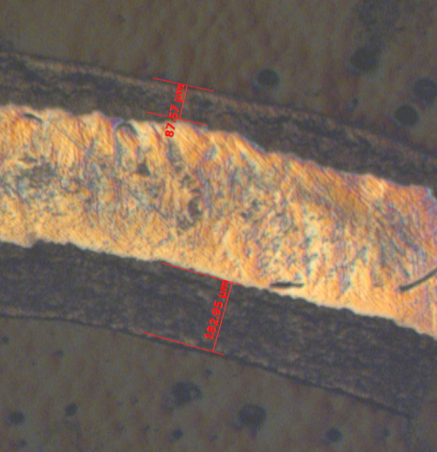
- Reference:

1. Skarohlid, J. et al. Nanocrystalline diamond protects Zr cladding surface against oxygen and hydrogen uptake: Nuclear fuel durability enhancement. Scientific Reports 7, 14, doi:10.1038/s41598-017-06923-4 (2017).
2. Ashcheulov, P. et al. Thin polycrystalline diamond films protecting zirconium alloys surfaces: From technology to layer analysis and application in nuclear facilities. Applied Surface Science 359, 621-628, doi:10.1016/j.apsusc.2015.10.117 (2015).

Biography:
As.prof. Irena Kratochvilova obtained very important results which were published in prestigious journals and were cited by scientific community. She has published 85 papers in impacted journals. She has been working in the Institute of Physics AS CR and teaching at the Faculty of Nuclear Engineering Czech Technical University.

Presenting author details

Full Name: Irena Kratochvilova
Session name/ number:
Category: Oral presentation

