Abstract Template

Title: Thermal Hydraulic Analysis of Supercritical Water Reactor Cooled By Al₂O₃ Nanofluid

Adel Alyanª, Ahmed El Kholy^{b}, Khairy Fakhry^{c}, Osayed Abu-Elyazeed^{d}

a | Nuclear Research Center-Atomic energy Authority, Cairo – Egypt.
b | Senior Piping Engineer-PDMS Designer.
c | Mechanical Power Engineering Department Faculty of Engineering, Mataria, Helwan University.
d | Mechanical Power Engineering Department Faculty of Engineering, Mataria, Helwan University.

Keywords: Supercritical Nanofluids , Nuclear reactors, Thermal–hydraulic analysis

- Abstract Body (up to 300 words)
The aim of this study was to perform a thermal–hydraulic analysis of SCWR cooled by nanofluids at various volume fractions (2%, 6% and 10%) of Al₂O₃${Al}_{2}O_{3}$ nanofluid. The temperature distribution of fuel, cladding surface and coolant in axial direction are investigated. The achieved results show that density, viscosity, thermal conductivity of the coolant increases with the increase of Nano particles volume fraction. Contrasting to specific heat, which decreases with the increase in nano particles volume fraction. For 10% volume percentage of nanoparticles the coolant temperature difference with pure water is about 24.2 °C $24.2℃$, 62.5 °C and 94°C $94℃$ at constant pressure 25, 30, and 35 (MPa) respectivly. Using nanofluids with 10% volume percentage of nanoparticles as coolant has significant effect on fuel temperature that the maximum fuel temperature reduced by 26.5%, 25% and 21% at constant pressure 25, 30, and 35 (MPa) respectivly.

Image:

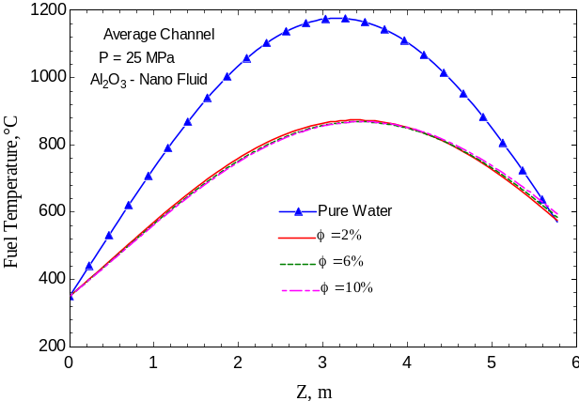
- Reference:

[1] Gupta H.K, Agrawal G.D, Mathur J., An overview of Nanofluids: A new media towards green environment, International Journal of Environmental Sciences 3 (2012) 433-440.

[2] Yang Y, Zhang Z G, Grulke E A, Anderson W B & Wu G., Heat transfer Properties of nanoparticle-in-fluid dispersions (nanofluids) in laminar flow, International Journal of Heat and Mass Transfer, 48(6) (2005) 1107–1116.

[3] Vasu VELAGAPUDI, Rama Krishna KONIJETI, and Chandra Sekhara Kumar ADURU.,
Empirical Correlations to Predict Thermophysical and Heat Transfer Characteristics of Nanofluids Thermal Science 12 (2008) 27-37.

[4] A. Suriyawong, A. S. Dalkilic, and S. Wongwises., Nucleate Pool Boiling Heat Transfer Correlation for TiO₂-Water Nanofluids Journal of ASTM International 9 (2012) 1-12.

[5] Wang, X., Xu, X., and Choi, S. U. S.,Thermal Conductivity of Nanoparticles-Fluid Mixture
J. Thermophys. Heat Transfer 13 ( 4) (1999) 474–480.

[6] Farag Muftah Bsebsu and Gabor Bede., A simple computer programmed for the calculations of reactor channel temperature distribution. PERIODICA POLYTECHNICA SER. ME CH. ENG. 2 (1997) 133-142.

[7] Samuel J Harvel, G and Pioro, I., Heat loss Analysis of a Re-Entrant Fuel Channel for SCWR Type Reactors Canda 5 ^{th} International Symposium on Supercritical Water-Cooled Reactors (ISSCWR-5) (2011) Mar 13-16.

[8] Y Oka and S Koshizuka., Supercritical-pressure, Once-through Cycle Light Water Cooled Reactor Concept Journal of Nuclear Science and Technology 38 (12) (2001) 1081-1089.

[9] Igor L. Pioro, Hussam F. Khartabil, Romney B. Duffey., Heat transfer to supercritical fluids flowing in channels—empirical correlations (survey), Nuclear Engineering and Design 230 (2004) 69–91.

[10] Grande, L., Peiman, W., Villamere, B., Rodriguez-Prado, A., Mikhael, S., Allison, L., et al. (2010c). Thermal aspects of alternative fuels for use in supercritical water-cooled nuclear reactors. Proc. of 11th International Conference on CANDU fuel (p. 15). Niagra Falls, Ontario: CNS.

[11] Ehsan Zarifi, Gholamreza Jahanfarnia, Farzad Veysi , Thermal–hydraulic modeling of nanofluids as the coolant in VVER-1000 reactor core by the porous media approach , Annals of Nuclear Energy 51 (2013) 203–212.

Biography:

Dr. Adel Alyan has completed his Ph.D from Cairo University. He is head of heat transfer lab. At Nuclear Research Center, Atomic Energy Authority, Cairo, Egypt. He has published more than 15 papers, the most of it devoted on nuclear reactors.

Presenting author details

Full Name: Adel Alyan Fahmy
number:
account:
Session name/ number:
Category: (Oral presentation/ Poster presentation) Passport Number: A21362606



