Lessons learned during the partial decommissioning process of Research Reactor in Sofia, Bulgaria
Aleksandar D Mladenov, MASc, INRNE-BAS, BG

Abstract (300 word limit)
The present work aims to give a clear idea of the progress lessons learned during partial decommissioning of the IRT-2000 research reactor, which is located of the capital of Bulgaria, Sofia town. The IRT-2000 Research Reactor was designed and built in compliance with the widely adopted norms and standards in force in the fifties in the former USSR, and was put in operation in 1961. The Bulgarian Nuclear Safety Authority and Institute for Nuclear Research and Nuclear Energy (INRNE) proposed a program containing alternatives for the future development of the IRT-2000 Research Reactor. Upon detailed consideration of this document by a number of authorities, the Council of Ministers issued Resolution No. 332/17.05.1999 on starting a large-scale program. As a result, subsequent Resolution No. 552/06.07.2001 was passed enacting the reconstruction the IRT-2000 Research Reactor into a low power reactor up to 200 kW.
Described is a cycle of activities beginning with the preparation of the necessary decommissioning documents (Safety Analysis report for dismantling activities, Environmental Impact Assessment Report, Detailed Plan included Radioactive Waste Management and personnel doses etc.), classification of areas, comparison for preliminary estimation and obtained doses, description of expected radionuclides and comparison between gained and planned radioactive waste. All activities that precede the decommissioning process include selecting a container for transporting of spent nuclear fuel, site preparation, bridge crane replacement, radiation system replacement, preliminary analyzes and calculations. A series of photos shows the initial state of the research reactor and its current state now. Now the nuclear research reactor is in extended shutdown position.

Image
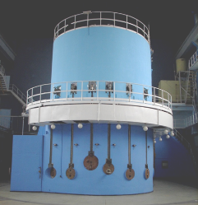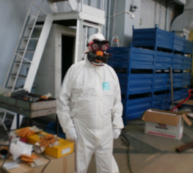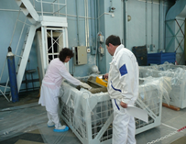
Recent Publications (minimum 5)
- Aleksandar Mladenov, Kiiril Krezhov, Radon concentration measurements at the IRT-Sofia research reactor site, Radiation & Applications 3/1 (2018) 52-58, https://doi.org/10.21175/RadJ.2018.01.010.
- Kiiril Krezhov, Aleksandar Mladenov, Dobromir Dimitrov, Radon levels and equivalent dose rates at the IRT-Sofia research reactor site, Radiation Protection Dosimetry 181/1 (2018) 42-47, https://doi.org/10.1093/rpd/ncy088.
- I.S. Dimitrov, Tz. Nonova, Al. Mladenov, K. Krezhov, Radiation levels at carrying out the refurbishment of the Bulgarian research reactor IRT 2000, Radiation & Applications 1/1 (2016) 62-68, https://doi.org/10.21175/RadJ.2016.01.12.
- Tzvetana NonovaDaniel StankovAleksandar MladenovKiiril Krezhov, Radiological characterization activities during the partial dismantling of the IRT-Sofia research reactor facilities, Romanian Journal of Physics 59/9-10 (2014) 976-988, http://www.nipne.ro/rjp/2014_59_9-10/0976_0988.pdf
- A. Mladenov, D. Stankov, K. Marinov, Tz.Nonova, K. Krezhov (2012) Radiation monitoring program at nuclear scientific experimental and educational center - IRT-Sofia. Proc. of European Medical Physics and Engineering Conference, October 18‐20, 2012, Sofia, Bulgaria, https://inis.iaea.org/collection/NCLCollectionStore/_Public/43/130/43130525.pdf?r=1&r=1

Biography (150 word limit)
Aleksandar Mladenov has his expertise in radiation protection, environmental and technological radiation control of nuclear reactors, management of radioactive waste, evaluation of radioactive discharges from nuclear facilities and estimation of doses for personnel and the population. As a Head of Radiation Protection Department of the Institute for Nuclear Research and Nuclear Energy of Bulgarian Academy of Sciences, his work is related also to the training of students and workers in the field of nuclear industry.
Email: mladenova@inrne.bas.bg

Notes/Comments:

