Addressing electrical power supply continuity by enhance the reliability of auxiliary power system to reactor coolant pumps after grid collapse due to natural disaster or man-made threats
Md. Shamsul Huda Sohel, MS in Nuclear Engineering, University of Dhaka

Abstract: Today’s nuclear power generation is the right example for peaceful use of nuclear energy. Generates electricity through nuclear energy become similar as fossil fuel plant except it’s heat producing method. Reactor core is that device to produce heat through controlled nuclear chain reaction and transfer them by coolant pumps. Since decay heat is sufficient to meltdown reactor core, we must be ensure to serviceable the coolant pumps continuously for overlong period after the chain reaction stopped. So, at this article just focus on long-term uninterrupted power supply to the Reactor Coolant Pumps if, all the incoming and outgoing grid towers are collapse due to natural disaster or intentionally through terrorism threats. Lack of grid supply for long period might be concerning with nuclear safety- security issue, because of towers re-construction is lengthy process and sooth to say mobile generators, UPS, battery back-up are not sufficient for yearly continuous power supply without interruption. To overcome this situation, established a diesel based peak load plant nearby or very closely with NPP and has a double capacity of coolant pumps. This diesel engines are one-tenth in total capacity and assembled them parallel. It’s because, if trouble occurs at individual unit, rest of the engines are capable to maintain the supply continuity and, whole plant not shut down. Hence, additional peak load diesel plant obviously enhance the safety of electrical auxiliary power supply system and at any nuclear power plant, it’s safety is the highest priority.

Image:
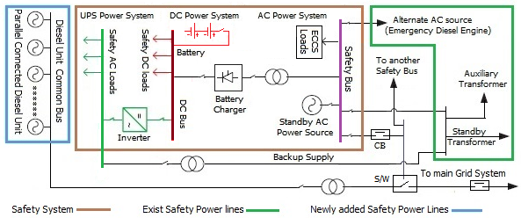
Figure^{[1]}: Emergency Power supply system of Nuclear Power Plant (Single Portion of Safety Bus)

References:
1. Design of Electrical Power Systems for Nuclear Power Plants, Specific Safety Guide, No. SSG-34, IAEA, March 2016 STI/PUB/1673
2. Andrew C. Kadak, Ph.D., A Comparison Of Advanced Nuclear Technologies, March 2017
3. The VVER Today - Evolution | Design | Safety, (available at
http://www.rosatom.ru/upload/iblock/0be/0be1220af25741375138ecd1afb18743.pdf)
4. Chapter 1, Electrical Systems Prepared by Dr. Jin Jiang, Department of Electrical & Computer Engineering, Western University
5. The Fukushima Daiichi Accident Technical Volume 3, Vienna, IAEA, 2015- STI/PUB/1710 ISBN 978–92–0–107015–9 (set)
6. The Daily Star newspaper, 02 May 2017, Grid Failure: Power outage hits half the country

Biography:
Hello, Myself Md Shamsul Huda Sohel and have to Completed my graduation in Electrical and Electronics Engineering and post-graduation in Nuclear Engineering. Presently, I works as an Assistant Engineer at Ashuganj Power Station Company limited (APSCL), which is government own largest power station in Bangladesh Under Bangladesh Power Development Board (BPDB). My carrier goal becomes to develop myself on nuclear safety and security sites. Recently, I achieved two success. My two safety & security based paper published in year 2017, one is new idea based focus on safety & security type at International Journal of Nuclear Security (IJNS) and another is safety of RPV crack analysis at Bangladesh Academy of Sciences.

Email: shamsulhuda.24@gmail.com

