SMR Neutronics and Thermal-Hydraulics Safety-Related Investigation
Yousef Alzaben, KIT, Germany
Victor Hugo Sanchez-Espinoza, PhD, KIT, Germany
Robert Stieglitz, Professor, KIT, Germany

Abstract
Worldwide many countries are interested in developing light-water Small Modular Reactors (SMRs) due to its (1) attractive economics which enables standardization, modularization and factory fabrication, (2) taking advantage of the accumulated industrial experience in LWRs, and (3) enhanced safety features through the integral design. SMRs can offer solutions for countries that have locations far away from electrical grids or limited infrastructure. It can also provide solutions for an increased demand for water desalination and district heating.
At Karlsruhe Institute of Technology (KIT), safety-related investigation has started to study the Korean’s soluble-boron operated SMR core concept (SMART) and to modify the core design to operate without soluble-boron in the coolant. Therefore, the details of the fuel assembly design and core arrangement are different from SMART core design. The developed core design is called Karlsruhe Small Modular Reactor (KSMR). The KSMR-core is a boron-free core characterized by enhanced safety features as a result of (1) avoiding concerns related to boric acid induced corrosion of pressure vessels internals, and (2) eliminating the probability of boron dilution accidents. Many proven PWR technologies were adopted in the KSMR core in terms of fuel assembly design and material selection.
The KSMR core was designed to limit and establish sufficient margins to thermal-crisis, cold shutdown margin, and pin peaking factor through the proper design of burnable absorbers and control rods. Utilizing multi-physics coupled tools; KSMR core behavior fulfilled the imposed design and safety objectives. In this presentation, core characteristics from both neutronics and thermal-hydraulics will be demonstrated and discussed along with strength assessment of the KSMR core under control rod ejection accident.

Image

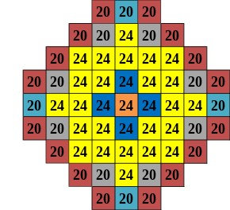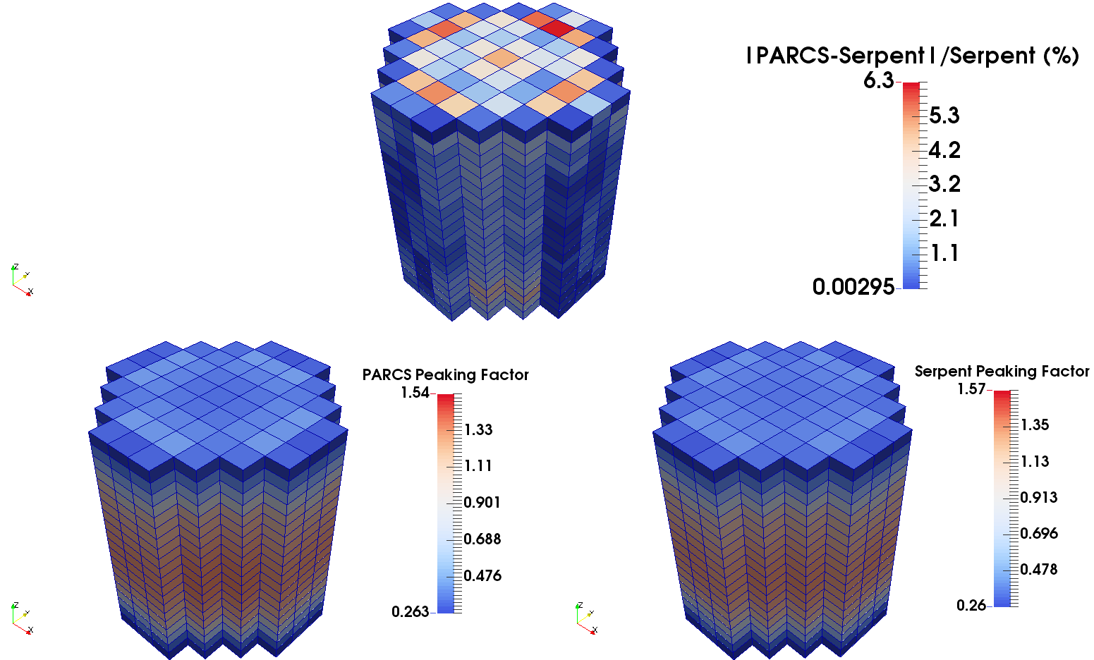

Fig. 1: KSMR Core Configuration Fig. 2: KSMR Power Peaking Factor

Recent Publications
- Y. Alzaben, V. Sanchez, R.Stieglitz, “Extending Serpent2/Subchanflow Coupling For Depletion Calculation - Current Status and Challenges”, In Proceeding of the PHYSOR 2018 conference, Cancun, Mexico, April 22-26, 2018.
- Y. Alzaben, C. Ziegahn, V. Sanchez, “Extension of Serpent2/Subchanflow Coupling For Hexagonal Fuel Assemblies”, In Proceeding of the PHYSOR 2018 conference, Cancun, Mexico, April 22-26, 2018.
- Y. Alzaben, V. Sanchez, R. Stieglitz; “Simulation of KSMR Core Zero Power Conditions Using The Monte Carlo Code Serpent”, 48th Annual Meeting on Nuclear Technology (AMNT 2017), Berlin, Germany, May 16-17, 2017
- Y. Alzaben, V. Sanchez, R. Stieglitz; “Neutronics Safety-related Investigations of a Generic SMART Core with State-of-the-Art Tools”, NUTHOS-11: The 11th International Topical Meeting on Nuclear Reactor Thermal Hydraulics, Operation and Safety; Gyeongju, Korea, October 9-13, 2016.
- Y. Alzaben, V. Sanchez, R. Stieglitz; “On the Use of Serpent for SMR Modelling and Cross Section Generation”, 6th International Serpent User Group Meeting in Milano, Italy. September 26-29, 2016

 Biography

Yousef Alzaben is a PhD student in his last year at Karlsruhe Institute of Technology (KIT). His PhD thesis is devoted to SMR investigation from both neutronics and thermal-hydraulics aspects. Mr. Alzaben prior of joining KIT, he worked as a core neutronics engineer for the design of the 1st Saudi-Arabian research reactor which was carried-out by INVAP company. In addition, he is holding a research associate position at King Abdulaziz City for Science and Technology (KACST).

Email: yousef.alzaben@kit.edu

Notes/Comments:

