Economic Prospects and Usefulness of Microbes in Bangladesh

Md. Amir Hossain
Assistant Professor, Department of English, IBAIS University, Bangladesh

Abstract

In this scientific research project, the researcher is of the view that the creature which is very tiny cannot be seen without the electron microscope is called Microbes. This study would like to focus upon the usefulness of Virus, Bacteria, Algae, and Fungi in the light of Bangladesh’s economy. Microbes are infectious diseases, and are very tiny in size; they cannot be seen through common microscope; so they are called ultra-microscopic. These microbes can bring about a bright future for the economic prosperity and potentiality. Virus is more harmful for human being. Due to the attack of virus, a man can become blind and get paralyzed, and even they can lead human being into premature death. On the contrary, the scientists have enabled to use virus in some positive ways. Small pox, polio, tuberculosis, cholera, typhoid, plague, dysentery, jandish, etc. are prevented with the beneficial virus. In this way man can be greatly benefitted. Bacteria have both harmful and useful aspects; Bacteria are very important for two sorts of qualities. They can help us prepare antibiotic medicine and preventive injection, increase the fertility of soil and crops, create nitrogen and make food for animal, pasteurize tea, coffee, and tobacco, prepare jute, leather industry, biogas testing salt, and chemical. Moreover, bacteria help human being digest, make vitamin, beautify environment, damage waste, and engineer genetic, etc. Again, Algae are well-centred, single or multi cell. There is no vascular tissue in their body; their sporangia have always a single cell. Algae are more useful than harmful. Algae help scientists create oxygen in the air, save environment from pollution, produce food chain and biofuel, determine human age, detective submarine and the location of fish in the ocean, etc. Also added that Fungi have no chlorophyll and vascular tissue; they are covered with nucleus, they spread gene through haploid. Most of fungi procure nutrition through absorption. However, the importance of fungi is unlimited. Though fungi are connected with our lives and activities, we are not conscious not only of their usefulness but also of their harmfulness. Like above microbes, fungi help us prepare food, medicine, hormone, and organic acid, preserve environment, utilize agriculture, investigate in potential research, produce cottages, prepare bread, cake, and wine, and also juice from date, grapes, and sugarcane, etc. Besides these, mushroom fungi play an important role for economic prospects in Bangladesh. They help human being make food, increase the nutrition of soil, make profit in the field of industry and business, prepare medicine, and earn foreign currency. Though Bangladesh is a very small country in the atlas, our scientists are able to utilize microbes in helpful ways for which the study would like to investigate. This research project assures that Virus, Bacteria, Algae, and Fungi can bring about a revolutionary change for the economic prosperity and potentiality in the 21st-century age. For this purpose, this study would like to examine Virus, Bacteria, Algae, and Fungi in the light of Economic Prospects and their usefulness in the Bangladesh Perspective.

Image

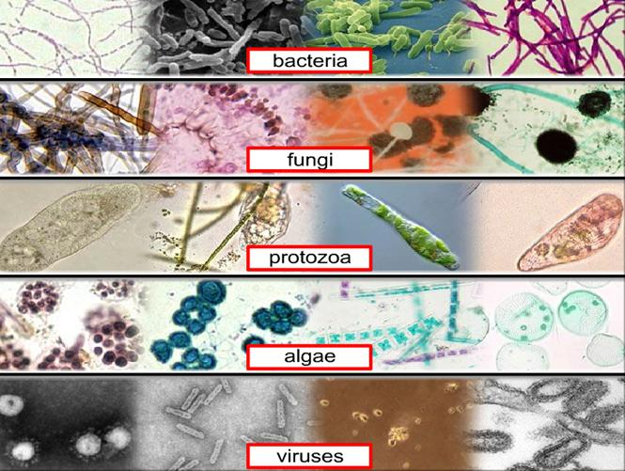
Recent Publications

- Hossain. M. Amir. (2017). “Research Integrity in Scholarly Writing: A Global Perspective.” International Journal on Studies in English Language and Literature (IJSELL), Vol. 5. No. 11, pp. 14-27.doi: http://dx.doi.org/ 10.20431/2347-3134.0511003.

- Hossain. M. Amir. (2017). “Motivation for the Young Teachers and Novice Researchers in Research Writing.” International Journal of Studies in Linguistics & Literature, USA

- Hossain, M. Amir. (2017). “Science and Technology in Rural and Urban Areas of 22st -Century Bangladesh,” Current Trends in Biomedical Engineering and Biosciences. ISSN: 2572-1151. Mini Review. Volume 6 Issue 5 - August 2017
DOI: 10.19080/CTBEB.2017.06.555697

- Hossain, M. Amir. (December 2015). “Impact of International Relations in Trade and Development from Bangladesh Perspective,” in Scholedge International Journal of Multidisciplinary & Allied Studies (ISSN 2394-336X), Vol.02, Issue 12 (2015) pp29-42., published by: Scholedge R&D Center [www.theSCHOLEDGE.org. DOI: 10.19085/journal.sijmas021203

- Hossain, M. Amir. (December 2015). “Social Realistic Projections of Galsworthy’s Strife” in English Language and Literature Studies; Vol. 5, No. 4; ISSN 1925-4768 E-ISSN 1925-4776 Published by Canadian Center of Science and Education



Biography: Mr. Hossain did his BA (Hons) and MA in English Literature at The People’s University. He is an M. Phil Research Scholar in English at Jahangirnagar University. As an Assistant Professor, he is teaching English Literature and Language at IBAIS University. He also did serve as a Research Associate (Part-Time) at Uttara University, as a Lecturer of English at America Bangladesh University, BGIFT-Institute of Science & Technology (BIST) and so on. He authored a book on Ibsen Studies published by Lambert Academic Publishing, Germany. He has written 50 articles and published 40 articles in the International Scholarly Journals around the world. He is a reviewer and editorial board member of more than 70 International Scholarly Journals. He has presented 10 papers in the International Conferences in Bangladesh, UK, and India. He is a member of Modern Language Association of America, TESOL International Association, Ibsen Society of America, British Shakespeare Association, Asian Council of Science Editors, The American Society for Theatre Research, The European Shakespeare Research Association, Australian Association for Research in Education, The European Association of Science Editors, International Literary Association, Association for the Study of Literature and Environment, Modern Humanities Research Association, Association for Literary Urban Studies, Manchester Literary and Philosophical Society, Global Research & Development Services, International Society of Development and Sustainability, International Society of Managing and Technical Editors, The John Donne Society of America, Milton Society of America, The Doris Lessing Society, The George Herbert Society, The William Morris Society of America, Association for Theatre in Higher Education, The International Research Foundation for English Language Education, Hereditary Genetics, OMICS Publishing Group, American Indigenous Research Association, Architectural Humanities Research Association and so on. As a curious researcher, he tries to remain himself busy to carry out scholarly research projects on English Literature, Language, Linguistics, and Social Sciences.

Presenting Author Details
Full name: Md. Amir Hossain
E-mail: amir.hossain.16578@gmail.com
Contact umber: +8801915908306
Scientific Session name: Introducing New Research
Category: (Oral/Poster presentation): Oral
Facebook account: amir.ju09@yahoo.com

Dear Organizing Committee: If you bear Round Trip with Accommodation, and Registration Fee I have sent my abstract and there I will play my role as a Speaker. Due to my financial constraints, I have no ability to bear travel expenses. Round trip is the main factor for me to pay plan fare.
Please let me know if possible for you.
Best

Amir

