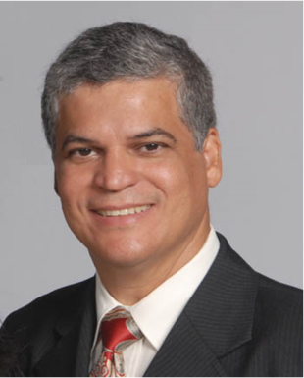

Title: Obtaining green diesel from thermocatalytic pyrolysis of sunflower oil using mesoporous catalyst
Antonio S. Araujo
Federal University of Rio Grande do Norte, Institute of Chemistry, 59078-970, Natal RN, Brazil

The search for new energy sources, due to the concern with the environment, has boosted research with this purpose. Thus, this research aimed at the synthesis and characterization of the mesoporous catalyst AlMCM-41, as well as the thermal and thermocatalytic pyrolysis of sunflower oil. The AlMCM-41 material was synthesized by the hydrotreating process and characterized by X-Ray Diffraction, Thermogravimetry, Scanning Electron Microscopy and Fourier transform infrared spectroscopy. The thermal and thermocatalytic pyrolysis of sunflower oil was performed in a pyrolyzer coupled to a GC/MS. Thermal pyrolysis showed a higher percentage of hydrocarbons in the range above 16 carbons, a range that is not feasible for use as a biofuel. However, the thermocatalytic pyrolysis showed greater selectivity to the fraction corresponding to diesel fuel, due to the pore system of the AlMCM-41 catalyst. It was observed that the AlMCM-41 material showed a lower percentage of compounds above 16 carbons and a greater selectivity to the fraction of diesel, as it presents in its structure a greater amount of acidic sites Bronsted. The fuel was thus called as “green diesel”. The diffusion of the compounds originating from the primary cracking of sunflower oil, especially fatty acids, through the mesoporous channels of the catalysts employed showed the good results. This diffusion attenuates the fragmentation of the carbon chains of these compounds, thus providing the obtaining of hydrocarbons in the diesel range. The kynetic study, carried out from multiple heating rate, via thermogravimetry showed a decrease in the activation energy when the AlMCM-41 was used in the process.

Biography
ASA has completed his PhD degree from University of Sao Paulo (Brazil) and postdoctoral studies from Kent State University (Ohio-USA). He is full professor and coordinator of the Laboratory of Catalysis and Petrochemistry at Federal University of Rio Grande do Norte, and has projects on development of new catalysts for fuels and renewable energy. He has published more than 170 papers in reputed journals and has been serving as advisory board member of international meeting and reviewer of repute journals in the field of thermal analysis, nanomaterials, fuels petroleum and renewable energy.
Presenting author details
Full name: Antonio S. Araujo
Email Address: araujo.ufrn@gmail.com
Contact number: +55 84 99172 8190
Linked In account:
Session name/ number: Next Generation Biofuels
Category: (Oral presentation/ Poster presentation) Oral presentation

