Intraventricular aneurysm of the distal segment of the anterior choroidal artery: A case report and review of literature.

Karrar Aljiboori B.S., Michigan State University College of Human Medicine, MI, USA
Mohamed Abouelleil, M.D., Spectrum Health Neurosurgery Department, MI, USA
Faculty: Justin Singer, M.D., Spectrum Health Neurosurgery Department, MI, USA

Abstract:
Anterior choroidal artery (AChA) aneurysms at the junction of the ICA and AChA are the most common AChA pathology, and they account for approximately 2-5% of all intracranial aneurysms; however, aneurysms of the distal segment of the (AChA) are extremely rare. We report a case of a 73-year-old male who presented with altered mental status. Non-contrast computed tomography (CT) of the head showed extensive intraventricular hemorrhage that is most intense in the right temporal horn. Initial computed tomography angiography (CTA) revealed a lobulated enhancing structure with a vascular pedicle in the right temporal horn. Digital substruction angiography (DSA) confirmed the presence of a ruptured aneurysm in the intraventricular segment of the AChA. The aneurysm was not amenable to endovascular treatment due to a stenotic proximal AChA. The patient underwent a right transtemporal transventricular approach and clip placement. To our knowledge, our report introduces the use of BrainPath for the first time for aneurysmal clipping involving the intraventricular AChA. This case emphasizes the consideration of intraventricular AChA aneurysms as a possible cause of intraventricular hemorrhage (IVH). We also review the current literature on AChA pathologies and aneurysms management.

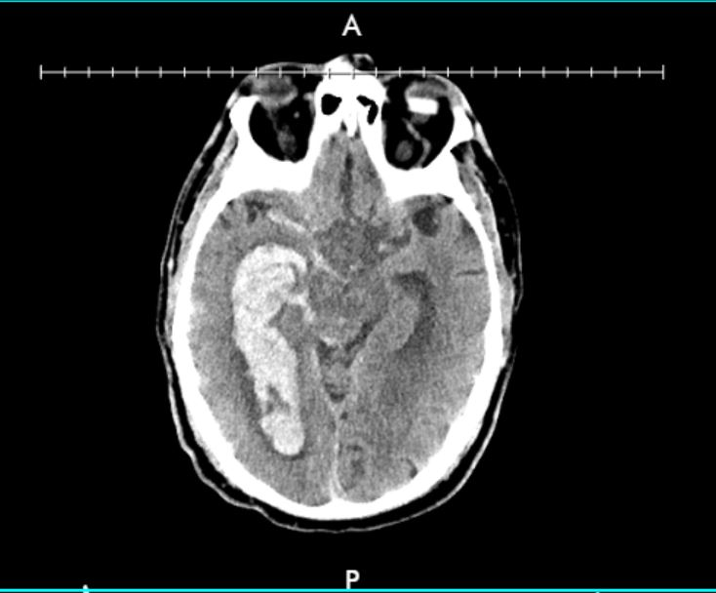
Figure 1: Initial head CT without contrast
Extensive intraventricular hemorrhage in the right and left lateral ventricles as well as the third and fourth ventricles (not shown in image). Extension of hemorrhage into the right sylvian cistern, basal cistern, and right ambient cistern.

References
- Ghali, Michael George Zaki et al. “Anterior Choroidal Artery Aneurysms: Influence of Regional Microsurgical Anatomy on Safety of Endovascular Treatment.” Journal of cerebrovascular and endovascular neurosurgery vol. 20,1 (2018): 47-52. doi:10.7461/jcen.2018.20.1.47
- Yu, Jing et al. “Clinical importance of the anterior choroidal artery: a review of the literature.” International journal of medical sciences vol. 15,4 368-375. 12 Feb. 2018, doi:10.7150/ijms.22631
- Zhang, Nai et al. “Using a New Landmark of the Most External Point in the Embolization of Distal Anterior Choroidal Aneurysms: A Report of Two Cases.” Frontiers in neurology vol. 11 693. 31 Jul. 2020, doi:10.3389/fneur.2020.00693
- Rutledge, Caleb et al. “Transcortical transventricular transchoroidal-fissure approach to distal fusiform hyperplastic anterior choroidal artery aneurysms.” British journal of neurosurgery, 1-5. 22 Apr. 2019, doi:10.1080/02688697.2019.1594691
- Feijoo, Pablo García et al. “Management of a ruptured intraventricular aneurysm arising from distal anterior choroidal artery (AChA): pediatric case report.” Child's nervous system : ChNS : official journal of the International Society for Pediatric Neurosurgery vol. 37,5 (2021): 1791-1796. doi:10.1007/s00381-020-04888-w

Biography: Karrar Aljiboori is a senior medical student at Michigan State University College of Human Medicine. His goal is to contribute to the advancement of the neurosurgical field. His interests include creation of surgical instruments, cerebrovascular neurosurgery, and general neurosurgery.

E-mail: aljiboo1@msu.edu

