Epistaxis as first clinical presentation in prolactinoma

Kaouther Somrani, Nesrine Jemel, Hichem Ammar, Mohamed Dahmani Yedeas, Khaled Radhouen, Ridha Chkili

Neurosurgical department, Military hospital of instruction of Tunis

Faculty of Medicine-University of Tunis El Manar Tunisia

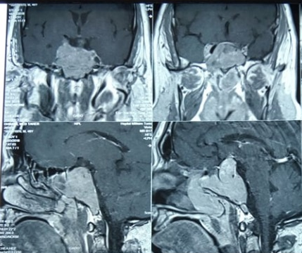

Abstract
Introduction:
Prolactinoma is the most frequent type of pituitary tumor. It may be particularly giant and invasive. It has wide way of presentation. Epistaxis due to prolactinoma has been rarely reported in the literature.
Material and methods:
We report the case of a 48 year old man presented with epistaxis and headache since two months, who was admitted for an acute worsening of his headache and epistaxis without visual troubles. Otherwise he had erectile dysfunction for 2 years.
Results:
The patient was fully conscious and didn’t present any localization sign. The examination of the cranial nerves was normal. He had gynecomastia and morbid obesity. Brain MRI revealed a pituitary macroadenoma which eroded the sella turcica with stigmata of recent bleeding. Hormonal tests concluded to a prolactinoma. The patient received cabergoline with favorable clinical course.
Discussion and conclusion:
Pituitary adenoma presents with headache, visual deterioration and various kinds of endocrinopathies. Rarely pituitary adenoma especially prolactinoma can present with epistaxis.
The first line treatment is based on dopamine agonist which can lead to a reduction of the tumor volume and disappearance of epistaxis.

Image

Figure 1: Brain MRI in coronal and sagittal view, in gadolinium-enhanced T1 weighted showing the pituitary macroadenoma with erosion of the sella turcica with stigmata of recent bleeding
Recent Publications
1. Godey B, Morandi X, Le Gall F, Feat S, Brassier G, Le Clech G (1999) Pituitary adenomas with infra-sellar extension into the nasopharynx. J Laryngol Otol. 1999;113:1109–11.
2. Kleinschmidt-Demasters BK, Lillehei KO (1998). Pathological correlates of pituitary adenomas presenting with apoplexy. Hum Pathol. 1998;29:1255–65
3-P Kumar Chaurasia (2011 ) Epistaxis as first clinical presentation in a child with giant prolactinoma: Case report and review of the literature J Pediatr Neurosci
. 2011 Jul;6(2):134-7
4- Sahoo JP, Kamalanathan S, Parida PK, Pillai V. (2015) A giant prolactinoma with nasopharyngeal extension presenting with nasal blockage and epistaxis. BMJ Case Rep. 2015 Apr 29;2015:bcr2014208811
5. Iglesias P, Díez JJ (2016) Macroprolactinoma: a diagnostic and therapeutic update. QJM. 2013 Jun;106(6):495-504

