Brain Hydatid Cyst cases in Neurosurgery ward of Aliabad Hospital

Neurosurgery department of Aliabad Hospital, Kabul University of Medical Sciences (KUMS).

Dr. Ahmad Fawad Pirzad M.D, Dr. Hashmatullah Rahimi M.D (Neurosurgery Dept.), Dr. Ibrahim Kamal (Pathology Dept.)

Abstract
Introduction: Brain Hydatid Cyst is one of rare causes of Intracranial Space Occupying Lesion (ICSOL), Hydatid disease is caused by the infestation of the larvae of Echinococcus. The definite hosts of Echinococcus are various carnivores, the common being the dog.. Humans get infected through the feco-oral route by ingestion of food contaminated by dog feces containing ova of the parasite or by direct contact with dogs. Brain involvement with Hydatid disease occurs in 1–2% of all Echinococcus granulosus infections.
Objective: Isolated cerebral Hydatid disease is a rare manifestation of it and discuss their mode of presentation, radiological features, operative procedure and outcome. The literature concerning isolated cerebral Hydatid disease is reviewed.
Method and material: Case series study, patient files.
Result: There were report 9 cases of successfully operated of Brain Hydatid Cyst from 2014 -2018.
In this report, we analyze nine cases of isolated cerebral Hydatid cysts In our two cases, radiological features and surgical approaches were different .
Patient chief complain was: Headache 77%, Vomiting 35%, Convulsion 45%, Vision problem 30%, Motor deficit 50%, Dysphasia19%, Sensory disturbances33%.
Cyst localization: left side of Brain 63%, right side of Brain 37%
Sex: 8 female and 1 male
Operation: by local Anesthesia. Craniotomy and Dowling-Orlando technique 7 cysts completely removed and 2 cases ruptured, and reported later.
Anthelmintic medicine before and after operation continued by consultation of Internist.
Conclusion: Brain involvement with Hydatid disease occurs in 1–2% of all Echinococcosis Granolosis infections. Isolated cerebral Hydatid disease is a rare manifestation of it. In this report, we analyze nine cases of isolated cerebral Hydatid cysts and discuss their mode of presentation, radiological features, operative procedure and outcome. In our two cases, radiological features and surgical approaches were different from one another. The literature concerning isolated cerebral Hydatid disease is reviewed.
Keywords: Dowling-Orlando technique, Echinococcus, Brain Hydatid cyst
References: will attached.

- Ahmad Fawad Pirzad’s Short Biography
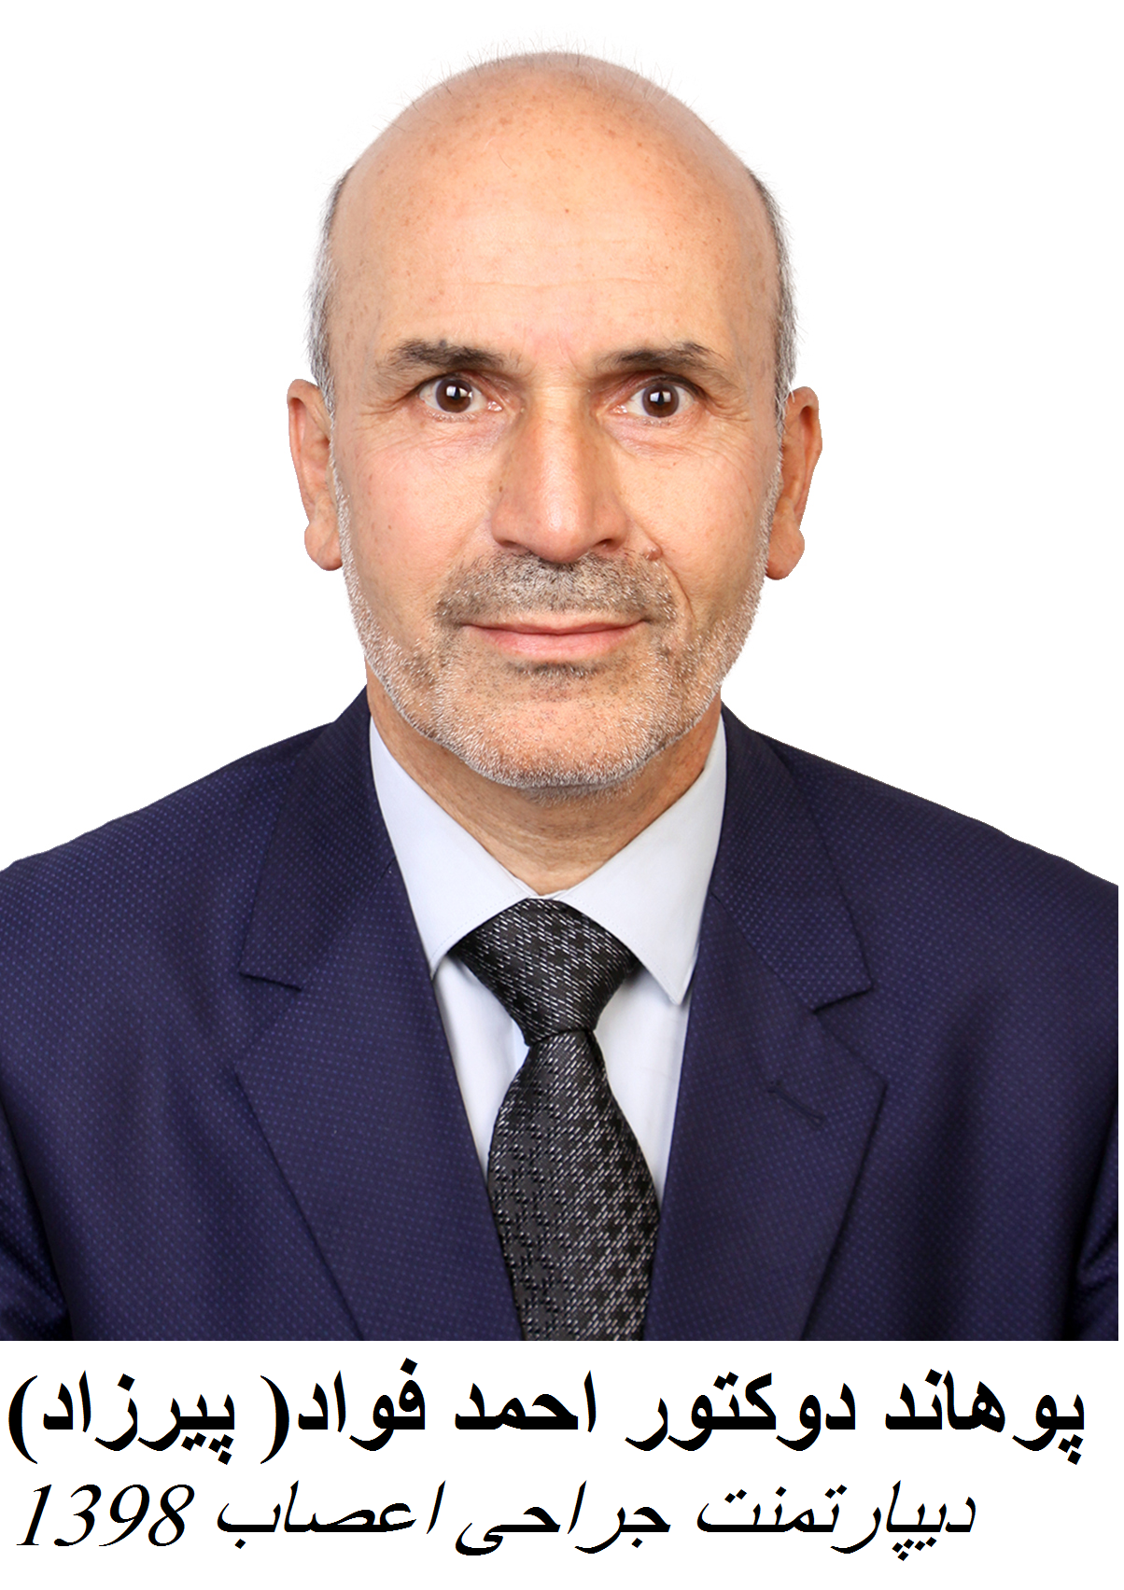You r Digital Photo

- Birth date and place: 11/10/1961, Kabul, Afghanistan.
- Education:
  - School: Ghazi High School: 1980
  - Undergraduate: Kabul University of Medical Science (KUMS) on 1987.
  - Post graduate: Residency Program: 1987-1995
- After passing exams became as a faculty member of Neurosurgery Department of Kabul university of Medical Sciences(KUMS),
- Ranked as Professor on 2019 , KUMS
- Ex-Chief of Education Development Center(EDC) ,KUMS
- Ex-Chief of Research Department of KUMS
- Neurosurgery consultant.
- Continuous Medical Education (CME):
Trainings: Medical Education: KUMS, JICA, USA and USAID
Leadership and Management: MSH, USAID.
Research Methodology Courses: WHO, MoHE
Neurosurgery: KUMS, Germany and USA
Foreign Language: English: KUMS, KU, USAID and UK.
Germany and French
IT: KUMS, USAID, UK.
- Membership: Afghanistan Neurosurgical Society
World Federation of Neurosurgical Societies (WFNS).
Asian Congress of Neurosurgery (ACNS)
Afghanistan Medical Council
Quality Assurance Committee of KUMS
Curriculum Development committee KUMS
Afghanistan Pvt. Hospitals Association (APHA)
- Current position:
    - Chief of Neurosurgery dept. (KUMS).
    - Pirzad Curative Clinic (Pvt.)
    - President of Afghanistan Neurosurgical Society.
    - Faculty of Kabul University of Medical Sciences (KUMS).
    - Expert review committee (ERC) of WHO (World Health Organization)
    - Specialty society membership/board position and trainer
- Research going backwards from fellowship, residency, to medical school
- Personal Hobbies (Running, Swimming, Photography
- Marital State :married, 4 kids
- Travel: International conferences and Seminars (Speaker, Presenter, Panel jury, Training and participant) 15 countries
- Virtual Activities: Webinars.
- Publications: Pirzad’s Textbook of Neurosurgery
Research Topics
- Email: fawadpirzad2@gmail.com , dr_pirzad@yahoo.co.uk
- Phone number: +93777215288
- Address: Karte 4 . Kabul, Afghanistan.
- Awards and Certificates: National and International Organizations.
- YouTube Channel: (Education) https://www.youtube.com/channel/UCFAMgsytHRph-TH7GDb-JDQ/videos

