Title: Swallowing Disorders in Myotonic Dystrophy Type 1

Diaz Borrego P¹
¹Department of Physical Medicine and Rehabilitation, Virgen Macarena University Hospital, Seville, Spain

Abstract (300 word limit)
INTRODUCTION
Myotonic dystrophy type 1 (DM1) is the most common form of muscular dystrophy in adults. Its main clinical features are myotonia and weakness of facial, axial, and distal muscles. Oropharyngeal dysphagia, although highly prevalent in DM1 patients, has received little attention in the literature but it leads to a high mortality rate.
The aim of this study is to describe the swallowing function through fiberoptic endoscopic evaluation of swallowing (FEES). and to correlate it with functional independence of DM1 patients.

MATERIAL AND METHOD
Consecutive DM1 patients underwent a motor, function and swallowing assessment, at Virgen Macarena University Hospital in Seville (Spain). Data collection included: age, gender, Barthel Index, standardized oromotor assessment, FEES protocol and Functional Oral evaluation (functional oral intake scale-FOIS).

RESULTS
18 patients, 83,3% males, mean age: 45,9. Mild or moderate proximal weakness (33,3%), moderate dependent (44,4%). Oromotor disfunction: 100% sample and a 6 FOIS level in 88,9%. FEES: basal secretions observed in 88,9%, pharynx sensitivity altered in 55,6%, postswallow vallecular/pyriform pooling in 22,2% with thin liquids and 100% with solids (biscuit). Aspirations described in 33,3% and delayed pharyngeal reflex in 100% of the sample. No correlations between dependence and swallowing function.

CONCLUSION
Dysphagia is common in DM1 patients. Its presence is probably underestimated in this population as patients do not usually report swallowing complaints unless specifically questioned. Besides it does not seem to be related to dependence. Aspiration, when occurred, is more often with thin liquid, athough pharyngeal residues are more usual with solids.

Image
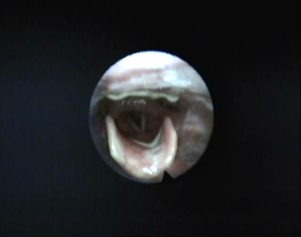
Recent Publications (minimum 5)
1. Ercolin B, Sassi FC, Mangilli LD, Mendonça LI, Limongi SC, de Andrade CR. Oral motor movements and swallowing in patients with myotonic dystrophy type 1. Dysphagia. 2013 Sep;28(3):446-54. doi: 10.1007/s00455-013-9458-9.
2. Pilz W, Baijens LWJ, Passos VL, Verdonschot R, Wesseling F, Nel Roodenburg, Faber CG, Kremer B. Swallowing assessment in myotonic dystrophy type 1 using fiberoptic endoscopic evaluation of swallowing (FEES) Neuromuscular Disorders 2014;24:1054–1062 http://dx.doi.org/10.1016/j.nmd.2014.06.002
3. Umemoto G, Furuya H, Kitashima A, Sakai M, Arahata H, Kikuta T Dysphagia in Duchenne muscular dystrophy versus myotonic dystrophy type 1. Muscle Nerve. 2012;46(4):490-5. doi: 10.1002/mus.23364.
4. Díaz Guardiola P, Olivar Roldán J, Azriel Mira S, García de Gregorio J, Martín González C, Casanova Rodriguez C, Moreno Zabaleta R, Gutierrez Gutierrez G. Sun-lb336: Prevalence of dysphagia in a cohort of patients with Steinert disease Clinical Nutrition. 2017 ;36(supplement 1): s178–s179 doi: https://doi.org/10.1016/s0261-5614(17)30627-1
5. Ladonna, KA, Koopman WJ, Venance SL Myotonic Dystrophy (DM1) and dysphagia: the need for dysphagia management guidelines and an assessment tool Canadian Journal of Neuroscience Nursing 2011;33 (1): 42-46

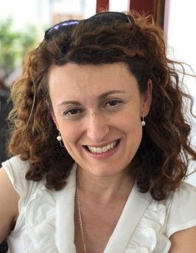Biography (150 word limit)
Paola Diaz Borrego has completed his PhD at the age of 27 years from Seville University and postdoctoral studies from Seville University School of Medicine. She is Physical Medicine and Rehabilitation Consultant, specialized in Phoniatrics, and the director of Phoniatric/Speech and Language Therapy Unit (Physical Medicine and Rehabilitation Deparment) in Virgen Macarena University Hospital, Seville, Spain. She has published more than 20 papers in reputed journals and has been serving as an editorial board member in several journals as: Rehabilitacion (Madr), Neurology &Neurosurgery, Ocronos

Email padibo2@gmail.com

Notes/Comments:

