Brain-centric Design Reverses Ebbinghaus’ Forgetting Curve
Timothy Kieran O’Mahony, PhD, FRGS, Institute for Connecting Neuroscience with Teaching and Learning, USA
Rich Carr, BcID, CRME

Abstract
A global manufacturing and retail corporate entity compared their traditional learning models with a new method of training for a cohort of North American customer service agents. The questions they were interested in exploring pertained to corporate Return on Investment (ROI) as measured in several meaningful outcomes regarding attrition, retention, and customer impact. The traditional model had been used for the previous ten or more years and involved a subject-matter-expert (SME) whose job it was to transmit company information (including culture) to new employees. This method is structured as a transmission model in a traditional lecture/student setting00students in rows facing forward towards a ‘sage on the stage’ compiler of pertinent knowledge. The comparison method comprised a break from traditional ‘sit-and-git’ models by embracing a neuro-based teaching and learning experience that focused on Me-Here-Now enhanced learner identity, and connectedness of conceptual components in a non-linear modality. Trainee agents (N=250) attended courses in face-to-face and tech-enabled learning labs for onboard training content—125 in a traditional ‘classic’ site and 125 in the new neuro-centric BcD site. Data were collected via online end-of-course instruments, interviews, and self-report surveys. Findings suggest that the neuro-centric methodology compared more than favorably with the traditional method so that trainees (i) learned with deep understanding, (ii) were more likely to retain important information and express contentment in their work, and (iii) were more successful at increasing ROI for the company. We describe the model, implications of these findings, and suggest further research avenues going forward.
Image
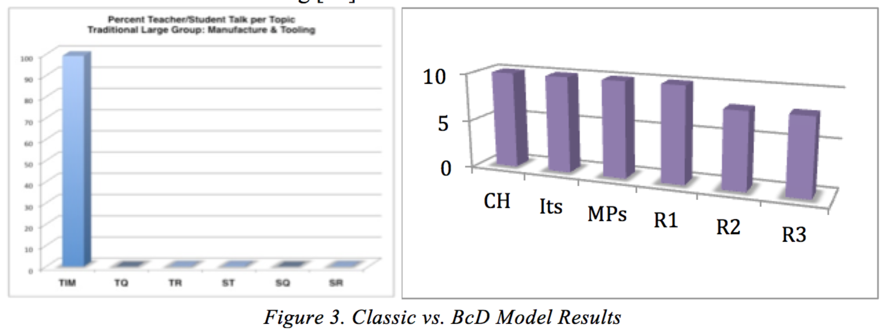
Recent Publications (minimum 5)
- O'Mahony, T. K., Carr, R. (2019 Brain-centric Design: the surprising neuroscience behind learning with deep understanding. Thanet House Publishing, New York, NY.
- O'Mahony, T. K., (2014) Mediated pedagogy in a blended environment: Impact of processes and settings during environmental monitoring of dam removal. In Ecojustice, Citizen Science and Youth Activism, Michael P. Mueller and Deborah J. Tippins, Eds. Springer International Publishing, Switzerland.
- O'Mahony, T. K., Thompson. E., Carr, R. (2019). Brain-centric Design transforms a learning community immediately and forever. International Conference on E-Learning in the Workplace (ICELW) Teachers College, New York, NY
- O'Mahony, T. K., Petz. J., Cook, J., Cheng, K., Rolandi, M. (2019). The design help desk: A collaborative approach to design education for scientists and engineers. PLoS ONE, 14(5): e0212501. https://doi.org/10.1371/journal.pone.0212501
5. O'Mahony, T. K., McQuinn, C. Williamson, J., Buckland, H., Abe, N., Cunningham, S. (2017). Neuroscience foundations in teacher professional development delivers unexpected adaptive expertise outcomes, EduLearn: Proceedings, Empowering learners in a digital world. Barcelona, Spain

 Biography (Dr. T. Kieran O’Mahony)
Kieran is a learning scientist with a focus on cognitive neuroscience, from the University of Washington College of Education LIFE Center (Learning in Informal and Formal Environments). Dr O’Mahony is founding member of the Institute for Connecting Neuroscience with teaching and Learning in Seattle. As knowledge and connections are made at the bio-molecular level in brain labs, and as research results emerge from imaging devices, his team translates pertinent findings to teaching and learning with applications in the real world that impact classrooms workplace and home. This work explores settings and processes that are aligned with pedagogical, brain-enabled methodologies, which are instrumental in fostering deep understanding, prolonged engagement, and collaborative outcomes that foster human development. The challenge is to align what is known in neuroscience with reference to learning sciences and align with modern teaching and learning settings that include personalized learning demands, LMSs, and other delivery mechanisms.
Email: Kieran@icntl.org

Notes/Comment

