Genomics of OLIG family of bHLH transcription factor

Shouhartha Choudhury¹ Prosenjit Paul² and, Supriyo Chakraborty^{3*}
¹Department of Biotechnology, Assam University, Silchar-788011
²School of Life Sciences, Assam University, Silchar-788011

Keywords: OLIG2, OLIG Family, bHLH transcription factor, Gene expression and Brain tumor
Abstract
The present study investigated common primary tumors of the human brain are thought to be of glial cell origin. OLIG (Oligodendrocyte lineage gene) family induce differentiation of neural progenitors and express oligodendrocyte and putative immature progenitor cells in adult central nervous system. The murine bHLH transcription factors OLIG1 and OLIG2 are essential for oligodendrocyte development found in chromosome 21. OLIG1 participate oligodendrogenesis and OLIG2 express in immature neuron and multipotential glia in embryonic olfactory neurons. OLIG1 promotes formation of chondroitin sulfate proteoglycan-positive glial progenitors. It has been suggested that novel molecular markers might be found among factors that have roles in glial development. OLIG2 a marker of diffuse glioma and faithfully restricted to the normal oligodendroglia in brain. In rodents, expression heterogeneity demonstrated OLIG1 and OLIG2 characteristics of various glial tumors. OLIG3 is a third gene of OLIG family detected in the dorsal neural tube in midbrain, hindbrain, and spinal cord. In this study, we curated literature-derived information of the OLIG family and their specific bHLH domain. We accumulate eukaryotic organism genome i.e. Homo sapiens and Mus musculus and performed comparative and functional analysis. The complete bHLH transcription factor data analysis suggested 7 OLIG genes and their domain, motifs, phylogeny, chromosome location and gene expression. Our technique can be adapted in a meaningful way to study the particular bHLH transcription factor genes of interest.

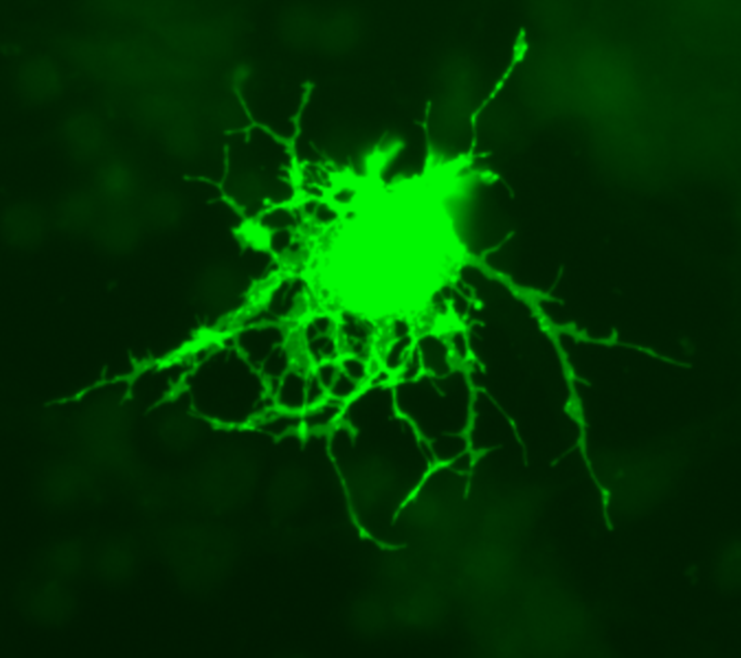

Reference
- Diamond, M.C., et al., On the brain of a scientist: Albert Einstein. Experimental neurology, 1985. 88(1): p. 198-204.
- Lu, Q.R., et al., Oligodendrocyte lineage genes (OLIG) as molecular markers for human glial brain tumors. Proceedings of the National Academy of Sciences, 2001. 98(19): p. 10851-10856.
- Marie, Y., et al., OLIG2 as a specific marker of oligodendroglial tumour cells. The Lancet, 2001. 358(9278): p. 298-300.
Biography
Shouhartha Choudhury has completed his B.Tech and M.Tech in Bioinformatics from India and now pursuing integrated pre-Ph.D. research in School of Life Sciences, Department of Biotechnology, Assam University, Silchar-788011

Author details

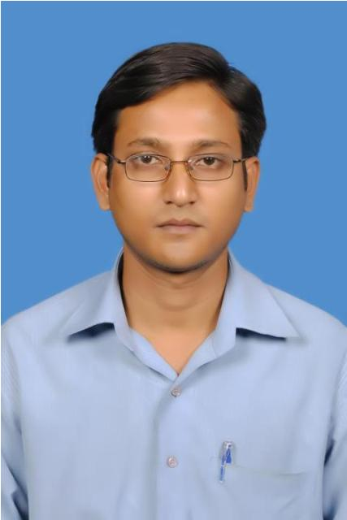
Full name: Shouhartha Choudhury
Contact number: +91-9954411181
Twitter account: Shouhartha Choudhury
Linked In account: Shouhartha Choudhury
Session name/ number:
Category: (Oral and poster presentation)
Passport Number:

