Title: "In-silico and in-vitro evaluation of two series of isoindolines/ dioxoisoindolines derivated from phenylethylamine as inhibitors of cholinesterases"

Omar Ruiz Maciel1, José Guadalupe Trujillo Ferrara²
Instituto Politècnico Nacional, Ciudad de México, México.
Escuela Superior de Medicina. Calle Salvador Díaz Miron S/N. C.P 11340

KEYWORDS: Isoindoline, dioxoisoindoline, acetylcholine, acetylcholinesterase, butirylcholinesterase, docking, Alzheimer.

- ABSTRACT:
Isoindolines and dioxoisoindolines are powerful groups of pharmacophores found in natural and non-natural products, with proven anticonvulsant, anti-inflammatory, analgesic, antihypertensive activity and antibacterial effects. In this research, two series of ligands derivated from isoindolines and dioxoisoindolines were proposed for the treatment of neurodegenerative diseases such as Alzheimer's disease. It was planned to design and synthesize both series of compounds as possible inhibitors of cholinesterases. It is proposed to determine the differences between both series of compounds: isoindolines and dioxoisoindolines. A computational study of interaction between both series of compounds with acetylcholinesterase and butyrylcholinesterase was carried out; as well as an in-vitro model to review the effectiveness and compare the activity of both families of ligands and their possible application in the treatment of Alzheimer's disease based on the cholinergic hypothesis. The inhibitors that act on the active center of the enzyme avoid the union of a substrate molecule or its hydrolysis by blocking the site by its high affinity and interacting in a reversible way with the serine, near the catalytic center; this will prevent the degradation of the neurotransmitter and increase its average life. As a result, it is a possible treatment of the pathology.

- Images:

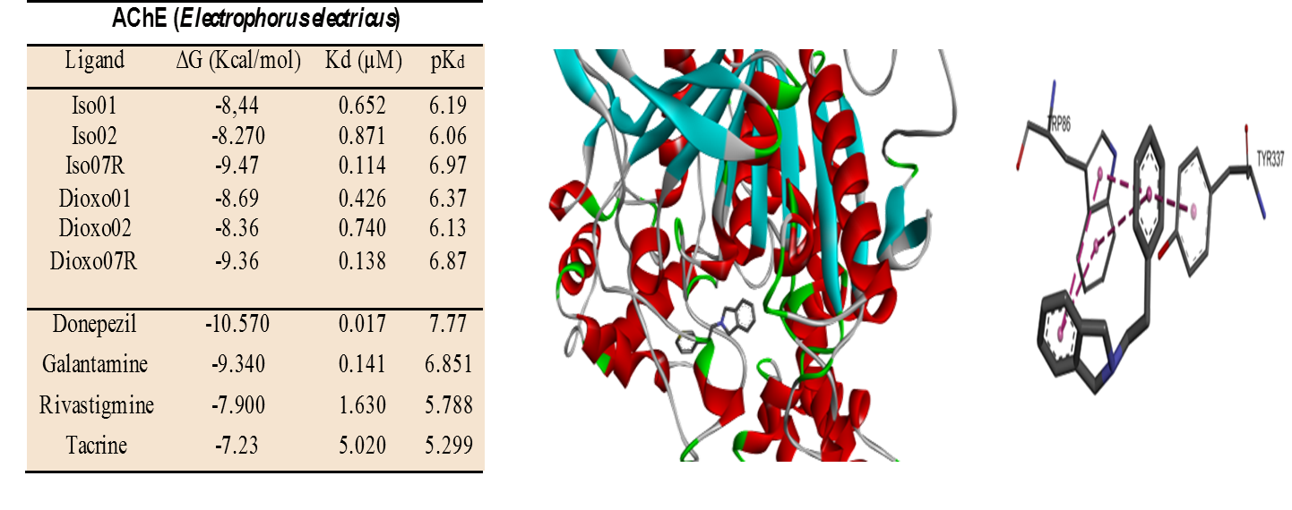Figure 1. Interaction of isoindoline with peripheral binding site of Acethylcholinesterase AChE (PDB ID:1C2B)
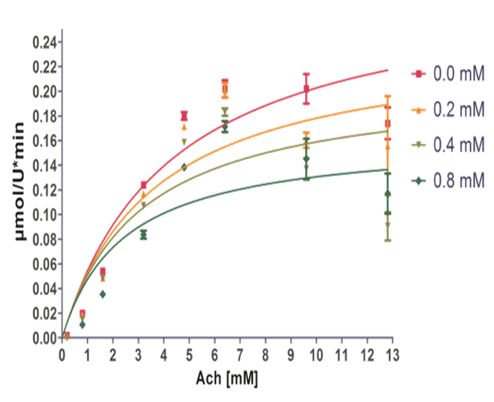

Figure 2. Inhibition plot of isoindioline derivated from phenylethylamine.

- Reference:
- Bourne, Y., Grassi, J., Bougis, P. E., & Marchot, P. (1999). Conformational flexibility of the acetylcholinesterase tetramer suggested by x-ray crystallography. Journal of Biological Chemistry, 274(43), 30370–30376.
- Colovic, M. B., Krstic, D. Z., Lazarevic-Pasti, T. D., Bondzic, A. M., & Vasic, V. M. (2013). Acetylcholinesterase Inhibitors: Pharmacology and Toxicology. Current Neuropharmacology, 11(3), 315–335.
- Worek, F., Eyer, P., & Thiermann, H. (2012). Determination of acetylcholinesterase activity by the Ellman assay: A versatile tool for in vitro research on medic.
- Bonting, S. L., & Featherstone, R. M. (1956). Ultramicro assay of the cholinesterases. Archives of Biochemistry and Biophysics, 61(1), 89–98. https://doi.org/10.1016/0003-9861(56)90319-8

- Biography:
Omar Ruiz Maciel has completed his Bachelor´s Degree in Pharmacobiological Chemistry from the Michoacan University of San Nicolas de Hidalgo in Morelia, Michoacan, Mexico. He is currently completing his Master´s Degree in Pharmacology with a focus on Alzheimer´s disease at the National Polytechnic Institute in Mexico City, Mexico.

- Presenting author details

Full Name: Omar Ruiz Maciel
Contact number: (+52) 5576183468
Twitter account: Omar Ruiz
Linked In account: https://www.linkedin.com/in/omar-ruiz-maciel-678453158/
Email: Omaruiz.1921@gmail.com
Session name/ number: Neuroscience & Therapeutics/1
Category: Poster presentation
Passport Number: G27453626

